Cheatgrass Invasions…in Lower Rolling Plains of Texas?!
*West Texas Rangelands extends heartfelt gratitude to Matthew Coffman, USDA-NRCS Rangeland Management Specialist (Snyder, TX), for his keen eye, rapid monitoring skills, and helpful communication in relaying this rangeland challenge.*
Well done Slim!

Cheatgrass (Bromus tectorum), an invasive annual grass, poses a significant ecological threat to the Southern Great Plains of Texas, particularly in the Rolling Plains region. Ranchers in this area, who depend on native perennial grasses for sustaining livestock grazing and maintaining ecological balance, should be concerned about cheatgrass invasions. Cheatgrass displaces native grasses, such as Bouteloua gracilis (blue grama) and Schizachyrium scoparium (little bluestem), which are key to maintaining soil stability, biodiversity, and forage quality (D'Antonio & Vitousek, 1992; Chambers et al., 2014).
One primary issue with cheatgrass is its early germination and rapid growth. It outcompetes native species for limited water and nutrients, leading to reductions in the establishment of native grasses, which are adapted to the local climate and soil conditions. Cheatgrass tends to complete its life cycle before native grasses even begin to thrive, monopolizing resources and thereby reducing the ecological resilience of the grassland ecosystem (Bradford & Lauenroth, 2006). This displacement leads to a decrease in the availability of high-quality forage for livestock, negatively impacting ranchers' livelihoods.
Moreover, cheatgrass increases the frequency and intensity of wildfires. Its dense, dry biomass acts as fuel for fires, which can destroy perennial grasses that are not adapted to frequent fire regimes. Cheatgrass, however, is fire-adapted and can quickly regenerate post-fire, exacerbating the cycle of degradation (Balch et al., 2013). This feedback loop not only degrades the grassland ecosystem but also threatens livestock and ranch infrastructure.
The reduction of native grass cover also leads to soil erosion, particularly in the semi-arid conditions of the Upper Rolling Plains. Native perennials play a critical role in preventing soil loss through their extensive root systems, but cheatgrass lacks this capacity, thereby increasing the risk of soil degradation and reducing the long-term viability of the land for grazing (Evans et al., 2001).
The invasion of cheatgrass threatens to disrupt the ecological integrity of rangelands in the Southern Great Plains, undermining both the environmental and economic sustainability of ranching. Effective management and restoration efforts to prevent cheatgrass establishment and promote native grass species are essential for maintaining the resilience of this landscape (Davies, 2011).
References
- Balch, J. K., Bradley, B. A., D'Antonio, C. M., & Gómez-Dans, J. (2013). Introduced annual grass increases regional fire activity across the arid western USA (1980–2009). *Global Change Biology, 19*(1), 173-183.
- Bradford, J. B., & Lauenroth, W. K. (2006). Controls over invasion of Bromus tectorum: The importance of climate, soil, disturbance and seed availability. *Journal of Vegetation Science, 17*(6), 693-704.
- Chambers, J. C., Bradley, B. A., Brown, C. S., D'Antonio, C. M., Germino, M. J., Grace, J. B., Hardegree, S. P., Miller, R. F., & Pyke, D. A. (2014). Resilience to stress and disturbance, and resistance to Bromus tectorum invasion in cold desert shrublands of western North America. *Ecosystems, 17*(2), 360-375.
- D'Antonio, C. M., & Vitousek, P. M. (1992). Biological invasions by exotic grasses, the grass/fire cycle, and global change. *Annual Review of Ecology and Systematics, 23*, 63-87.
- Davies, K. W. (2011). Plant community diversity and native plant abundance decline with increasing abundance of an exotic annual grass. *Oecologia, 167*(2), 481-491.
- Evans, R. A., Holbo, H. R., & Young, J. A. (2001). Cheatgrass: Invasion, occurrence, biological characteristics, and control. *Invasive Plant Science and Management, 54*(3), 69-85.

2024 Production Estimates
Very Shallow Clay 78B ecological site:
Total Estimated Herbaceous production = 2,263 lbs/ac (does not include trees or shrubs)
Total Estimated Cheatgrass production = 1,086 lbs/ac
Cheatgrass % of total production = 48%

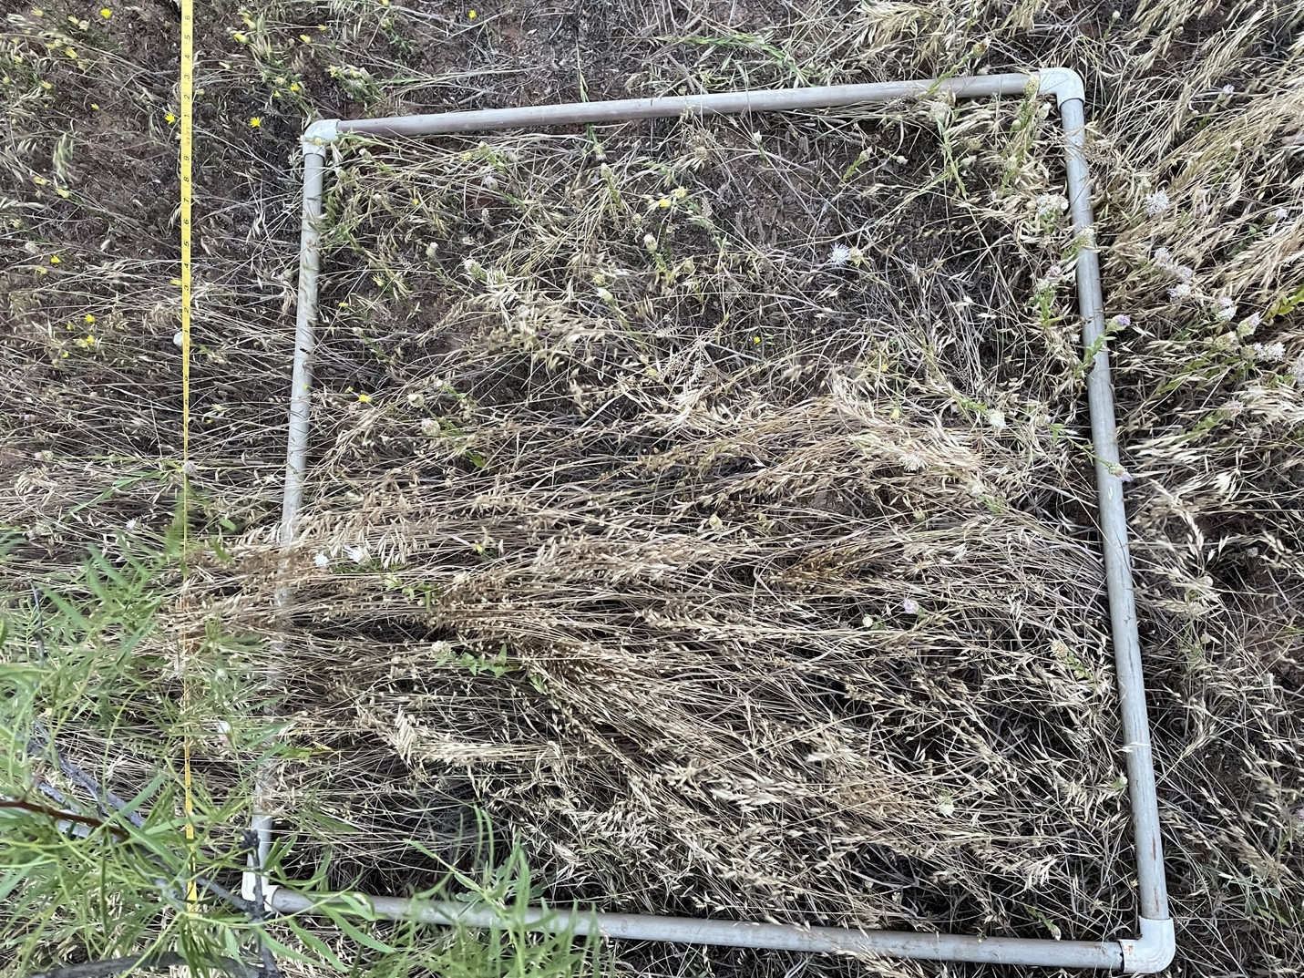
Figure 1. Hardeman County, Very Shallow Clay, 5-2024 frame.
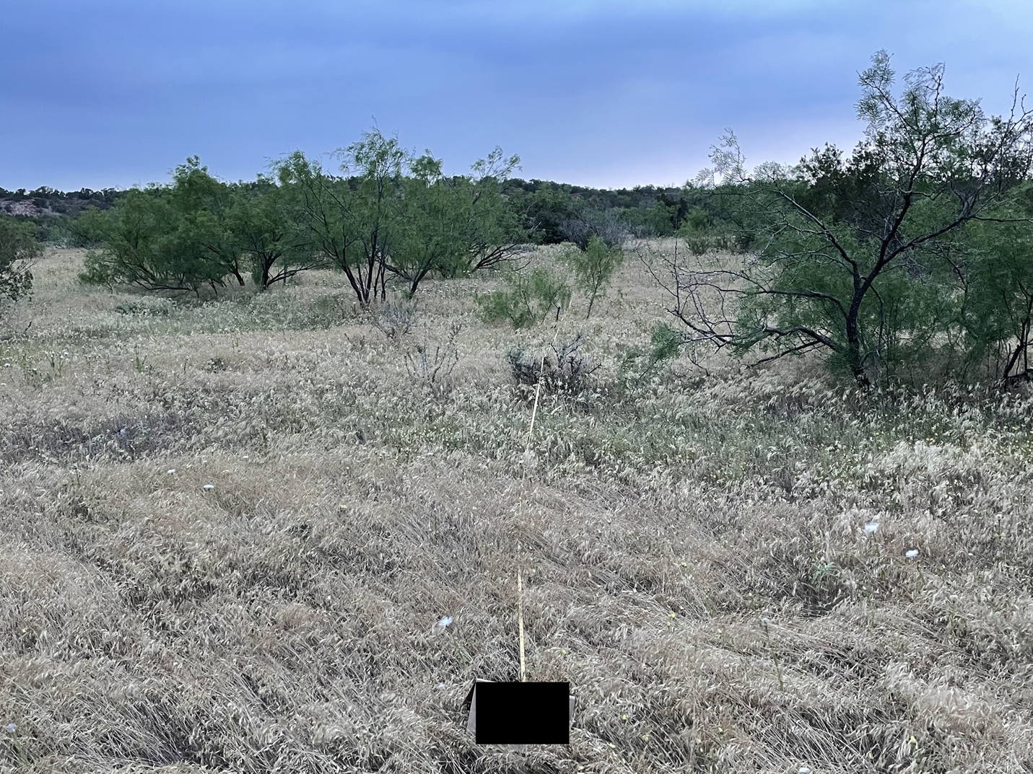
Figure 2. Hardeman County, Very Shallow Clay, 5-2024 transect.
Sandy Loam 78B ecological site:
Total Estimated Herbaceous production = 2,196 lbs/ac (does not include trees or shrubs)
Total Estimated Cheatgrass production = 1,054 lbs/ac
Cheatgrass % of total production = 48%

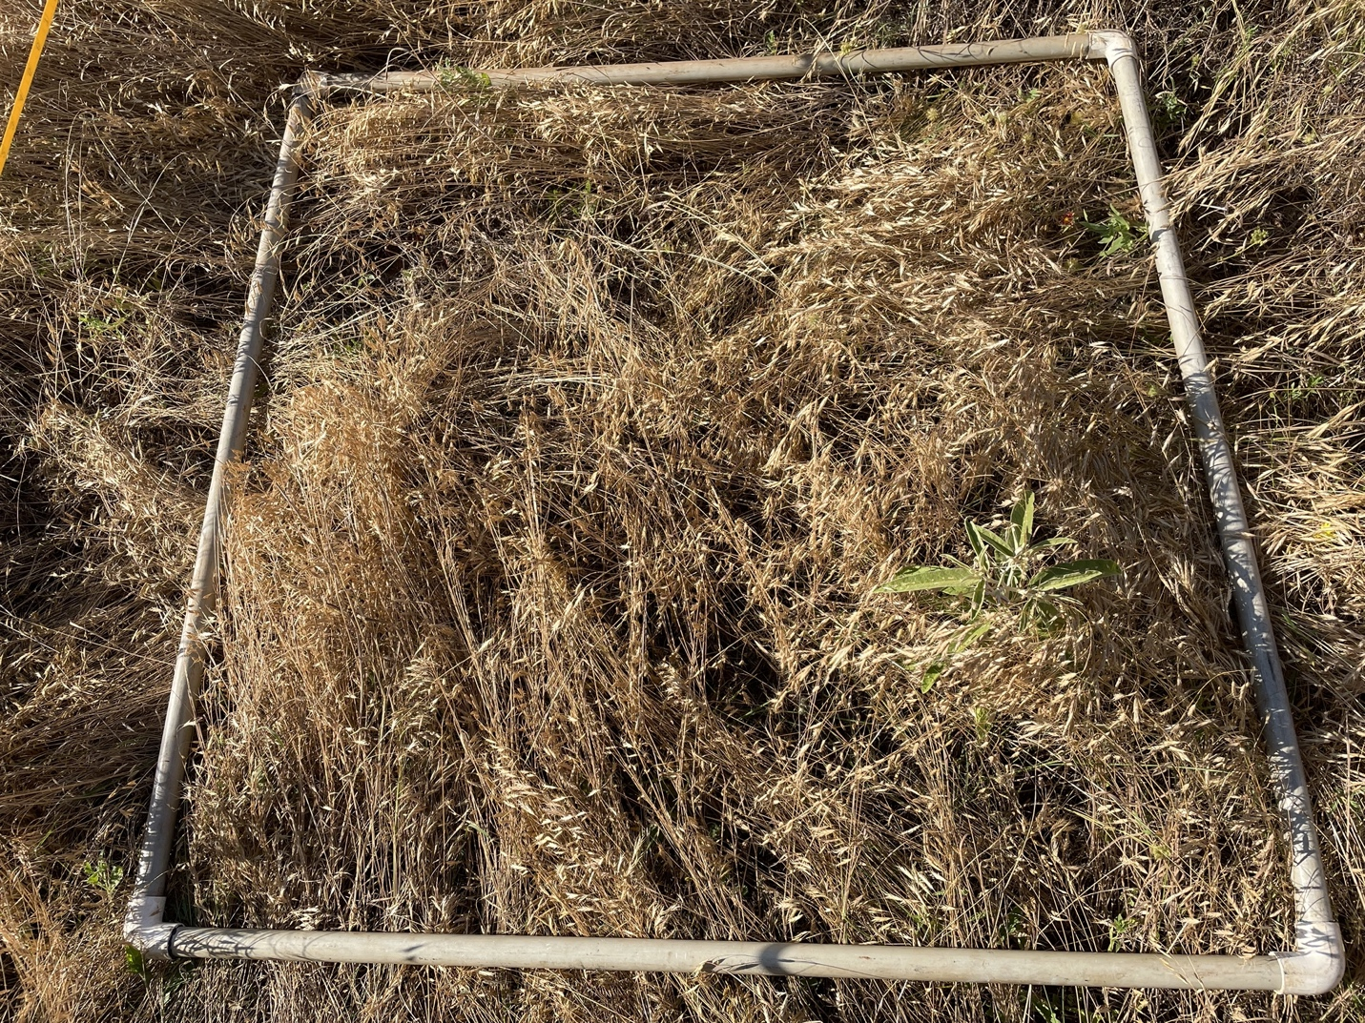
Figure 3. Hardeman County, Very Shallow Clay, 5-2024 frame.

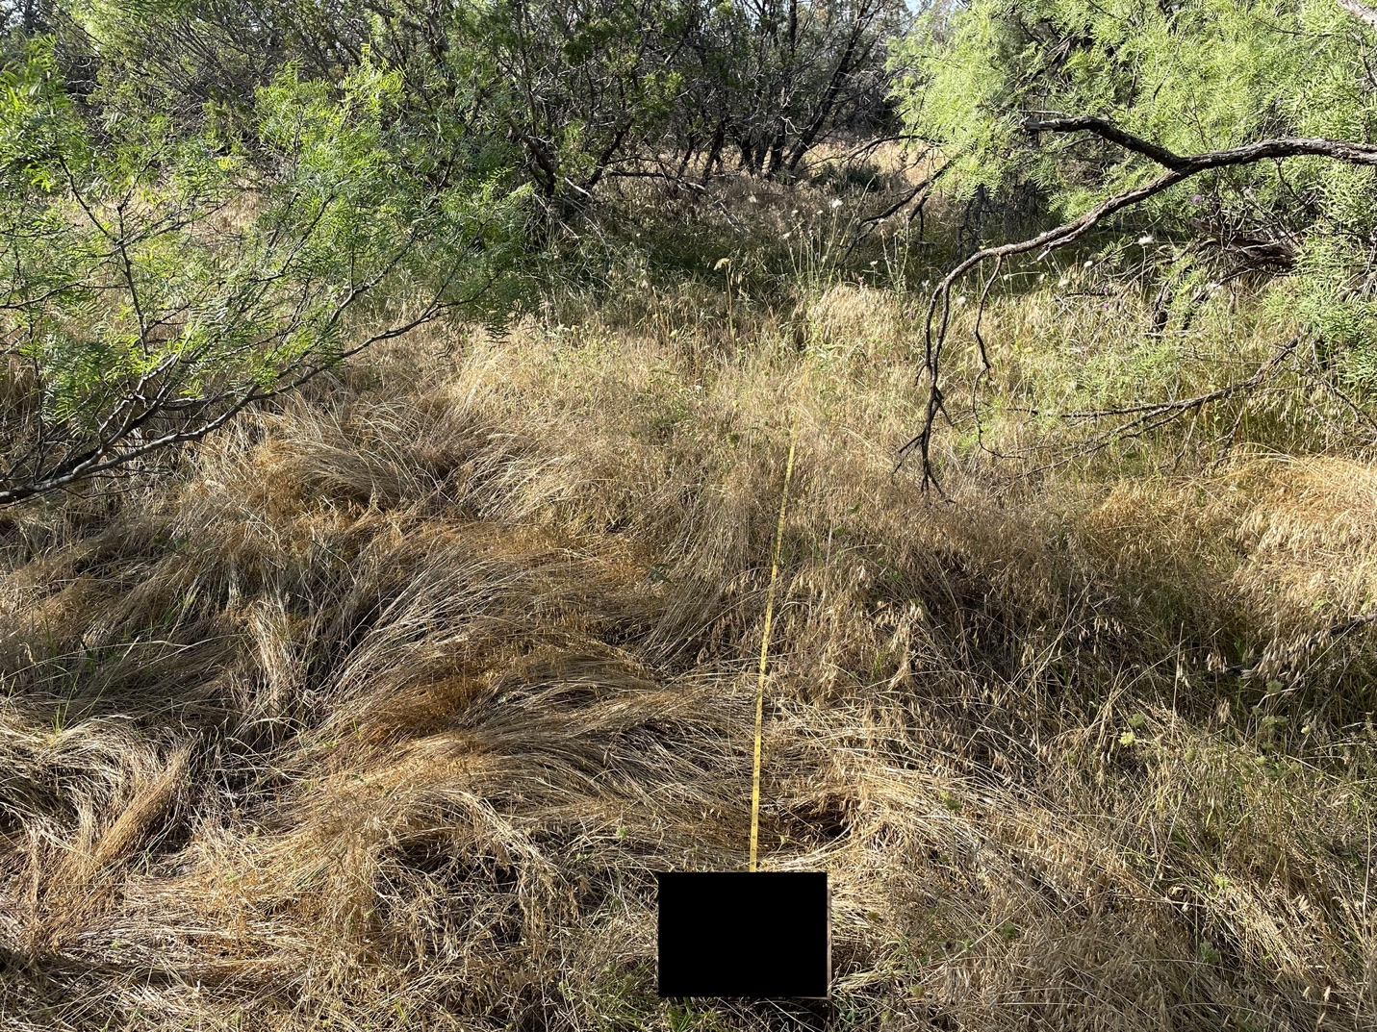
Figure 4. Hardeman County, Sandy Loam, 5-2024 transect.
Clay Loam 78B ecological site:
Total Estimated Herbaceous production = 3,768 lbs/ac (does not include trees or shrubs)
Total Estimated Cheatgrass production = 1,432 lbs/ac
Cheatgrass % of total production = 38%

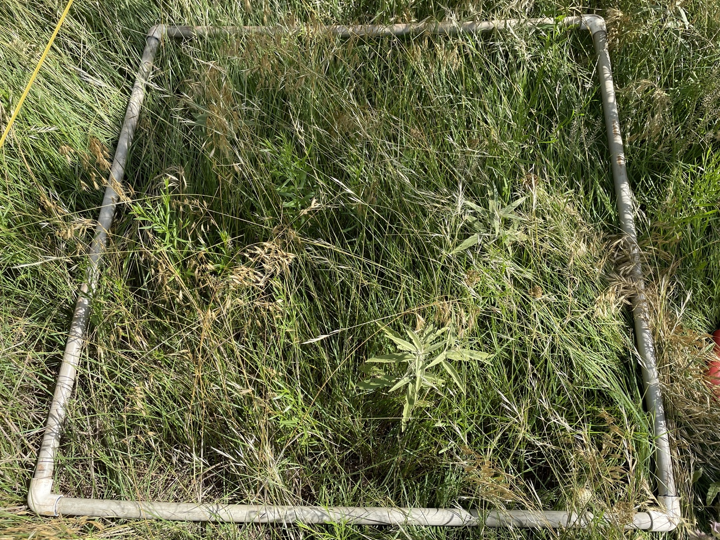
Figure 5. Hardeman County, Clay Loam, 6-2024 frame.

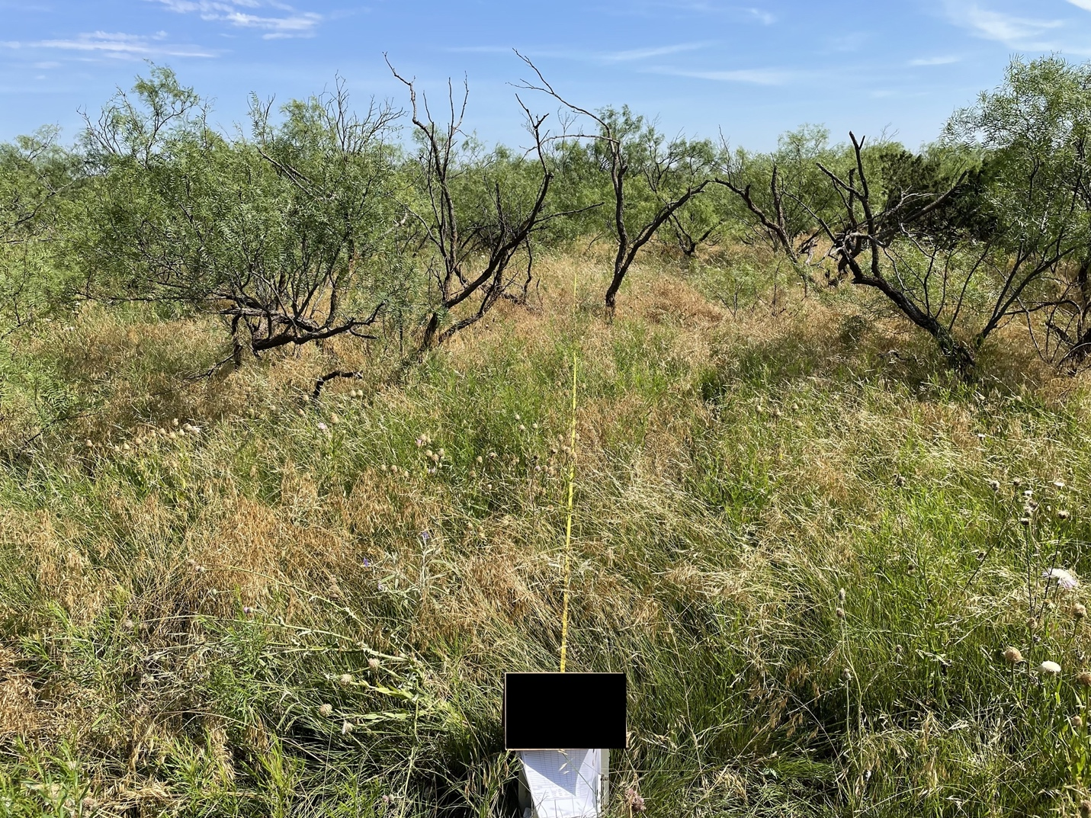
Figure 6. Hardeman County, Clay Loam, 6-2024 transect.

