

Perspectives

Bi-Monthly Publication of the Urban Development Program Area

Issue 1 Volume 4

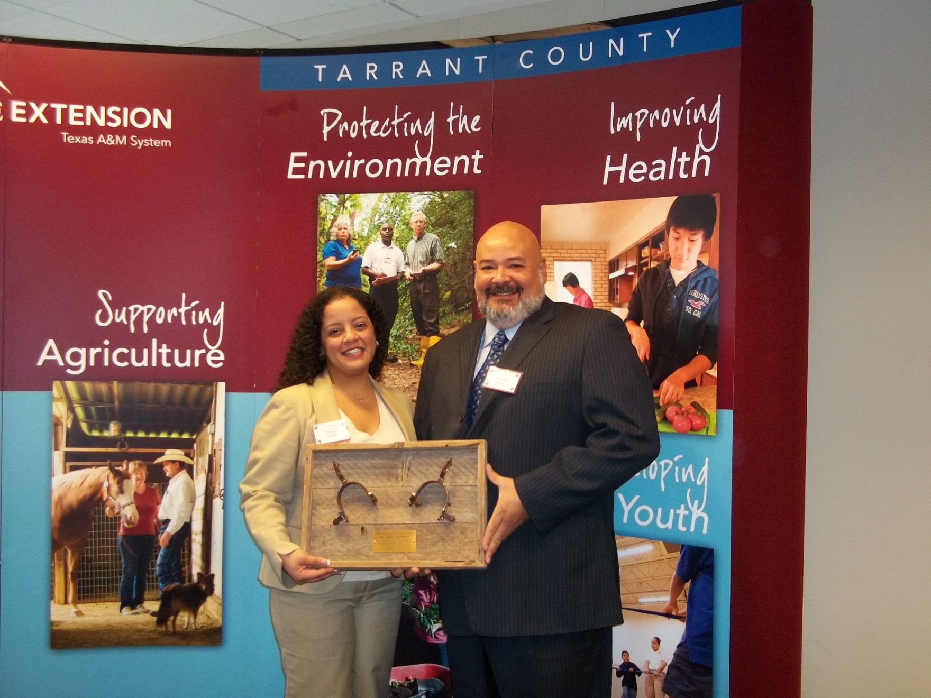

**this issue**

UD-PAC Member Recognized

2010 Outcomes in Programming Efforts

Clash of the Generations

UD-PAC Member Update

The PAC Corner

Would you like to be a contributing writer?

Metroplex Unemployment

Web Sites of Interest

A Note from your CEA

**“Access Tarrant’s Urban Scene” Blog**

After completing the online survey that asked you to communicate your satisfaction with the blog, those who responded voiced the following:

**94%** of you use it for your clients

**72%** of you, use the blog for yourselves

**33%** of you use it for your friends

**28%** of you use it for your families

**94%** of you have either already referred others to the blog or expressed the likelihood that you would!

As a result, this year finds the blog no longer sharing educational articles and highlighting the categories you stated were used the most, including information on county events, resources, workforce opportunities and networking opportunities.

Continue to enjoy and never hesitate to communicate how the blog can best serve you!

Happy blogging!

**UD-PAC Member Recognized**

During the 2010 Annual Volunteer Reception, Texas AgriLife Extension Service – Tarrant County honored Dr. Angel Ilarraza, member of the Urban Development Program Area Committee with the John South Spirit of Extension Award.

John South was an Agriculture and Natural Resources agent in Tarrant County for 14 years. He served a total of 31 years within Extension enhancing the quality of life of our Texas community members. John had a coveted ability to involve and empower volunteers contributing at a grass roots level, enabling them to not only develop programs, but implement and evaluate them as well. In memory of his passion, Extension honored Dr. Ilarraza for his exemplary support of Extension educational programs that serve to enhance the quality of life for people living in Tarrant County.

C:\Documents and Settings\msantiago\Local Settings\Temporary Internet Files\Content.IE5\6N6T38LM\MC900230997[1].wmf

Clash of the Generations!!!

**“What are they thinking?”**

**UD-PAC Member Update**

**Lylette Pharr** has been a UD PAC member since its inception in 2008. Once the Community Kitchen Director at the Tarrant Area Food Bank, she is now taking on a new responsibility here in Fort Worth!

***A Note from Lylette Pharr***:

My new position is Homelessness Coordinator for the City of Fort Worth. I work with Otis Thornton who is the Homelessness Program Manager. We oversee the Directions Home program, which is the 10 year plan "to make homelessness, rare, short-term and non-recurring in Fort Worth, Texas." We are now halfway through program year two. The City has committed funds for Directions Home and, through those funds, various programs at several Tarrant County agencies are in place. Directions Home is a Housing First program, which means that someone experiencing homelessness does not have to demonstrate that they are deserving of or ready for housing. Rather, Housing First says that housing comes first so that a person has a safe and more stable environment to then begin to deal with other issues.

To find out more details about the programs, how many have been housed and other information about Directions Home please visit www.directionshome.org.

If you have questions please contact Lylette at [Lylette.Pharr@fortworthgov.org](mailto:Lylette.Pharr@fortworthgov.org)

.

Pac Corner

**Next PAC Meeting**

Monday, January 10, 2010 11:30 – 1:00 PM AgriLife Extension Office (Brown Bag Lunch) Bring a Friend

***Topics of Discussion:*** 2010 Programming Outcomes 2011 Programming Areas of Focus Walking School Bus Member Roles 2011 C-LEC Conference Planning Future Meetings

**Special Thanks!**

Member, Cathy Young for already looking into a potential location for the 2011 C-LEC Conference!

Member, Bill Russell for sharing the relevance and work of the committee with our new Commissioner for Precinct 2, Andy Nguyen!

Member, Anita Young for her continued support of the Tackling the Tough Skills curriculum with the Texas Youth Commission clients!

Member, Marcela Nava for her supportive marketing of the Urban Development blog.

All members for your willingness to continue advising and working with this department in an effort to serve the Tarrant County community in 2011.

As we enter a new decade, I am sure many have thought about their “good ol days”. As decades come and go, so do generations of thought, fashion, ethics, technology, and existence. However, in an ever increasing need to stay employed and survive current economic times, we often find ourselves working with and among as many as four different generations within one work place. This can be a blessing in all its wisdom and a curse in all its misunderstandings and differing perspectives.

You may often find yourself wondering, “what were they thinking?” when you look at a co-worker with a very different approach to their work and you may have asked yourself, “can’t they see that times have changed?” Generational differences are accompanied by different historical events, distinct theories of thought, unique experiences in technology, and ever advancing science and literary frames of mind that contribute to a vast array of differences between and among us.

If we learned to seek understanding of the underlying causes for certain types of thinking and certain preferences in behaviors, we would minimize instances of misunderstanding and engage in much more meaningful opportunities to work toward a common goal and purpose.

Regardless of our generational perspective, we co-exist and seek a better quality of life, so let’s help one another achieve it through understanding.

Learn more about the “Embracing Generational Differences” lesson of the professional development series offered through your Urban Development Program Area.

2010 Outcomes - UD Program Area

***Would You Like to Contribute?***

Your Perspectives is seeking guest writers to share their thoughts with our readership. Each issue, we will provide three topics of interest that you can focus a written piece on, no more than 250 words.

You’d be required to provide the topic, title of the article, name, title and agency of the contributing writer.

For example,

Topic: generational differences Title: Clash of the Generations! Monica Santiago, CEA-Urban Development, AgriLife Extension

***Topics for Next Issue:***

Recruiting Quality Volunteers Strategic Planning Motivating Your Employees

**Submit your contributions via e-mail as a word attachment to**

**Monica Santiago msantiago@ag.tamu.edu**

**FYI –** Receipt of your article does not guarantee publishing. CEA reserves the right to edit submitted articles.



**Statistical FYI – Unemployment in the Metroplex**

According to the Bureau of Labor Statistics, Texas had an 8.2% unemployment rate as of November 2010 and includes all “jobless” individuals who are actually available to take a job and have actively sought employment in the four weeks prior to the statistic measurement. This is lower than other similar populous states, including California (12.4%) and New York (8.3%). In the DFW & Arlington Metropolitan Area, the unemployment rate mirrors the state at 8.0%.

There are many local job training programs and workforce opportunities. For more information on a few, visit your “Access Tarrant’s Urban Scene” blog at http://tiny.cc/urbanscene

**Building Connections PD**

758 adults participated in the ***Building*** ***Connections programming***, including 58 local leaders who participated in the full day 2010 Community Leadership Empowerment Conference. According to the post-survey completed by a sample group of 45 individuals, 92% had an increase in their knowledge and skill base associated with communicating across cultures, implementing various leadership styles, and managing volunteers (among other topics), while 73% intend on seeking further professional development opportunities in the 2011 calendar year through the Extension leadership educational programs.

A total of 5,196 issues of ***Perspectives*** were distributed (2,550 hard copies at 425 every two months and 2,646 electronic copies at 441 every two months – 231 individual contacts and 210 contacts through one yahoo group).

***Access Tarrant’s Urban Scene*** - A total of 228 entries were shared with the Tarrant County public in the form of 52 Tarrant County events, 30 Tarrant County resources, 40 Community development opportunities, 48 networking opportunities, 54 educational opportunities, and 4 educational articles.

**Tackling the Tough Skills**

238 adults and 29 youth participated in the ***Tackling the Tough Skills and CIA programming***. According to post-programming case studies and follow-ups, adults increased their abilities in resume preparation, interviewing skills and techniques, dressing for success, and career exploration and preparation, while youth showed improvement in their abilities to resolve conflict, research their careers of interest, and making healthy decisions when faced with difficult circumstances. Adult and youth audiences ranged from community residents to Texas Youth Commission studentsand federal inmates and state parolees/probationers.

***Access Tarrant’s Urban Scene*** - A total of 631 entries were shared with the Tarrant County public in the form of job opportunities, open positions, and career fairs.







**Welcome to a new year and I hope the new and improved Perspectives can provide you with information that is relevant, timely, and educational in nature.**

**I am here to serve your needs. Please do not hesitate to communicate your thoughts and seek assistance with UD programming access.**

**My contact information appears below.**

Tech Times  
ISSUE 00 MONTH YEAR

**A Note from your Agent**

To join our mailing list, receive more information, make an appointment to meet with your CEA, request an event to be placed on our community calendar, or express interest in our programs, contact:

**Sonia Benavides**

**Admin Asst – Urban Development**

**918-884-1946**

**Urban Development Program Area**

500 Taylor Street, Suite 500

Fort Worth, TX 76196

Mail: P.O. Box 1540

Fort Worth, TX 76101-1540

Ph: 817 . 884 . 1946

Fx: 817 . 884 . 1941

Mónica Santiago

CEA – Urban Development

msantiago@ag.tamu.edu

**Web Sites of Interest**

**http://tiny.cc/urbanscene**

Access the friendly and informational blog updated weekly by your Urban Development County Extension Agent. Find up to date information on events, resources, networking opportunities, workforce opportunities, and more.

**http://tarrant.tamu.edu**

Access your Tarrant County extension web site and learn about all of our available program areas – Urban Development, Home and Commercial Horticulture, Agriculture & Natural Resources, 4H & Youth Development, Family & Consumer Sciences, Health & Nutrition.

**http://communityeconomics.tamu.edu**

Educational information regarding our local agricultural economy brought to you through the Department of Agricultural Economics of the Texas A&M University System.

**http://buildingconnections.tamu.edu**

Find downloadable material related t the Building Connections educational program as well as supplementary aids and resources.