75th Southern Pasture and Forage
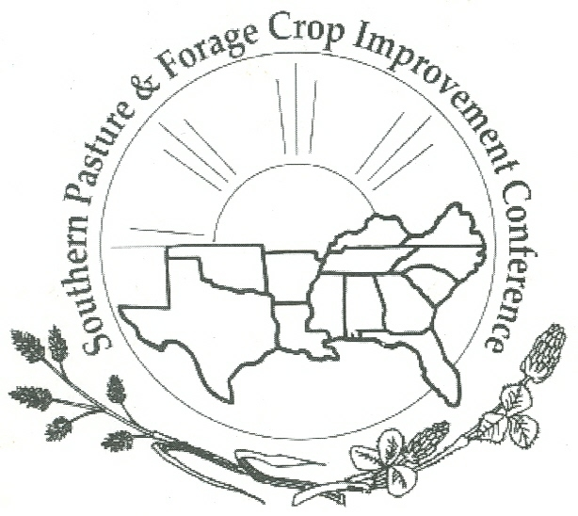
Crop Improvement Conference (SPFCIC)

Hosted by North Carolina State University
Asheville, NC July 26-27, 2022

CALL FOR POSTER SESSION ABSTRACTS

Accepting abstract submissions until July 15, 2022

We are accepting abstract submissions for the 2022 Southern Pasture Forage Crop Improvement Conference, July 26 – July 28.

Abstracts should be submitted to Dr. Rocky Lemus (Rocky.Lemus@msstate.edu) by Friday, July 15, 2022 at 5:00 P.M. CDT

GUIDELINES

ABSTRACT:

- Abstracts should be between 300-350 words.
- The abstract should include a title (Bold, Times Roman 14); authors (Times Roman 12), author’s affiliations (Times Roman 12), the rationale (one or two sentences); objectives (one or two sentences); materials and methods; brief results; implications (see attached example).
- Use English units in text, tables, and figures.
- Center the title, authors, abstract heading, and table titles.
- Use a zero placeholder to the left of decimal points (0.05, not .05) in text, tables, and figures.
- Add a contact email for the leading author at the bottom of the abstract.

POSTER:

- Posters should be submitted as a PDF document to be displayed on demand on the SPFCIC’s website.
- Posters should be submitted to Dr. Vanessa Corriher-Olson (vacorriher@ag.tamu.edu) no later than Friday, July 21, at 5:00 PM CST.

Visit the website http://agrilife.org/spfcic/ for conference information, updates, conference registration.

