Smith County 4-H Shotgun Drawing

All Proceeds Go To Support Smith County 4-H

|  | **Action** | **Gauge** | **Barrel Length** | **Capacity** | **Chamber** | **Length** | **Weight** | **Drop** | **Stock** | **Finish** |  |
| --- | --- | --- | --- | --- | --- | --- | --- | --- | --- | --- | --- |
|  | Pump | 12 GA | 18 1/2" | 4 + 1 | 3" | 37 5/8" | 7 1/2 lbs | 1 1/2" @ Comb & 2 1/ | Black Synthetic | Black |  |

**H&R® Pardner® Pump Shotgun**

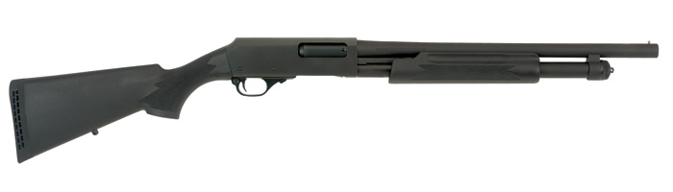

Tickets:

1 for $5

Or

5 for $20