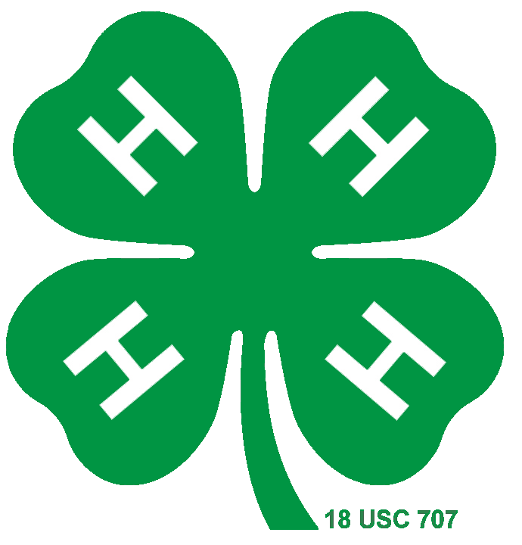
2023-2024 Montgomery County 4-H Council
Updated 8/23/23 Watch 4-H Updates and 4-H Focus for the most current details.
Council Meeting | Programs (tentative) | Service Project | Meal
September 25, 2023 | Poultry Project/Industry – Ella | Sept. 23 8:00 a.m. Make Project Linus Blankets – Karis | Enchilada Casserole – Ella
October 23, 2023 |  | Operation Christmas Child – Jessica  Solar Eclipse Viewing Event – October 14, 2023 9:30 a.m. -  Conner | Lasagna – Jessica
November 27, 2023 | Rabbits – Jessica | Veterans Service/winter clothing drive – Jackson | Breakfast Casserole - Lani
December Cancelled due to schedule conflicts

January 22, 2024 | Fashion Designer – Ali | Make Dog Toys for shelter adoptions – Ali | Ali
February 26, 2024 | Ambassadors – All | Angels Rodeo Feb 11th – Dean  Sock Roundup - Dean | Pulled Pork – Connor
March 25, 2024 | Congress – Business | Birthday Boxes - Conner
April 22, 2024 |  | Snack Packs for Food Bank | Walking Tacos - Karis
May 21, 2024 ?
(office is booked up on the 20th)

Programs
Master Gardener/Nursery Professional Horticulture/Floral Design at MCF – Ali
Friends of Texas Wildlife – volunteers that nurse sick/injured animals back to health – Lani
Hailey Mills Foundation – October or April
Community Service
Ella – Sleep in Heavenly Peace – making bunk beds
Lani – Non-slip socks for elderly Save for later

Officer | Com Serv Flyer | Program | Meal
Dean Holtkamp | Sock Roundup – Feb  Angels Rodeo 2/11/24
Jessica Skelton | Operation Christmas Child – Oct | Rabbits – Nov | Lasagna Oct
Lani Duncan | Snack Packs - April |  | Breakfast Casserole – Nov
Ella Porter |  | Poultry Proj – Sept.  Ambassadors – Feb | Enchilada Casserole – Sept
Jackson Skelton |  | Ambassadors – Feb
Karis Downs | Project Linus Blankets – Sept 23, 2023 | Hailey Mills – Oct or Apr | Walking Tacos - April
Health and Safety | Birthday Boxes – March  Eclipse Viewing - Oct | Ambassador – Feb JD | Pulled Pork – Feb
Ali Denson | Make Dog Toys – Jan | Fashion Designer – Jan  Ambassadors – Feb | ??? - Jan

