**The Easiest Way To Make A Transparent Signature Stamp**



[**WATCH THE VIDEO**](https://www.youtube.com/embed/yV7NfhiD9XQ)

If you sign a lot of documents that are sent to you electronically in PDF format, you can save a lot of time by using a PDF stamp of your signature. This way you can simply stamp the document, flatten it, and return the document electronically instead of printing, signing with a pen, and scanning the signed the document. The problem is that if the signature stamp has a white background instead of a transparent one, the white will cover portions of the document:

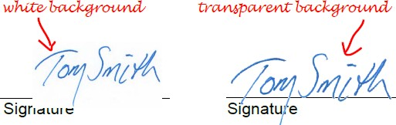

There have been several articles written about how to make a signature stamp with a transparent background but many of these methods result in a fuzzy, poor quality signature stamp. I will outline the fastest method I have found that produces a high quality transparent background signature stamp using software that you probably have on your computer, and free online tools. It looks like a lot of steps but I break each step down into a short bullet point:

CREATING A SIGNATURE PNG FILE

1. Sign your name on a blank sheet of printer paper. Paper quality and type of pen doesn't really matter, just make sure your signature is straight and not on an angle.
2. Scan the paper to PDF. With Acrobat Pro DC select File > Create > From Scanner > Color Document.
3. Press the “Print Screen” button on your keyboard.
4. Open Microsoft Paint.
5. Press Ctrl + v on your keyboard to paste the screen shot from step 3.
6. Click the select tool in Paint.
7. 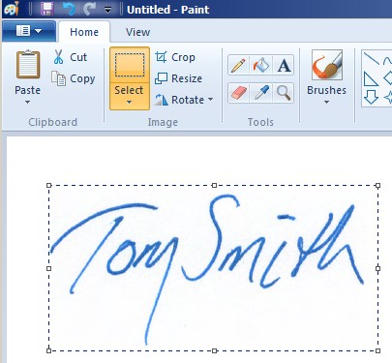Drag a rectangle around the signature staying as close as possible to the outer edges of the signature.
8. Select “Crop”, and the image should be resized to the size of the rectangle in the previous step.
9. Select “Save As > Png Picture”, name the file “My Signature”, and save it to your desktop.

MAKING THE BACKGROUND TRANSPARENT

1. Find a free online image converter by Googling “Convert Image To Transparent Background Online” and use the image converter to make the background transparent. When I Googled that, number one was Lunapic (<http://www125.lunapic.com/editor/?action=transparent>). The next steps use this particular tool to convert the



image to

one with a transparent background.

1. Click “Choose File” and upload the .png file from step 9.
2. From the Lunapic toolbar, select Edit > Make Transparent.

Leave a message

1. 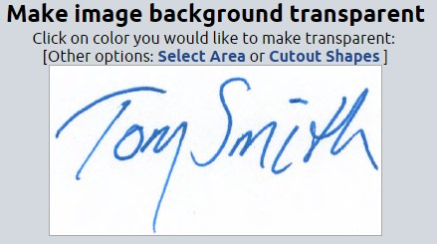Click a white part of the image.

This shows the transparent image.



1. Click “Save” and save the new transparent signature to your desktop. CREATING THE STAMP
2. Select the stamp menu on the Acrobat Pro comments toolbar menu and select Stamps > Custom Stamps > Create.
3. Click the “Browse” button in the dialog window, change the file type dropdown to “.png”, browse for and select the transparent signature file from step 14.
4. Click “Open”.
5. Click “OK”.
6. Name the stamp category (something like “My Signatures” or you can select the pre-existing “Sign Here” from the dropdown menu).
7. 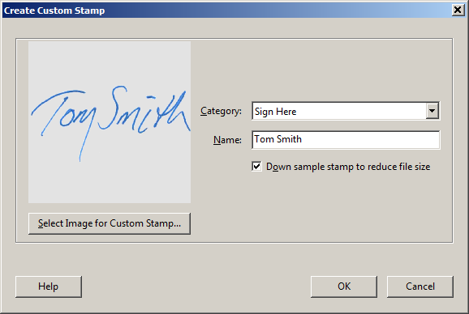Name the stamp.
8. Click “OK”. You will most likely have to create this stamp twice due to sizing issues.
9. Open a blank PDF. You can create one by opening the javascript console (ctrl + j) and running the following script: app.newDoc(); You run the script by placing the cursor anywhere on the line containing the script and pressing ctrl + Enter on your keyboard.
10. Go back to the stamp menu and select the stamp you just created and stamp the document. You'll notice that the signature is probably much too large. Resize it by dragging one of the corners inward.
11. When you have the signature stamp to the correct size, save the PDF to your desktop.
12. Repeat steps 15 through 21 EXCEPT, use the PDF file created in the previous step as the file from which you will create the stamp. This will create the stamp the correct size so you don't have to resize it every time you apply it.