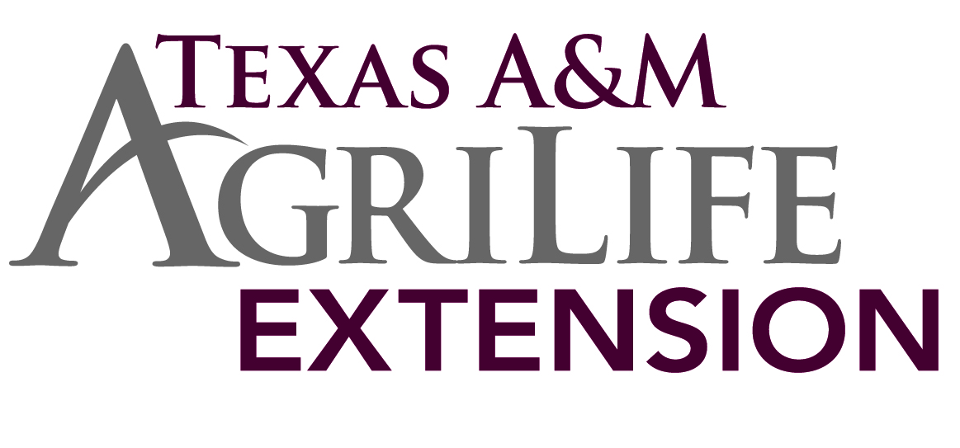**Brazoria County 4-H News**

**September 2015**



**September Reminders -** This month’s reminder is being sent to all 4-H families that were registered on [4-H Connect](https://texas.4honline.com/Login.aspx?4079444C6D387A6E595A2F6F3D) for the 2014-2015 year. Re-enrollment began August 15th.  If your membership status is pending you are in good shape.  Your membership status will become **"Active"** once your club manager and then the county program both confirm your membership.  The fee is $20 until October 31, 2015. The fee will increase to $25 November 1st. Need help with enrolling in Connect? [Instructions](http://agrilife.org/brazoria4h/files/2014/08/WelcometoTexas4H_1415.pdf) on the second page!

* A few things to keep in mind when you are enrolling:
* Make sure that you have the correct school listed.
* If you have a resubmit status, check your email for the instructions.
* 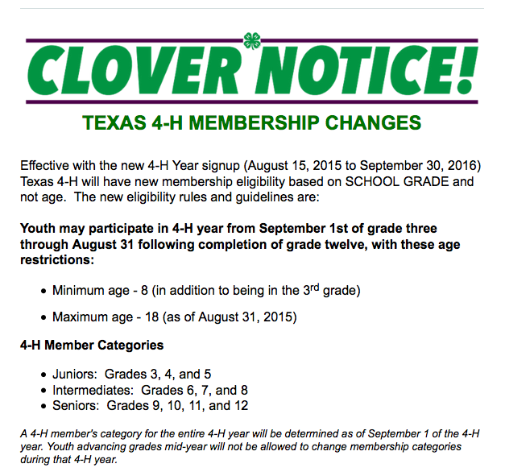The system seems to like the Mozilla FireFox Browser. If you’re having problems with adding a credit card to your account usually switching Browsers and logging back in works to correct this issue.

All exhibitors must be Quality Counts certified. 4-H members that turned 14 years old before September 1, 2015 will now need to take the senior test. Go to [Quality Counts website](http://agrilife.org/qualitycounts/) - click on *Texas Trail* for the tutorial then *Verification* to take the test.

[](http://www.hotfair.com/)

Heart O’ Texas Fair & Rodeo – if you are planning to enter the HOT Livestock Show please contact the 4-H office by Tuesday, September 8th.



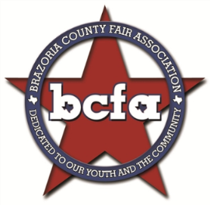The 4-H office will be closed for the Holiday on September 7th

*Brazoria County Livestock Fair* entries are turned in by club September 5th – contact your club manager for club deadlines and more information. Rabbit validation is September 12, 2015. The Brazoria County Fair will be held October 9-17, 2015.

The *Junior Creative & Culinary Arts Department* entries are due September 11, 2015 The contest is open to 4-H and FFA members in Brazoria County. In addition, a Horticulture division has been created. The Horticulture Division includes the traditional classes of potted plants, cactus, terrariums, seedlings, and lawn/garden decorations along with new class “Miniscapes”. Miniscapes can be designed and planted by individuals or teams. At the designated time, teams/individuals will bring their plants and equipment and create a miniscape that will be displayed on the grounds during the fair. Additional details for the Miniscape class 108 can be found in the Divisions and Class Descriptions document.

Entry forms are online with a deadline of September 11. 2015.  Complete rules and forms are available at the 4-H office or on our [website](http://agrilife.org/brazoria4h/jcca/). Online registration is now available!!

If you would like to be a judge for JCCA please go to the [4-H website](http://agrilife.org/brazoria4h/jcca/jcca-judges/) and fill out the JCCA Judge form

Brazoria County 4-H will host our One Day event on Saturday, September 12th at Hood-Case Elementary School in Alvin. We will give the Science Learning Center a makeover. They have a facility that has not been in use for a number of years. Our plan is to help them clean it up and provide a setting for the students to learn about agriculture. On this day we will install raised garden beds, organize the green house, prepare chicken coops, clean up walk ways, and more. We will start at 9am and work till 2pm. Drinks and lunch will be provided. Mark your calendars today.

One Day 4-H is one day for all the 4-H members, parents, leaders, and volunteers to step out into their communities and county and say "thank you" by giving back for them more than 105 years of support to 4-H in Texas. This day of community service is whatever each 4-H members, club, or county 4-H Program wants it to be. It could be as simple as picking up trash and mowing the lawn for senior citizens to elaborate as hosting a 5K Walk/Run and raising money for a cause.

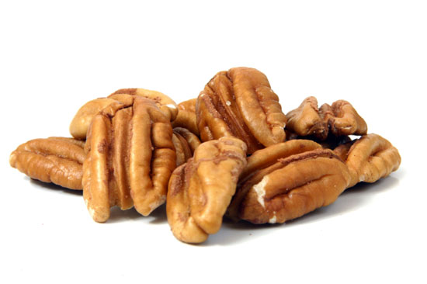 **Pecan sales are under way!** Get with your Club manager or Sales Committee Chair to get all the latest information. Remember that the first sale guarantees the pecans come in before Thanksgiving, and the club sales are due to the 4-H office on October 7th. Second Sale gets them in before Christmas, due November 12th to the 4-H office. We have a wide verity this year. Check out the sales [brochure](http://agrilifecdn.tamu.edu/brazoria4h/files/2012/04/2015-Sales-Brochure-Corrected.pdf).

[](http://www.sarodeo.com/)

4-H members interested in participating in the San Antonio Livestock Expo and Rodeo CALF SCRAMBLE notify the Brazoria County 4-H office by Thursday, September 17, 2015. Things to keep in mind about San Antonio:

* Participant must have reached his or her 12th but not their 18th birthday on January 1 and not enrolled beyond their Junior year in high school.
* Each participant is only eligible to be awarded a scramble certificate one time during their show career.
* Each potential participant is required to complete a Calf Scramble Application, SALE Release and Indemnification Agreement, and Medical Questionnaire as part of the nomination process.



Major Show Broiler Order due Thursday, September 17, 2015 – It’s time to order Broilers for the Houston Livestock Show and Rodeo, San Antonio Stock Show and Rodeo and the Star of Texas Fair and Rodeo. The standard order is increments of 25 broiler chicks up to a maximum of 75 broiler chicks per exhibitor. The cost per box of 25 is $31.25. Please bring payment to the 4-H office with entries by the deadline.



Major Show Swine Validation Tag orders are due Thursday, September 17, 2015 Tags are $11 each. Validation will take place on November 23rd. Complete this [form](http://agrilife.org/brazoria4h/files/2015/08/Livestock-Validation-Tag-Order-Form-2016-Swine.pdf) and return with payment to the 4-H office.

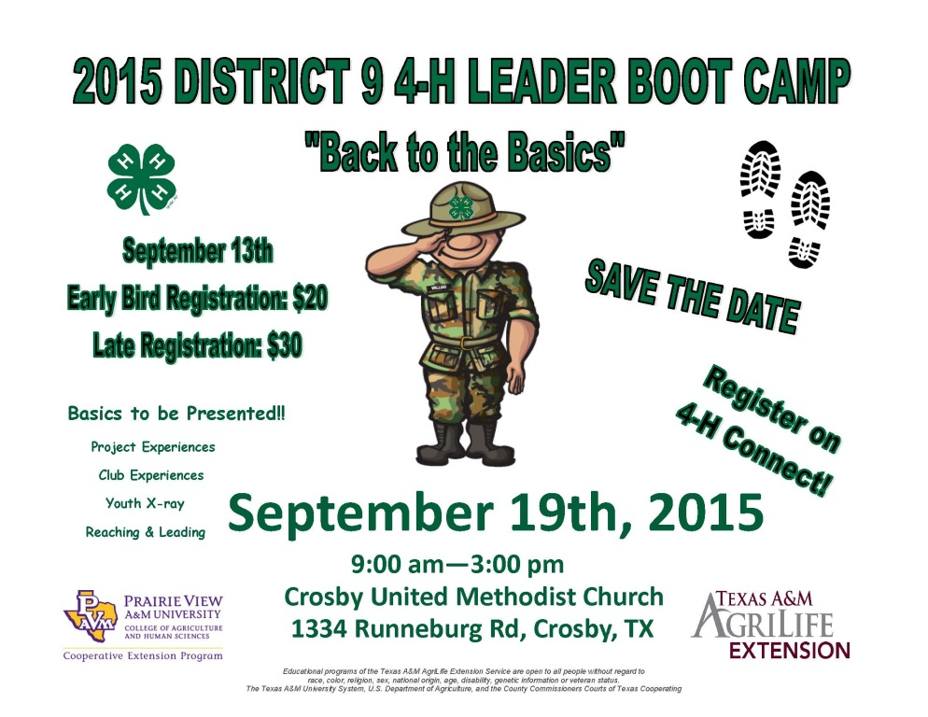 District 9 4-H Adult Leader Boot Camp is September 19, 2015!  This event was formerly known as Leader College but this year’s theme is “Back to the Basics” and Boot Camp is a more appropriate title. The event will take place at the United Methodist Church in Crosby Tx.  1334 Runneburg Road.

We will kick things off at 9:00 am and be done by 3:00 in the afternoon.  In the past there has been a youth component at this event.  There will not be a youth program this year.  All training will be geared toward adults.  We will not prohibit youth from coming or registering, but the presentations will be targeted toward the newer adult volunteer.

Here is a hit list of the topics participants can expect:

* Project Experience
  + Livestock Projects
  + FCS Projects
  + Science Engineering and Technology
  + Natural Resources:  Shooting Sports and Sport Fishing
  + Expressive Arts:  Public Speaking and Share the Fun
* Club Experience
  + Club Officer Team
  + Club Manager Roles and Responsibilities
  + Engaging 4-H Parents
  + Planning and Visioning for 4-H Clubs
  + Fun 4-H Meetings
* Youth X-Ray
  + Ages and Stages of Youth
  + Engagement of Youth and Exploration of Youth Trends
  + Youth Protection
  + Recognition Models and 4-H Awards
* Reaching and Leading
  + Community Service and Service Learning
  + Leadership as a Subject

Early bird registration is due September 13, 2015 at $20.  Late and on-site registration is $30.  All pre-registration will occur via 4-H Connect.





The **Southeast Region 4-H Shooting Sports Coach Training** will be held on **October 10-11** in Victoria.  Registration is currently open on **4-H Connect** and will close on September 18th with a late registration from September 19th-24th.  This training is **open to all** eligible individuals across the state.

Additional information on training dates and sites within the upcoming 4-H year will be posted by September 1st on the 4-H Shooting Sports webpage (<http://texas4-h.tamu.edu/shootingsports/>); under the title ‘Coach Training/Certification’, choose ‘Training Schedule’.

Where is Brazoria County 4-H going? Be part of the solution. Every 4th Monday at 7:00 pm, the Adult Leaders of Brazoria County 4-H meets to discuss where we’re headed. Be part of this exciting team where the parents and leaders come together from all the various clubs in the county to discuss how best to help out our 4-H’ers in our program. All are welcome to come to help lead us into the future. Next meeting September 28th at 7pm.

County Council and Ambassadors will meet on Monday, September 28 at 7pm at the 4-H office. All 4-H members are welcome. This month’s theme is Back to 4-H: **Green Out!** So dress up in **green** and show us your 4-H pride and have a chance to win prizes. Each club should send at least 3 representatives to each council meeting. Those that attend will leave with tools to provide programs and leadership at their club meetings. Plus have FUN with fellow county members. A light supper is included.

**You heard right! Alvin’s 4-H club has expanded! 🎯🎯 ALVIN’ 4-H ARCHERY – Every Sunday (**except holiday weekends**) from 6:00 pm – 7:00 pm.**No archery experience needed to join.  Learn with a certified archery instructor how to shoot a bow in a safe environment.  Bows and arrows are available to utilize for 4-H members.  Contact Jeff Weber Archery Coach at 281-658-6882 if you have any questions. 🎯🎯





**2014-2015 Texas 4-H and FFA Heifer Validation Program**

If you purchased a new heifer and she has not been validated under your ownership, you will need to validate her for the Major shows.  Heifers only need to be validated once in their lifetime as long as they do not change ownership. We will be validating **any** breeding heifers that will be entered or substituted for the Texas Major Shows (Fort Worth, San Antonio, Austin, San Angelo, and Houston). We will be collecting the following:

Hair DNA sample from heifer.

Signed ethics policy forms.

Signed and completed Validation forms.

Scan of the ORIGINAL heifer registration paper.

We have set two dates to validate heifers, October 15, 2015 and October 31, 2015 at the Brazoria County Fairgrounds. The October 15, 2015 date is during the Brazoria County Fair and will be **ONLY** for cattle that are already on the grounds. Any cattle that are purchased or did not go to the Brazoria County fair will need to come to the November 1st date. **Cost is $12 per heifer** validated and we will collect that at the validation site. You may bring your heifer papers to the 4-H office to be uploaded prior to the validation date but we will have a scanner onsite at both validations.