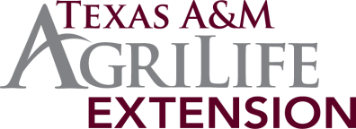
Brazoria County 4-H
October 2015 Newsletter

Brazoria County 4-H 2015-2016 Calendar

Let’s give a warm welcome to our new 4-H and Youth Development Agent Kelsey Schueler! Miss Schueler earned a Master of Science Degree in Agriculture Education and Leadership from the Illinois State University and a Bachelor of Science Degree in Animal Science with a minor in Ag Extension and Education from New Mexico State University. While at Illinois State and New Mexico State, she was a pitcher on NMSU’s Women’s Softball team, involved in Collegiate Farm Bureau, Collegiate 4-H, and Horseman’s Association.
Miss Schueler grew up in California and was very active in the Fresno County 4-H Program for 11 years, FFA for 2 years, and girls’ softball. She served in leadership roles with these youth organizations and competed with horse, lamb, poultry, rabbit, dog, leadership and public speaking projects. She served in several leadership positions and earned the 4-H All Star Award in Fresno County. We’re proud she is part of our team! Should you need to get in touch with her please feel free to contact her by email at Kelsey.Schueler@ag.tamu.edu or by phone at 979-864-1558 x 117.

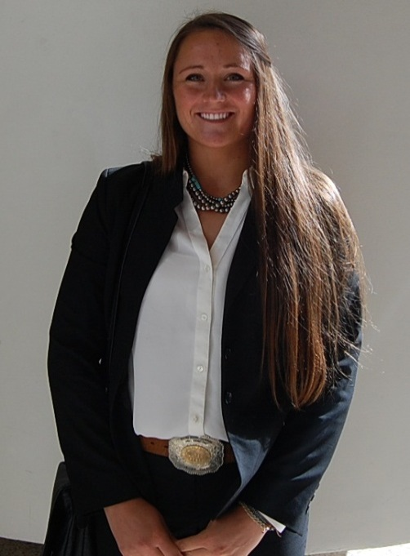

2014-15 Enrollment
In order to show at the county fair your status must be “Active”. If your status is “Pending” that means your club manager needs to approve you. If your status shows “Inactive” that means you haven’t started yet. If your status is “Incomplete” that means you did not complete the process; be sure you get through submit step on the payment page. If your status is “Must Resubmit” there is a problem with your enrollment – first make sure the member’s school information appears on first page, then check your payment page, if all these look good then call Jami. It is possible to go from Pending to Must Resubmit so check back until you see Active. If you need assistance completing the online process, please call Jami at (979) 864-1558 x114.

Major Show Broiler Order Deadline Extended

Due October 1, 2015 – It’s time to order Broilers for the Houston Livestock Show and Rodeo, San Antonio Stock Show and Rodeo and the Star of Texas Fair and Rodeo. The standard order is increments of 25 broiler chicks up to a maximum of 75 broiler chicks per exhibitor. The cost per box of 25 is $31.25. Please bring payment to the 4-H office with entries by the deadline.

Pecan sales are under way!

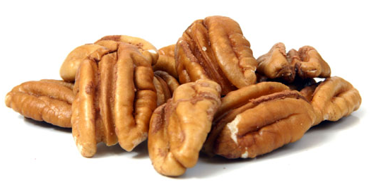
Pecan Sales Fundraiser Get with your Club manager or Sales Committee Chair to get all the latest information. First Sale Due to the 4-H office October 7th. Remember that the second sale gets them in before Christmas, due November 12th to the 4-H office. We have a wide verity this year. Check out the sales brochure.

Quality Counts verification will still be required for all youth exhibiting livestock (market and/or breeding) at major livestock shows in Texas (including the Ft. Worth Livestock Show, San Antonio Stock Show & Rodeo, Houston Livestock Show and Rodeo, Star of Texas Fair in Austin, San Angelo Livestock Show, Sandhills Stock Show in Odessa, State Fair of Texas in Dallas, and Heart O’ Texas Fair in Waco). The verification process will require junior exhibitors to pass an online test that measures their knowledge on quality assurance and character education content items. You only need re test if your child has moved into the senior age category (14). If you have never tested before, go to the link below to become verified. You may take the exam as many times as necessary to obtain an 80% grade. To learn more about Quality Counts including the verification process, please visit: http://qualitycounts.tamu.edu/
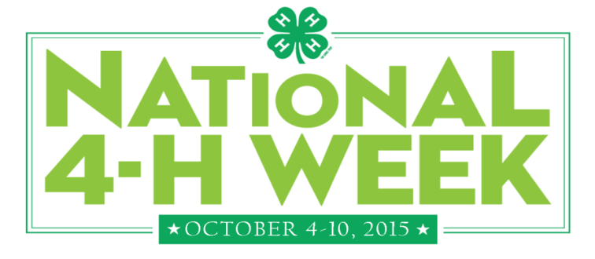

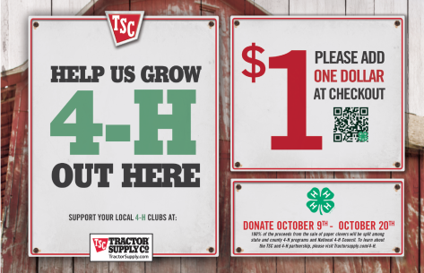
TSC Paper Clover Campaign begins October 7 and runs through October 18th. If your club would like to host a promotional table at either store in Brazoria County, please contact the store manager to set a date and time, and then let the 4-H office know so we can provide you with some 4-H promotional items. In this campaign, customers are offered to purchase a clover for $1 to support the Texas 4-H program. Sixty cents of each dollar will be returned to the county program and the rest goes to the state program.

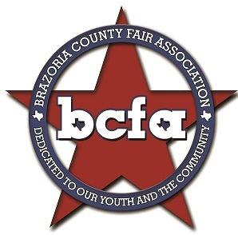
BCFA Junior Creative & Culinary Arts
Contest items check in is Saturday October 3rd from 12noon-3pm. JUDGES NEEDED! If you or a friend would like to help judge- please call the 4-H office (979) 864-1558 x125 or email Cameron Cameron.Arias@ag.tamu.edu . The Baked Confections division will be judged Saturday at 4 pm. All other divisions will be judged Monday at 10am.

BCFA Tour Guide Barn
If you need something to do at the fair between shows, head on over to the tour guide barn and lend a hand. Mrs. Amie Osburn will put you to work helping with the visitors at the different stations or leading groups on tours.

BCFA Livestock High Point Awards
BCFA will recognize the Top 10 4-H and FFA exhibitors in the Junior Livestock Show. Complete this form and turn in to the Livestock Office by 5:00 pm Friday, October 16. Be sure to attend the Livestock Awards on Saturday, October 17th at 10:00 am in the Show Arena. Awards Program Rules

BCFA Eligibility remember to get your eligibility form signed by your school and bring with you to check in your animals.

Junior Lab Entries due October 11th. District 9 Junior Leadership Lab will be in Ledbetter Texas this year! Join 4-H members from across the district on November 13th–14th Register on 4-H Connect by October 11th Junior Leadership Lab is for intermediate (11-13 yrs) age 4-H members. Senior 4-H members can apply to be teen leaders. This year’s theme is “The Amazing Race”. Participants will learn the basics of golf in a kid friendly format. Go to the District 9 4-H webpage for more information. Or view their BROCHURE.

Brazoria County 4-H @BrazoriaCo_4H brazoriacounty4h

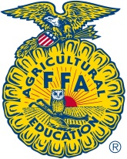

2015-2016 Texas 4-H and FFA Heifer Validation Program

If you purchased a new heifer and she has not been validated under your ownership, you will need to validate her for the Major shows. Heifers only need to be validated once in their lifetime as long as they do not change ownership or breed. We will be validating any breeding heifers that will be entered or substituted for the Texas Major Shows (Fort Worth, San Antonio, Austin, San Angelo, and Houston). We will be collecting the following:
- Hair DNA sample from heifer.
- Signed ethics policy forms.
- Signed and completed Validation forms.
- Scan of the ORIGINAL heifer registration paper.

We have set two dates to validate heifers, October 15, 2015 and October 31, 2015 at the Brazoria County Fairgrounds. The October 15, 2015 date is during the Brazoria County Fair from 3:00-6:00pm and will be ONLY for cattle that are already on the grounds. Any cattle that are purchased or did not go to the Brazoria County Fair will need to come to the October 31st date from 7:00-10:00am. Cost is $11 per heifer validated and we will collect that at the validation site. You may bring your heifer papers to the 4-H office to be uploaded prior to the validation date but we will have a scanner onsite at both validations.

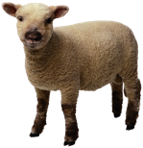
Major Show Sheep & Goat Validation

Will be on Tuesday, October 27, 2015 from 4:00-7:00pm at the Brazoria County Fairgrounds. This will be for the Spring Major Shows such as, Fort Worth, San Antonio, Houston, San Angelo, Austin. You must have already ordered your tags to validate an animal. Ownership deadline for registered breeding sheep and breeding boer goats is October 1st! Registered papers
must be transferred by October 1st.

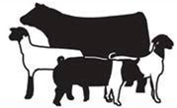
Livestock & Horse Judging

The Horse Judging Team will have their first meeting October 22nd at 6:00pm at the Brazoria County Extension Office.

If you would like to be a part of the Brazoria County 4-H Livestock or Horse Judging Teams that will train for the District and State contests, follow this link http://agrilife.org/brazoria4h/projects/livestock/4-h-judging-teams/ and fill out the form. Once you fill out the form you will be added to the Remind and email list so you can stay up to date on all contest and practice information! Be part of this growing and successful Brazoria County 4-H program.
Aggiefest
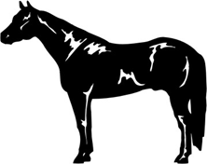
A Livestock Judging Contest will be held October 24, 2015. Visit their website for more information regarding this contest. A Horse Judging Workshop will be held the same day in College Station on October 24, 2015. More information is available at following website. The 4-H van will be going if there are enough members interested in attending!

Brazoria County 4-H County Council and Ambassadors

Meeting will be held on October 26th at 7:00 pm. October’s theme is Oktoberfest – so come dressed in your favorite costume to get your name in the drawing for a door prize. All clubs should send at least 3 representatives. The knowledge you gain at this meeting will not only help you more effectively serve your club, but also develop your communication and leadership skills. Refreshments and drinks will be provided.

District 9 4-H Council
The District 9 Council meeting will be at the Montgomery County Fairgrounds (9201 Airport Rd Conroe, TX 77303) on October 24, 2015 starting at 6pm ending at 9pm. The district meeting will be at 6pm and the dance will follow. There is a $10 entry fee.

Parent and Adult Leader Association
Where is Brazoria County 4-H going? Be part of the solution. Every 4th Monday at 7:00 pm, the Adult Leaders of Brazoria County 4-H meets to discuss where we’re headed. Be part of this exciting team where the parents and leaders come together from all the various clubs in the county to discuss how best to help out our 4-H’ers in our program. All are welcome to come to help lead us into the future. Next meeting: September 26th at 7:00 pm.

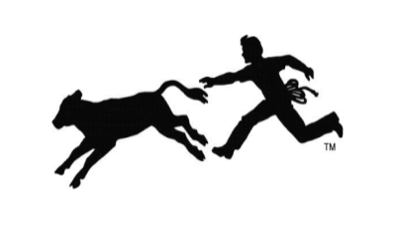
Calf Scramble
Calf Scramble forms for the Fort Worth Stock Show and Rodeo and the Houston Livestock Show and Rodeo will be available online this month.
Fort Worth Stock Show & Rodeo forms can be found at fwssr.com. Brazoria County 4-H is limited to six entries. Fort Worth accepts entries on a first come first serve basis so in order to insure spots for our members’ entries will be due to the 4-H office by November 6th or when the first six are received. Review the rules before making the decision to enter. When signing read General rule #2 carefully – both parents must sign form.
Houston Livestock Show & Rodeo Calf Scramble forms will be available soon. If Brazoria County 4-H has limited entries, then once the number of qualified and complete entries are received in the county office they will be sent on to Houston. Entries will be taken at the Major Show entry nights in November.

Major Show Entry Night

Major Show Entry night will be for the spring Major Shows: Fort Worth, San Antonio, Houston, San Angelo, and Austin. This year major show entry night will be set up differently than in the past. This year you will sit down with an Extension Agent who will directly enter you into the online system that night! This process will take a little longer than previous years, so please plan accordingly. We will have two entry nights. If you plan on showing at Fort Worth you need to come to the first night! You will not be able to enter FWSSR on the second date.
Wednesday, November 4th from 3:00-8:00pm
Tuesday, November 17th from 3:00-8:00pm
The entry applications are posted to our website for you to fill out and bring with you! (Houston’s information is to be updated on October 15, 2016. So keep on the lookout for that updated information. All other Major Shows have current and correct applications at that page.) Please remember, tag orders, validation, turkey, and broiler order does not enter you in the shows. You must still go through that process. If you have any questions, call the 4-H office at (979) 864-1554 ext. 114 or visit our Major Show webpage for the most up-to-date information.

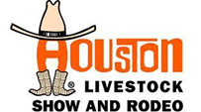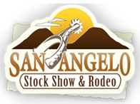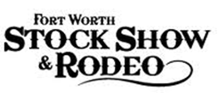

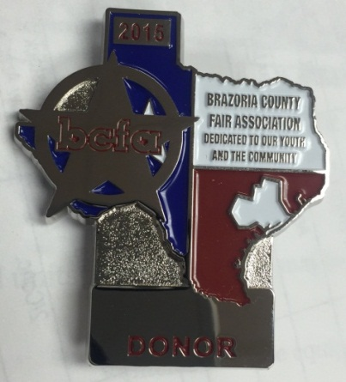
Hug a BCFA Donor? YES! At least do it if they’ll let you. When you see someone wearing this badge, please go up and tell them Thank you! BCFA is giving pins out this year to all the Donors and we want to show them how much we appreciate their dedication in making our year at the Brazoria County Fair so very successful.

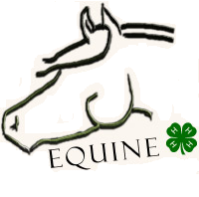
****Upcoming Horse Show Changes****
Last year, we started registering online for the Brazoria County 4-H Horse Shows. It was so successful that this year we’re going to expand and use an online validating system for the horses and electronic acknowledgement for the forms you’ve typically had to get notarized and sign. Once this process is complete you will get emailed the forms for Sponsorship and Eligibility that will still need to be turned in as a hard copy. It’s a work in progress so be looking for more details in next month’s newsletter!

The BCFA Youth Horse Show is this Sunday, October 4th at 8:00 am. Books open at 7:00 am, then the show kicks off with Halter/Performance events. Speed classes will start after Performance events but not before noon. For more information, go to: BCFA Youth Horse Show for registration entry forms and rules.

Brazoria County Fair October 9th through October 17th.
Good Luck to all of our 4-H members.
We’re so proud of you!

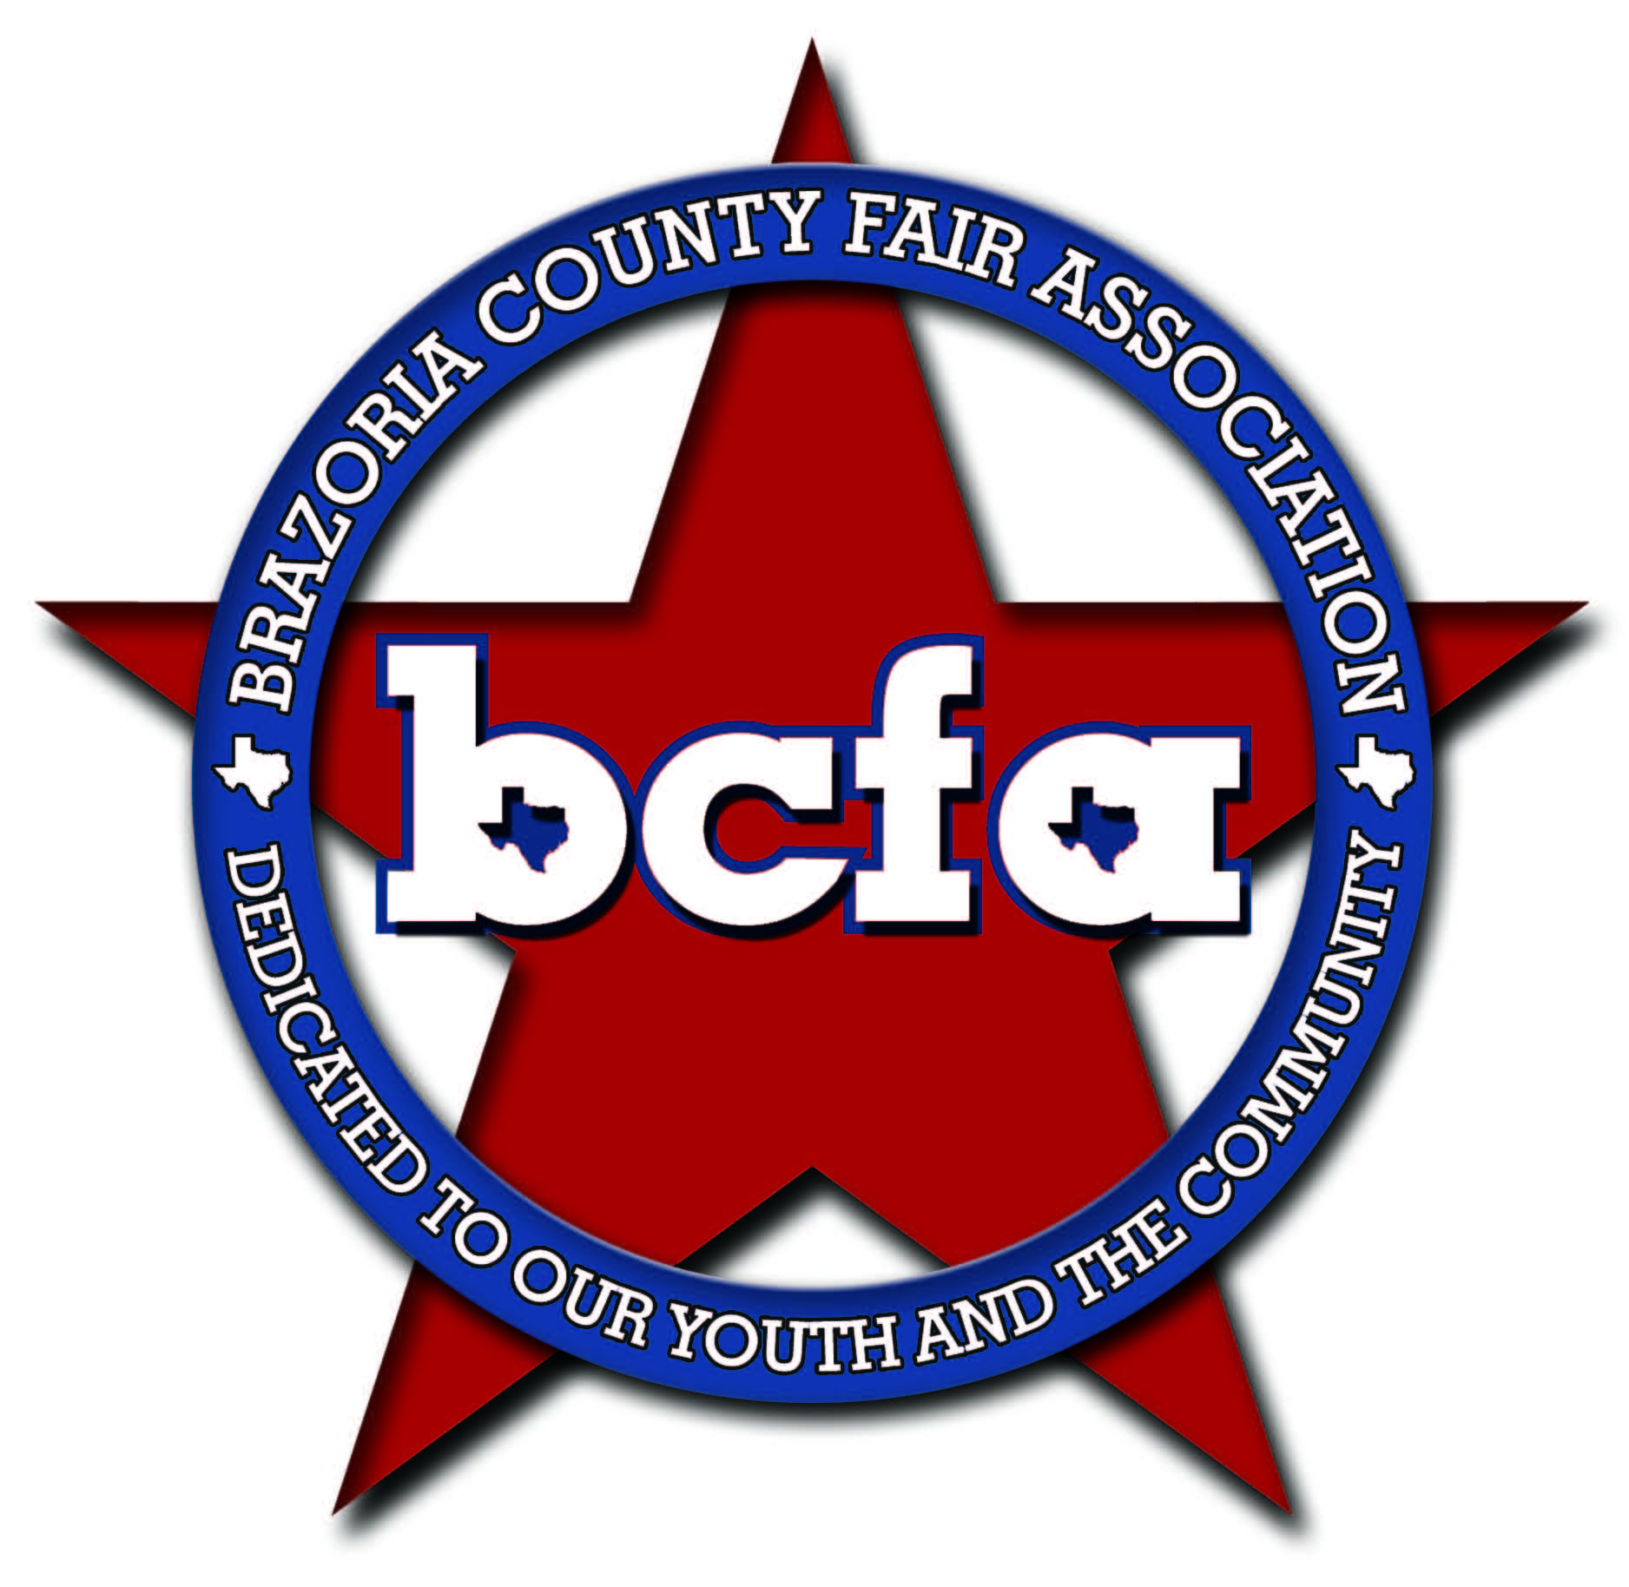
Brazoria County Fair Association, Inc.

“Country Nights & Carnival Lights”
October 9th -17th, 2015

P. O. Box 818 ▪ Angleton, Texas 77516-0818
Office 979-849-6416 ▪ Fax 979-849-6985
www.bcfa.org

September 25, 2015
Dear Exhibitors and Parents,

The Junior Livestock and Commercial Heifer Auctions have been growing by leaps and bounds – more buyers and more money! This is great news; however, the larger crowds are creating a few problems that need to be addressed in order to keep our buyers coming back year after year. The auctions have become so popular that it is literally standing room only. The buyers are winning the bid, moving to the photo area, signing the disposition paper and returning to their seats all while maneuvering through an extremely dense crowd. Change is difficult, but in this situation it is definitely needed. The General Sales committee has developed some new policies to make the bidding, buyer-exhibitor photo, and paying processes easier on our buyers.

- New buyers will be asked to complete a pre-qualification packet and make a down payment of $25. This amount will be credited toward the purchase. Pre-qualification forms are available at www.brazoriacountyfair.com
Important NEW information!
- All buyers that have purchased in the student art, junior livestock, commercial heifer, or ag mechanics auctions in the past two years will not need to pre-qualify.
- Buyers will be given wristbands to designate their status. The wristband entitles buyers to the meal, bidding area, and auction refreshments.
- The pre-auction meals and auction refreshments are for the buyers only, therefore, only buyers should be in the auditorium during the meals (Thursday 5pm-6pm / Saturday 12noon-1pm).
- At auction time the auditorium will be divided into a bidder area and a spectator area. The bidding area will be exclusively for buyers. Spectators and family members will be able to watch their exhibitor proceed through the sale through a live feed projection in the dining area.

These new policies are intended to create a more hospitable atmosphere for our buyers; after all, without buyers there would not be an auction. It is our hope that by making special accommodations for our buyers, they will be more comfortable and can move around easily and quickly between their seats, the auction photo area, and the check-out area. Remember happy buyers – spend more money – and that makes a happy exhibitor.

Thank you,
General Sales Committee

