Better Living for Texans
Volume 1, Issue 1
January 2016

Slow Cookers (Crock Pots): The Basics
Inside this issue:
On the Track to Better Health

Slow Cooker Safety Tips
Slow Cookers (Crock Pots): 1
The Basics
Slow Cooker Safety 1
Monthly Recipe 2

Slow Cookers (or Crock Pots) are a great way for the busy family to enjoy a nutritious, economical, home-cooked meal without a lot of hassle.
The great advantage of slow cookers is that they do the cooking while you are away. They allow a busy family to go about their daily affairs and still come home to a delicious, hot meal. Still, some are wary of slow cookers because of concern that they are not safe. However, according to the United States Department of Agriculture (USDA), slow cookers are not only safe, but they also use less electricity than ovens.
How They Work:
Slow cookers cook foods slowly at temperatures that generally range from 170 to 280 degrees F, over several hours. The low heat helps less expensive cuts of meat to become tender and shrink less.
Food Safety:
Slow cookers destroy bacteria through direct heat from the pot, the lengthy cooking time, and the steam created within the tightly-covered container. While foods are cooking and even after they’re done, food will stay safe in a slow cooker as long as the cooker is operating.
How Much Food?
Slow cookers come in many sizes, so you should always consult the instruction booklet for suggested sizes of meat and poultry to cook.
How Much Liquid?
Water or liquid is necessary to create steam. Water or liquid levels in slow cookers should cover the ingredients to ensure effective heat transfer throughout the crock pot.
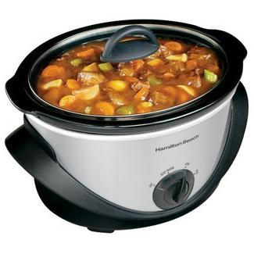
Start with clean hands and a clean cooker and utensils.
Red kidney beans should be soaked in plenty of water and then the liquid should be drained and replaced with fresh water. The beans should be boiled for 10 minutes before going into the slow cooker. Why? Dried beans have a toxin in them called phytohaemagglutinin (phyto-heme-a-glu-tin-in). Eating raw or undercooked red kidney beans can lead to a severe debilitating illness (Red Kidney Bean Poisoning).
Thaw meat or poultry before putting it in a slow cooker. Without proper thawing, frozen foods will not reach 140 degrees quickly enough and could result in a foodborne illness.
Cook and drain ground meats before adding to the slow cooker.
Don’t peek inside.
Vegetables cook slower than meats, so place them near the bottom and sides of the slow cooker.
Makes: 6 servings
Total Cost: $8.26
Serving Cost: $1.38

Ingredients:

2 pounds stew meat (cut into 1 inch cubes)
¼ cup flour (all purpose) salt and pepper (optional, to taste)
2 cups water
2 teaspoons beef bouillon (2 cubes)
1 garlic clove (finely chopped)
3 carrots (sliced)
3 potatoes (diced)
2 onions (chopped)
1 celery stalk (sliced)
Add herbs as desired: by leaf, basil, oregano, etc.

Directions
1. Place meat in slow cooker.
2. Mix flour, salt, and pepper in a medium bowl, and pour over meat; stir to coat.
3. Add remaining ingredients and stir to mix.
4. Cover and cook on LOW for 8 to 10 hours or HIGH for 4 to 6 hours.
5. Stir stew thoroughly before serving. If using bay leaf, discard before serving.
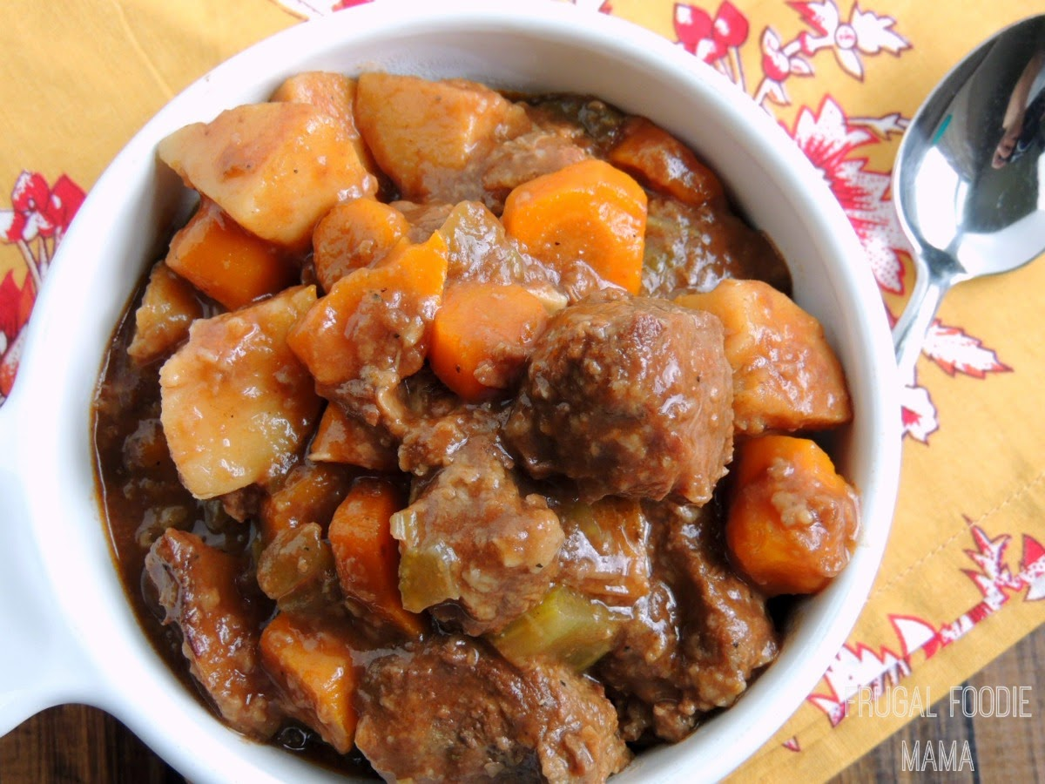

Monthly Recipe: Slow Cooker Beef Stew

For more information on SNAP-Ed, contact your local county extension office. BLT is located in over 200 counties across the state.
On the Track to Better Health
Page 2

