Thanksgiving Turkey Do’s and Don’ts

Can you believe it’s almost Thanksgiving? If you’re like most of us, you’re starting to think about family get-togethers and menu items for the Thanksgiving meal. You might also be thinking of different ways to make your turkey.

It’s easy to find new or alternative ways to cook turkey other than the traditional baked variety, but it’s important to know which methods are safe and which are not.

Let’s look at a few safe and unsafe methods.

Safe, alternative methods include:

- The Oven cooking bag method involves preheating your oven to 350 degrees Fahrenheit and should produce a moist-heat cooking environment for the turkey (use fresh or thawed turkey for this method).
- The Fried method is usually done with smaller turkeys (8-10 pounds) and peanut oil.
- The Grilled method is also used with smaller, unstuffed turkeys, weighing 8 to 14 pounds. The oven should be set between 325 to 350 degrees Fahrenheit to grill a turkey.

Whichever method used, remember that the minimum internal temperature for a whole, cooked turkey is 165 degrees Fahrenheit. It is also important that you carefully read the instructions for the cooking method and that you wash your hands, utensils, and counters that may have been contacted by raw turkey. You do not need to wash the turkey.

Unsafe, alternative methods include:

- The Brown Paper Bag Method involves placing the turkey in a large brown paper bag and cooking. Chemicals in the bag may seep into the food, making it unsafe.
- The Slow-cooking overnight method puts you and your dinner guests at risk of food poisoning due to the low cooking temperature used.
- The Trash Bag method involves placing the turkey in a trash bag and marinating it for several hours at room temperature, which could result in bacteria buildup.

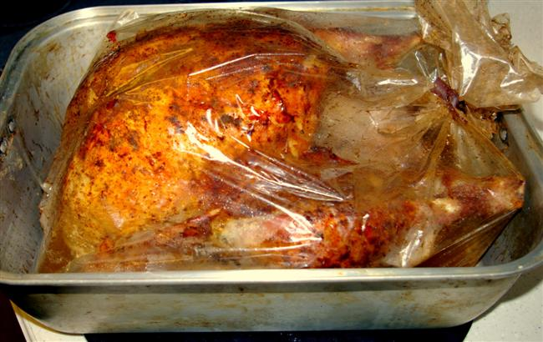
Local Events

Recipes of the Month
(Source: adapted from the USDA Mixing Bowl)

Grandma’s Stuffing
Makes: 8 servings

Ingredients:
10 cups whole wheat bread cubes
1/3 cup water
1/2 cups of onion and celery (chopped)
1 teaspoon parsley, dried or freshly chopped
1/4 teaspoons of salt and black pepper
1 1/2 cups milk
1 egg (lightly beaten)
2 chopped apples (optional) or 1/4 cup raisins

Directions:
1. Preheat oven to 350 degrees.
2. Put cubes in a large bowl and set aside.
3. Put water in a medium saucepan. Add onion, celery, parsley, salt and pepper. Cook for 5 minutes. Do not drain. Pour over bread cubes.
4. Stir in the milk and egg. Gently stir in apples, and raisins, if desired.
5. Spoon into a greased 2-quart baking dish. Bake at 350 degrees for 1 hour.

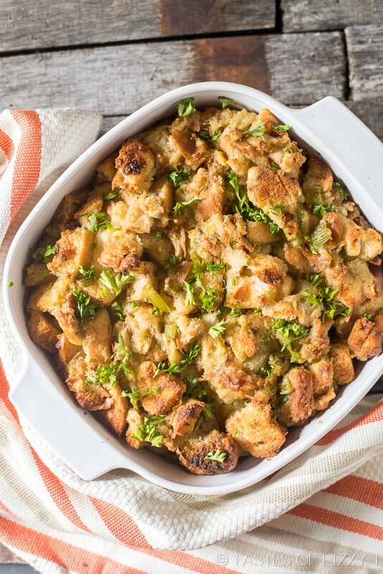

150 Calories, 3g Fat, 7g Protein, 1g Saturated Fat, 25g Carbohydrates, 1g Dietary Fiber, 330 mg Sodium

Homemade Cranberry Sauce
Makes: 8 servings

Ingredients:
3 cups of fresh cranberries (can also use frozen cranberries –12 ounces)
1 orange (peeled and sectioned)
1 cup sugar

Directions:

- Place all the ingredients in a blender and blend until mixed well.
- Heat up and serve over turkey.

Notes:
1 cup of white grape juice concentrate can be substituted for 1 cup of sugar.

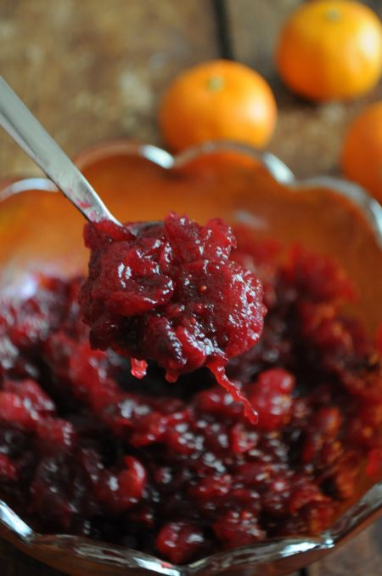

122 Calories, 0g Fat, 0g Total Fat, 31g Total Carbohydrates, 2g Dietary Fiber, 62mg Potassium, 10g Calcium

