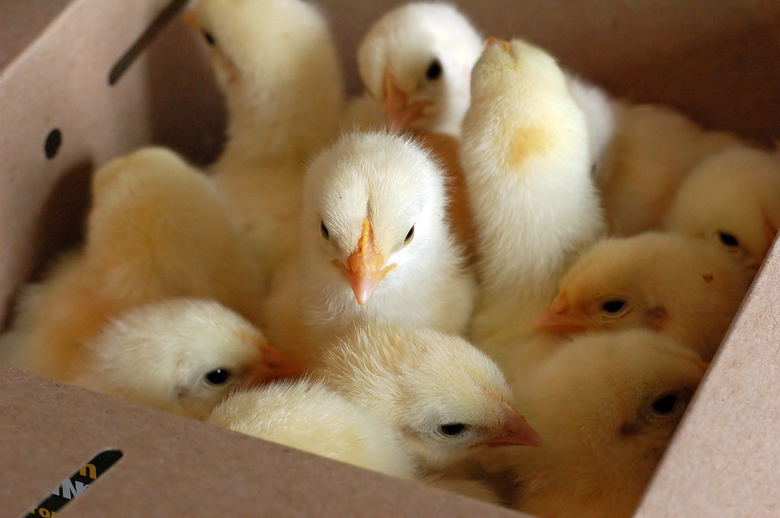
This Photo by Unknown Author is licensed under CC BY-ND
2023 BCYF BROILERS
Exhibitors must order and pay for 25 or 50 birds, with 50 birds being the maximum allowable order per exhibitor/family. Exhibitor may enter 2 pens of broilers

Payment and order due by November 4, 2022

Birds will be at the County Extension Office on January 9, 2023, - 3:30—5:30 p.m.

Please make checks payable to: Bell County Youth Fair, P.O. Box 1058, Belton, 76513
Questions: call 254-933-5309 or email cheri.obraden@ag.tamu.edu

Cost of Broilers is $46.00 per order of 25 birds.
If ordering as a family, all exhibitors names must be listed below, or they will not be able to show the birds.
------------------------------------------------------------------------------------------------------------------------------------------------------------
NAME CLUB PHONE # QTY

_______________________________________________________________________________________________

_______________________________________________________________________________________________

_______________________________________________________________________________________________

_______________________________________________________________________________________________

_______________________________________________________________________________________________

_______________________________________________________________________________________________
EMAIL ADDRESS:
_______________________________________________________________________________________________

Total Amount $ ___________________

Method of Payment ______ Check ________ Cash

