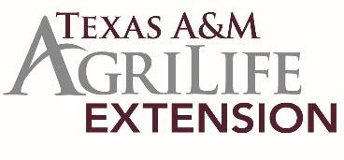

D8 4-H CONSUMER DECISION MAKING

Tentative Contest Schedule
Monday, April 17, 2023
8:00 - 8:30 am Agents Arrival & Committee Set-up 8:30 - 8:45 am Registration – Lobby
Participants and parents wait in Auditorium
8:30 – 8:45 am Group Leader Orientation - Chisholm Trail Board Rm 8:45 - 9:00 am Participant Orientation - Auditorium
Group Leaders take participants to contest rooms

9:00 - 10:40 am Judging of Classes
- Jr & Int - Cross Timbers
- Sr - Cross Timbers Branch

10:00 am Oral Reasons
- Int - Yellowjacket (those doing FS or D2D need to go first)
- Sr - Gen Pat Cleburne & Camp Henderson (those doing FS or D2D need to go first)

About 12:45 pm Awards Presentation - Cross Timbers
Post classes

Lunch will not be provided. You are welcome to bring your own food or visit one of the nearby restaurants, if you plan to stay for the Fashion contests.

