2022-2023
BELL COUNTY 4-H AMBASSADOR APPLICATION
NOTE: All 4-H Ambassador Applicants must complete this form and submit it to the County Extension Office by 5:00 p.m. on Friday, June 3, 2022.

Bell County 4-H Ambassador Application Requirements (NEW AND RENEWAL)
- Application completed and signed.

- Renewing Ambassadors, attach your 2021-2022 Hours Sheet

- Recommendation Letter from a 4-H leader or club manager (not County Extension Agent)

- Sign Code of Conduct and Consequences of Misbehavior

- 1 Essay completed (minimum 100 words)

  - Renewing Ambassador: If selected again as a 4-H Ambassador, what parts of the 4-H program do you think should be promoted?

  - New Ambassador: Please state why you want to serve as a 4-H Ambassador.

NAME: ____________________________________

4-H CLUB:______________________________________ SCHOOL: _______________________

HOME PHONE NUMBER: ______________________ CELL PHONE NUMBER: ________________

E-MAIL ADDRESS: _______________________________________________________________

DATE OF BIRTH: ___________________

GRADE (9th, 10th, 11th, 12th): ________________

NUMBER OF YEARS IN 4-H: _________

MAIN 4-H PROJECT: ________________________

PARENT/GUARDIAN NAMES: ____________________________________________________

Have you previously served as a 4-H Ambassador? _____YES _____NO

If yes, did you complete all the required activities? ______ YES _____ NO

Did you submit a 4-H recordbook? (DUE June 3, 2022)? ___YES ____ NO
(required for renewal)
List your 4-H projects:

Summarize your 4-H leadership experience:

Summarize your non-4-H activities and leadership experiences:

List the honors you have received as a 4-H member:

Summarize your involvement in church, school, and other community organizations.

Statements/Signatures:
I will, to the best of my ability, participate in all 4-H Ambassador meetings and activities if selected to serve during the upcoming 4-H year. My signature indicates that I have carefully read, understand, and agree to comply with all of the requirements, and that I make a commitment to fulfill the requirements as a Bell County 4-H Ambassador.

4-H MEMBER’S SIGNATURE: ________________________________________________________

DATE: ___________

As the Parent/Guardian of the 4-H member, I have carefully read and understand the requirements. I fully agree to support my child in his/her commitment to serve as a Bell County 4-H Ambassador.

PARENT/GUARDIAN SIGNATURE: ___________________________________________________
DATE: ___________
2022-2023
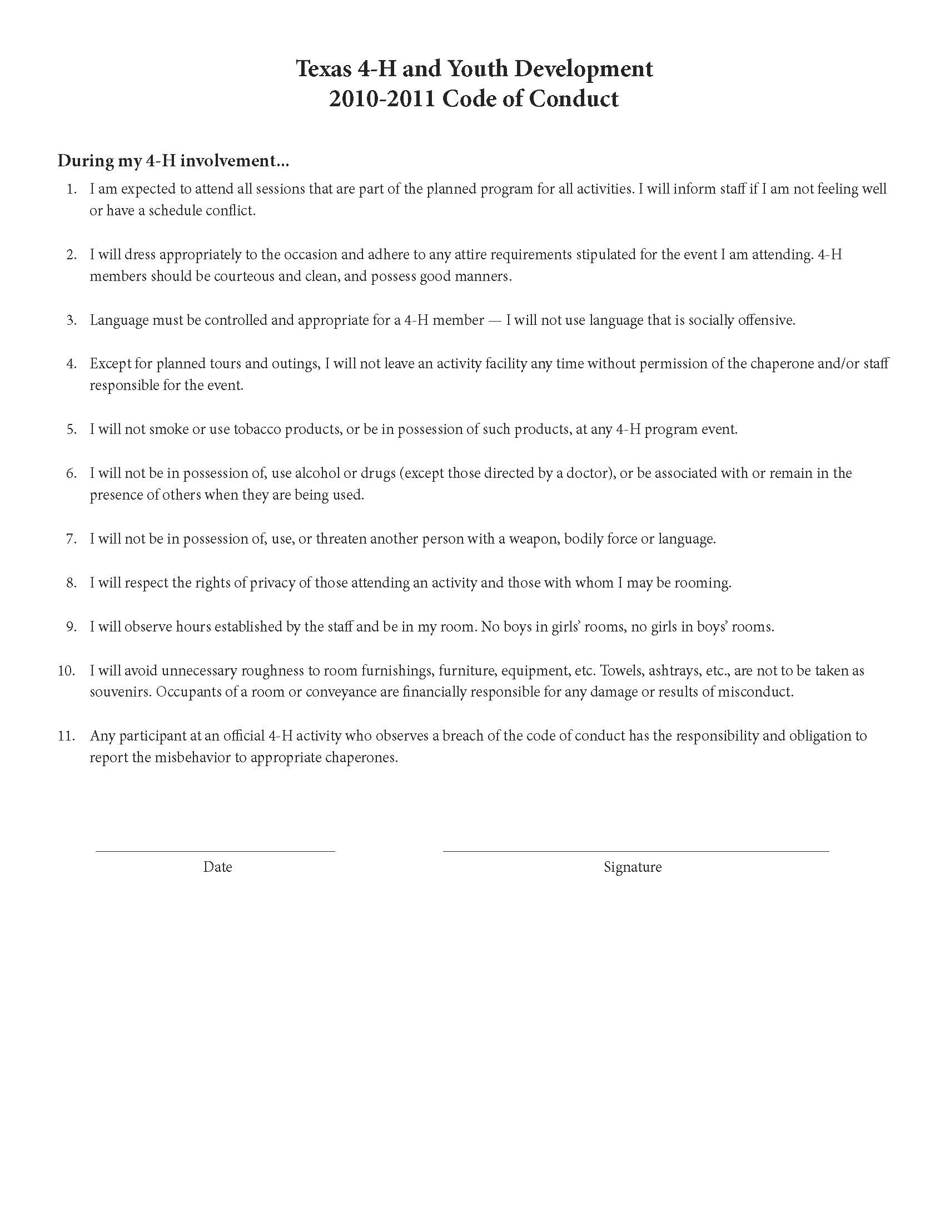
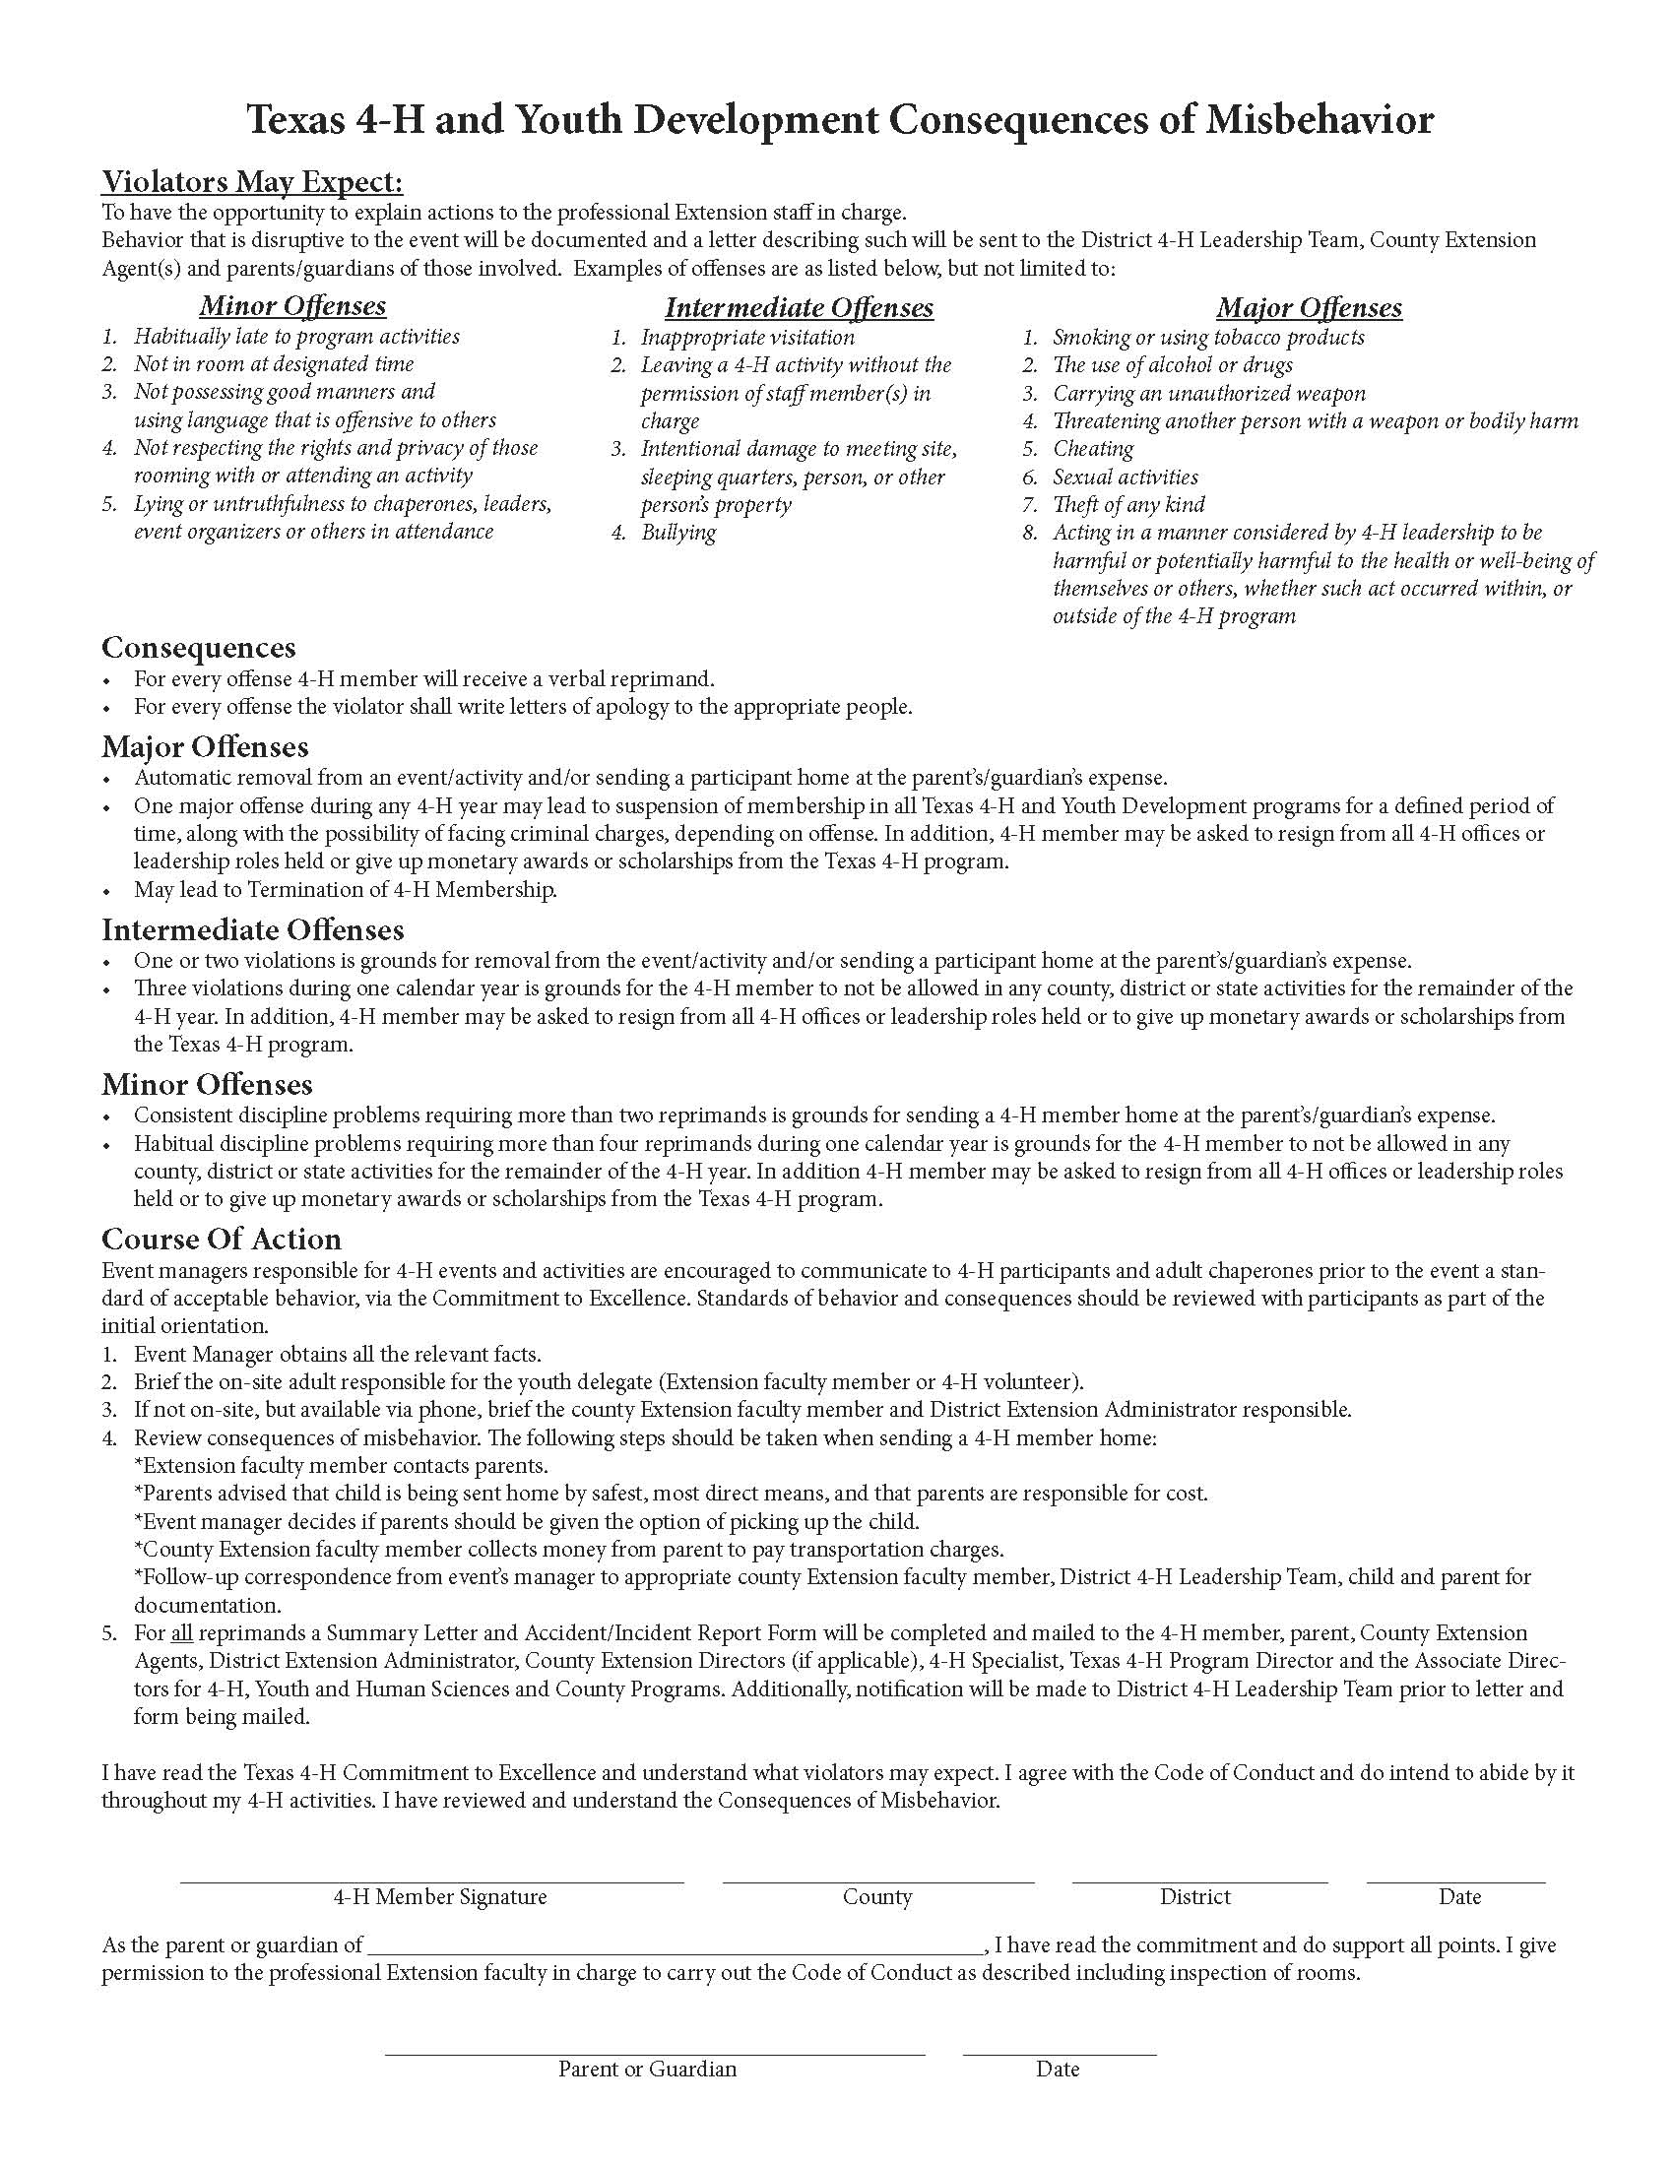
Bell
8

