Using Color Harmonies in Photography

# 5 to 9: Cool and Warm, Split Complementary,
Tetradic and Square Color Harmonies

by
Alain Briot

1 - Cool Colors Dominance harmony
In a Cool Colors Dominance harmony we use colors that have a cool quality. These include blues, violets and greens
This color harmony is useful to express feelings of cold or remoteness. It is also useful to represent scenes where you want the elements to recede away from the viewer and appear distant.

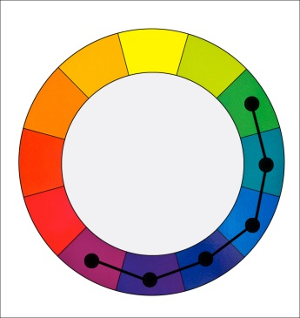

A cool color dominance harmony that uses
purples, blues and blue-greens

2 - Example
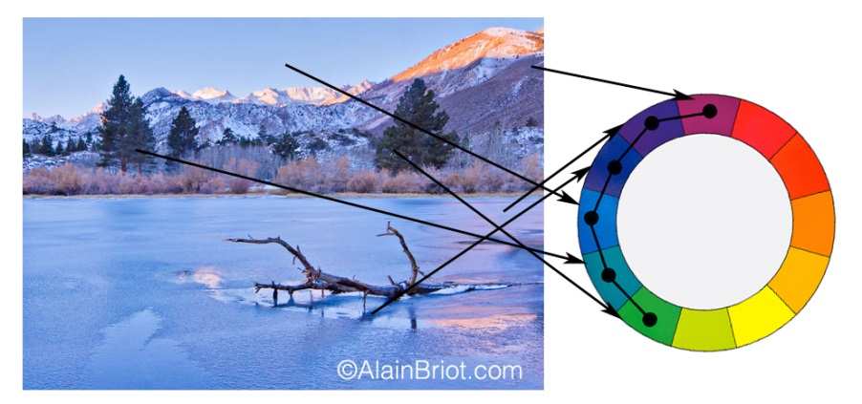

Example 1 – Lake Sabrina Sunrise, Eastern Sierra Nevada

3 - Notes
Creating a Cool Color Dominance Harmony does not mean there are no warm colors in the image. It only means that cool colors dominate.
- This harmony features a wide range of colors.
- It is therefore different from a Monochromatic Harmony
- Half of the colors on the color wheel are used

4 - Warm Colors Dominance harmony
In a Warm Colors Dominance harmony we use colors that have a warm quality. These include reds, oranges and yellows. This color harmony is useful to express feelings of warmth and comfort. It is also useful to represent scenes in which you want the elements to move towards the viewer and appear to be close by.

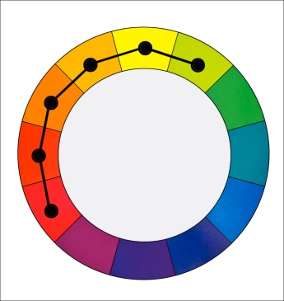

A warm color dominance harmony that uses
Reds, Oranges, Yellows and Yellow-Greens

5 - Example
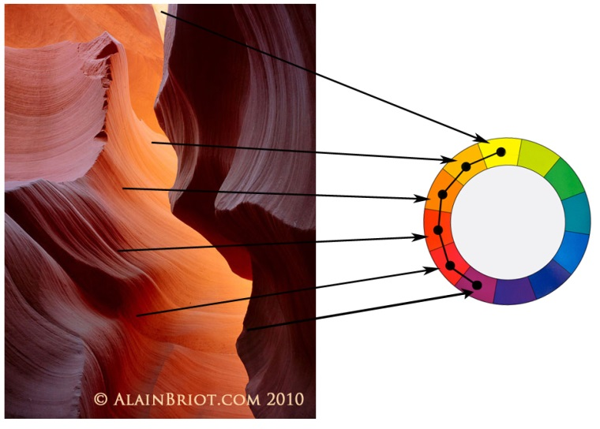

Example 2 – Antelope Canyon

6 - Notes
Creating a Warm Color Dominance Harmony does not mean there are no cool colors in the image. It only means that warm colors dominate.
- This harmony features a wide range of colors.
- It is therefore different from a Monochromatic Harmony
- Half of the colors on the color wheel are used

7 - Exercises
A - Create a photograph featuring a Cool Color Dominance Harmony.
B - Create a photograph featuring a Warm Color Dominance Harmony

8 - Split Complementary color harmony (also called Compound Harmony)
In a Split Complementary color harmony we use two colors plus the color that is oppositeto them on the color wheel. For example blue and purple with yellow.
This harmony has a strong visual contrast, similar to the complimentary color harmony (see my previous essay), but with less tension because three colors are used instead of two.
This is an easy harmony to use and therefore it is appropriate for study and practice.

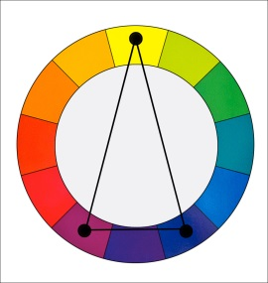

A split complementary color harmony using yellow, purple and blue

9 - Examples

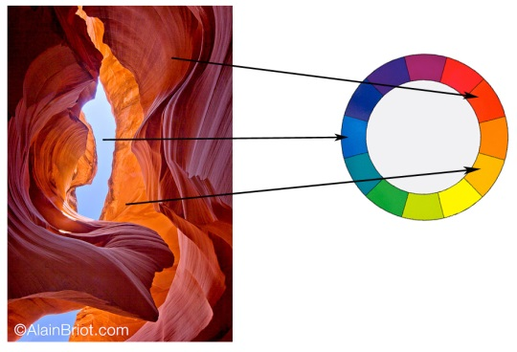

Example 1: Antelope Canyon and Sky
An example of a blue-red Split Complementary Color Harmony.

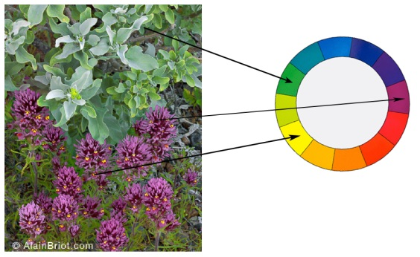
Example 2: Wildflowers close up
A second example of a purple-green Split Complementary Color Harmony

10 - Notes
- Comparable to Tetradic harmony except colors are not evenly spread.
- Actually between Tetradic and Analogous.
- Comparable to analogous harmony except there are 2 opposite colors spaced 1 color apart
- Very visually pleasing and artistic harmony.
- Common in nature
4 - Exercise
Create a photograph that features a split complementary color harmony.

11 – Tetradic color harmony (rectangle)
In a Tetradic color harmony we use a combination of four colors that consist of two sets of complementary colors. For example: purple and blue green plus yellow green and red.
These colors form a rectangle on the color wheel. The colors on the short side of the rectangle are spaced one color apart.
This is a rich color harmony that offers many opportunities for variations. To be most effective it is best to let one of the 4 colors dominate. It is also important to pay attention to the relationship between the warm and the cool colors used in this harmony.

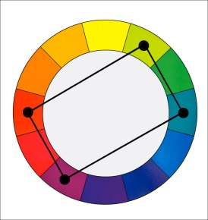
A tetradic color harmony that uses red, purple, yellow-green and blue-green

12 - Example

Example 3: Route 66 Dinosaurs
An example of a Tetradic Color Harmony

13 - Notes
- Very colorful harmony
- Tends to be ‘in your face’
- Works well with ‘flashy’ subjects
- Easily gets ‘crude’ if overused
- Works when you want to call attention in a dramatic manner
- Similar to square harmony except that colors are one apart on the short side

14 - Exercise
Create a photograph that features a Tetradic Color Harmony.

15 - Square color harmony
In a Square color harmony we use a combination of four colors equally spaced around the color wheel. For example: orange, yellow-green, blue and violet.
These colors form a square on the color wheel, with each color being spaced two colors apart from the the other colors.
This harmony is comparable to the Tetradic harmony but with the four colors spaced evenly around the color wheel. This harmony works best if one color dominates. Just like the Tetradic harmony, you need to keep track of the relationship between the cool and the warm colors.

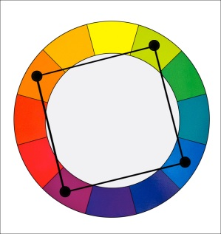
A square color harmony that uses orange, purple, yellow-green and blue

16- Example

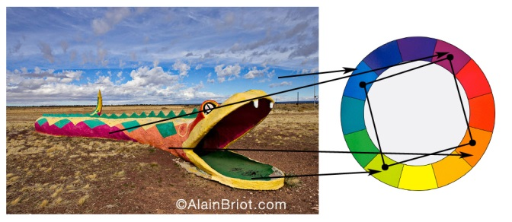
Example 4: Snake
An example of a Square Color Harmony

17 - Notes
- Very colorful harmony
- Tends to be ‘in your face’
- Works well with ‘flashy’ subjects
- Can easily give a ‘crude’ effect if overused
- Secret is to use small amounts of three colors and a larger amount of 1 color.
• For example here lots of blue is used and only small amount of green, violet and red are used.
• This prevents the effect from being overly flashy.
- Works when you want to call attention in a dramatic manner
- Similar to Tetradic harmony except that colors are two apart on the short side

18 - Exercise
Create a photograph that features a Square Color Harmony.
Alain Briot
Vistancia, Arizona
December 2012

