How Using Color Relationships Can Impact Your Photography
By littlemisspatricia on 10 Mar 2013 in Guides Patricia is a photographer from Brisbane, Australia.

Color has such a huge impact on anything and everything. It’s everywhere, so we sometimes take it for granted. Some colors are unpleasant to look at, causing us shield our eyes and turn away, but others are aesthetically pleasing. They just work. They evoke positive emotions. They make us buy products we don’t even really want or need. They make us like photos we don’t find that interesting, but just because the colors are nice, we do it anyway. Color controls so many things and yet not many of us know how to really use it.
Here are a few simple color tricks that you can incorporate into your photography:

Advancing and Receding Colors
In general, warm, saturated colors visually advance while cool, dark value hues recede. Some colors remain visually neutral. So if you were to fill a room with red furniture, it will feel more intimate and enclosed. Cool-toned furniture would make it feel more open and spread out.
In photography, positioning a warm-colored subject at the foreground against a cool-colored background can emphasize a shallow depth of field or make it pop out more. This technique can really make your warm, saturated subject stand out.
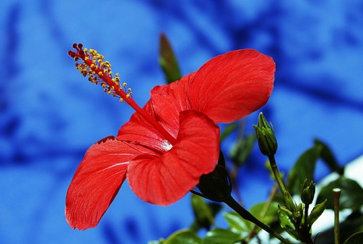
Red Green Blue by @Doug88888, on Flickr
Red on blue will appear more as a red ball in front of a blue wall, rather than a red hole in a blue wall. Blue on warm can appear as if it is receding into the background, like a red wall with a blue hole.

Monochromatic Color Harmony
Colors can be very distracting, so by eliminating contrasts and keeping within the same color family, you can place more focus on your subject. It also helps to set the overall mood of the photo.
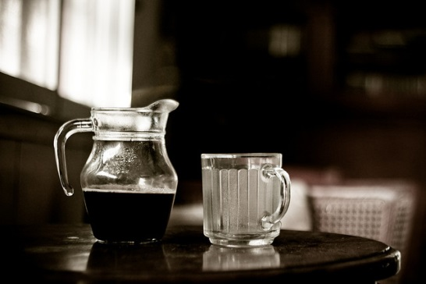
Photo by Patricia Ramos

Split-Complimentary Color Harmony
This results from one color paired with two other colors on either side of the original color’s direct complement. For example, yellow with violet and blue.
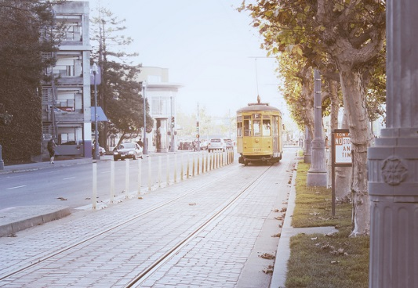
Photo by Patricia Ramos

Analogous Color Harmony
This is based on three or more colors sitting side-by-side on the color wheel. For example, yellow, yellow-green and green.
Photo by Patricia Ramos

Complementary Colors
Choosing colors that sit directly opposite each other on the color wheel is one way of showing contrast and emphasis in your photos. Complementary colors together can increase their intensity, creating simultaneous contrast. For example, blue and orange.
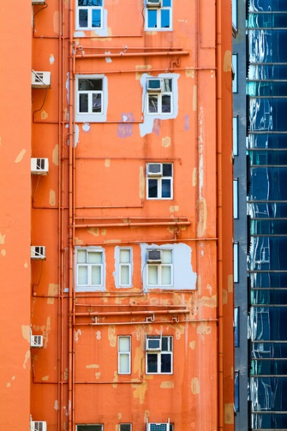
“對比 Contrast” / 城市建築之形 Urban Architecture Forms / SML.20130211.7D.22547.P1 by See-ming Lee 李思明 SML, on Flickr
Unlike painters, many photographers have little to no training in color theory and color relationships. These are complex topics that involve both psychological and physiological factors that can be hard to understand. Sometimes even if a photo has a lot of technical errors, it just works. It feels right. Your gut can tell you a lot about color too. If you’re not formally trained in color theory, there’s always that.

Go with Your Gut
Even if you weren’t born with an artistic eye, you must have your own color preferences: do you prefer cool colors or warmer tones? Are you drawn to a particular shade of blue? Do you react negatively to neon colors? Your photos are a reflection of you; if you like a certain color family, it’s bound to come across in your work because you can. Take note that your favorite color in photography might be different from your favorite color in general. I love navy blue, white and red, but you wouldn’t be able to tell based solely on my work because I favor warmer colors – oranges, yellows and greens. I know this because I’m a sucker for golden hour light.
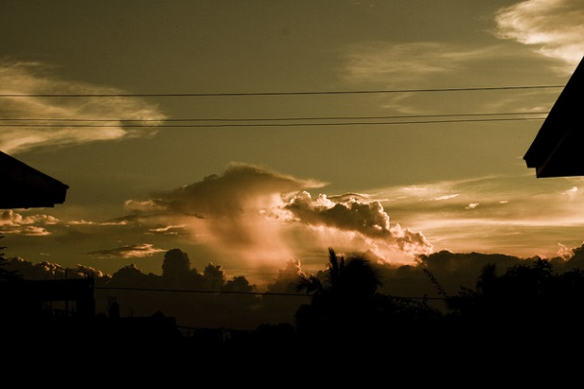
Photo by Patricia Ramos
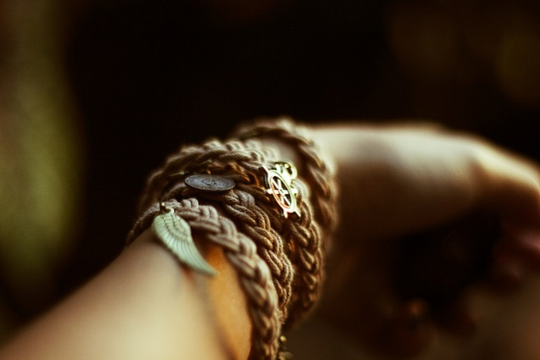
Photo by Patricia Ramos
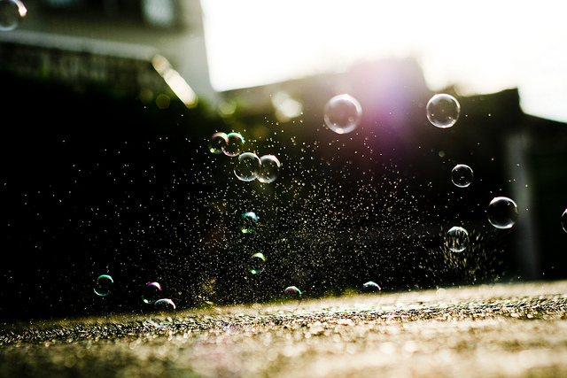
Photo by Patricia Ramos

One of Each
You might be one of those people with one photo of each color. When I say color, I mean the dominant color in the photo. For example, on my page on Flickr, I need to have variations in the dominant colors on the first page of my photostream. At the moment, I have violet, B&W, yellow and green. Some people react to a wide range of color to maintain a sort of ‘balance’ within your body of work, while others will prefer a common color/color family to tie everything together. Consistency helps in showing your personal style; without it, your portfolio can come across as a random assortment of images by different people. The common element doesn’t have to be color. It can also be lighting, processing style, subject, location or technique.

Saturation
Sometimes all you need to do in post is to tweak the saturation and you’re good to go. Personally, I’m not a fan of overly saturated photos because it hurts my eyes, but in come cases high saturation can add a surreal effect to your photos, almost as if it were a painting. You can lose quite a bit of detail in the process, which is why I’m more likely to decrease saturation than increase it.
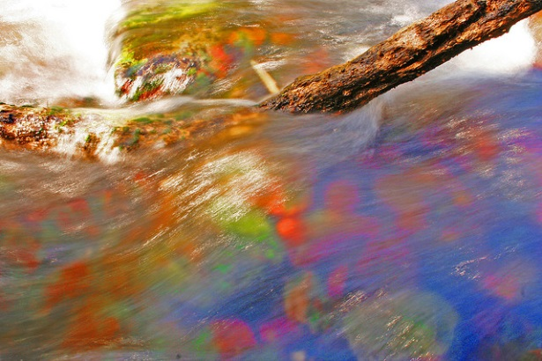
saturated stream by YanivG, on Flickr
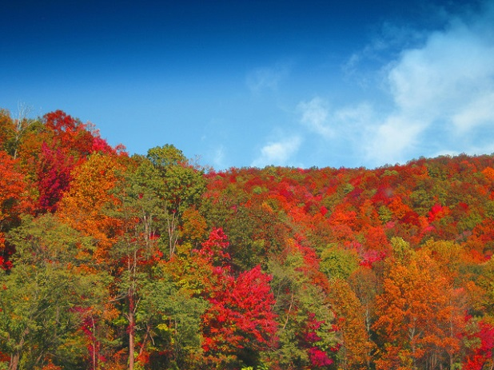
Fall leaves, extra saturated by moonlightbulb, on Flickr

Be Creative
It’s been said a 54890385408 times already, but it’s true. Explore your options. Combine colors that you wouldn’t normally combine because you’ll never really know until you put them side by side and really look. Try every possible color relationship that you can and decide on the one you like best.
Color is such a broad concept, and the best part about it is that you can achieve so many different effects without even trying. Don’t make the mistake of limiting yourself because your subject only comes in one color. “Oh I’ve already taken a picture of this yellow car.” Well, stay in one spot the whole day and tell me you don’t see subtle variations in color there. Before you complain, make sure you’ve exhausted your resources because you’re not always going to get a picture-perfect scene. On the off chance that you just can’t get anything good out of a photo in color, there’s always black and white.

