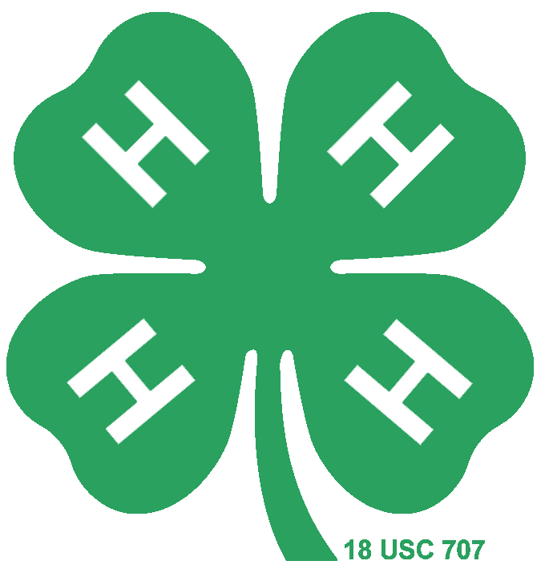

Record-Keeping Score Sheet
JUNIOR LEVEL
Name: County: District:
Category:

Instructions: Check one box (or award the point value) for the statement on each row that best describes each recordbook section/criteria. Should be judged on current year’s projects only. Total the check or point value at the bottom of the chart. Provide specific details in the comment boxes if necessary.
 | Not at all  (1 Point) | Somewhat  (2 Points) | Mostly  (3 Points) | Completely  (4 Points) | Comments
Personal Information
Selection, Goals and Diary
Project Selection
Project Goals
Diary of 4-H Events
My 4-H Story
Organization
4-H Focus
Main Project
Spelling/Punctuation/Grammar
Creativity
Awards, Service, and Leadership
Awards
Service
Leadership
Photographs
Photographs
TOTAL POINTS
GRAND TOTAL (out of 64)
Please include any other specific comments or suggestions for improvement here:
RIBBON COLOR:

PLACING/RANK:

ADVANCE TO NEXT LEVEL: Yes / No
Judge’s Initials:
RIBBON COLOR:
PLACING/RANK:
ADVANCE TO NEXT LEVEL: Yes / No
Judge’s Initials:_______________



Record-Keeping Scoring Tip Sheet
JUNIOR LEVEL

Score Sheet Overview
Personal Information | Complete; no additions or corrections necessary
Selection, Goals and Diary
Project Selection | Member clearly describes reason for selecting main project.
Project Goals | Current and future goals are clearly outlined for 4-H project(s).
Diary of 4-H Events | Member effectively demonstrates high level of involvement in 4-H and non 4-H activities.
My 4-H Story
Organization | The story sections are well organized. One idea follows another in a logical sequence with clear transitions.
4-H Focus | The story emphasizes 4-H project work and experiences
Main Project | The story summarizes activities and learning experiences within the main project category.
Spelling/Punctuation/Grammar | There are minimal spelling, punctuation, or grammatical errors in the story.
Creativity | The story contains creative details and/or descriptions that contribute to the reader's enjoyment.
Awards, Service, and Leadership
Awards | 4-H member effectively describes what the recognition or award means to them.
Service | Engaged in wide array of activities impacting individuals and groups.
Leadership | Member describes appropriate type, number, and level of leadership activities suitable for age/experience level.
Photographs
Photographs | Photos are detailed, attractive, creative, and relate to the member’s 4-H involvement.

