It is understood that if this application is accepted, a check for $300 must be submitted by May 31, 2014 to cover the applicant's meals and lodging expenses, made payable to TSSRM Youth Activities. Transportation cost to the workshop site and return home will be the responsibility of the local sponsoring group, nominator or participant.

Sponsor (Group/Organization)

C/o Name of Responsible Person

Address

City State Zip

Email

Phone

County Extension Agent/Ag Science Teacher

(Please print or type)

County Extension Agent/Ag Science Teacher
(Signature)

Address

City State Zip

Email

Phone

Extending the knowledge learned and gained to others is one of the highest goals of this program.

60th Annual Youth Range Workshop
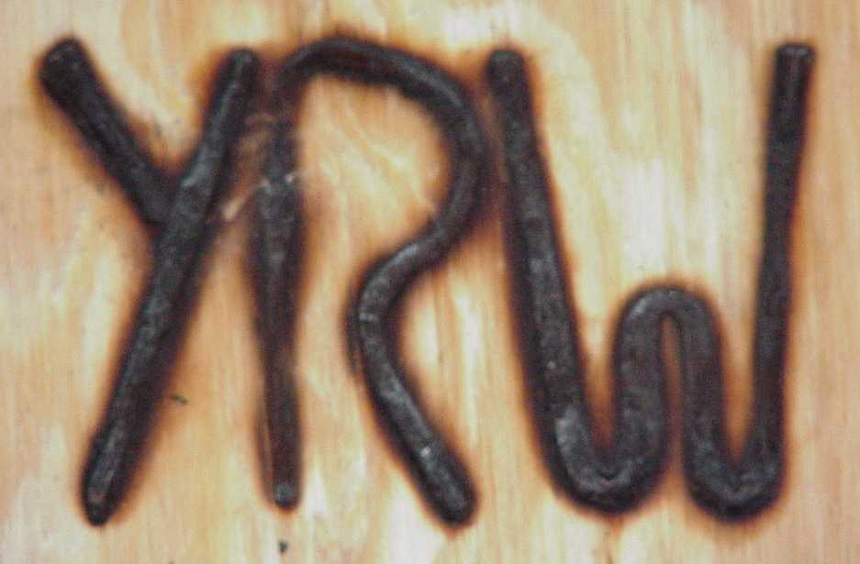

Training tomorrow's
leaders today in range
and natural resource
management, and the
stewardship of
natural resources

June 22-27, 2014

held at:
Texas Tech University
Junction Campus

Sponsored by:

Participants are exposed to actual land management practices and decisions through field trips to ranches, and a wildlife management area.

These field trips bring out facts on goals of landownership and the responses of vegetation to practices conducted for livestock, wildlife, recreation and range restoration. All examples will be real-life applications.

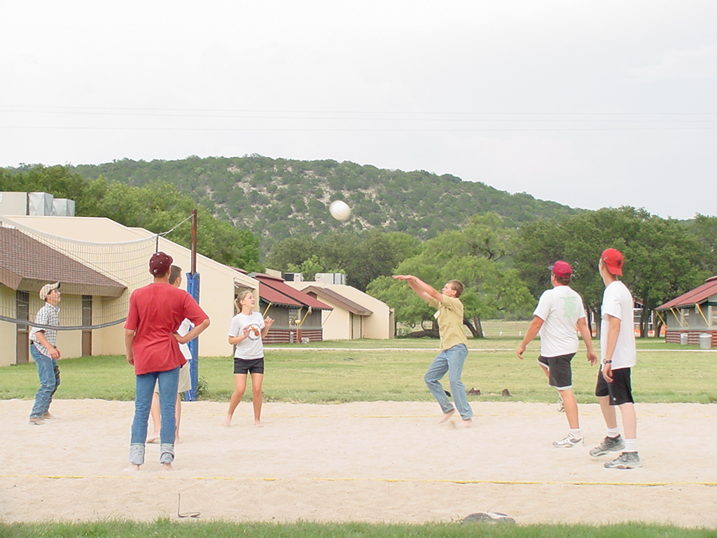
It is not all work! Fun activities are also planned.

June 22-27, 2014 marks the
60th Consecutive Annual
Youth Range Workshop.

Rangeland - it covers 59% of the state of Texas.

Management needs of rangelands are as diverse as the state - and require innovative approaches for good management. Each part of the state is unique and no two management approaches will achieve the same results, even on adjacent properties.
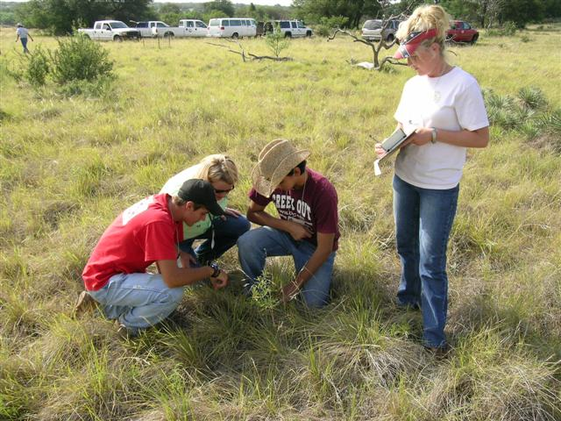
Users of rangelands are also varied. Most people think only of beef cattle, but wildlife, and humans are also users. Remember, rangelands are a type of land - not a land use.

This Workshop is structured to provide critical knowledge in the areas of:
- Stewardship
- Rangeland Ecology
- 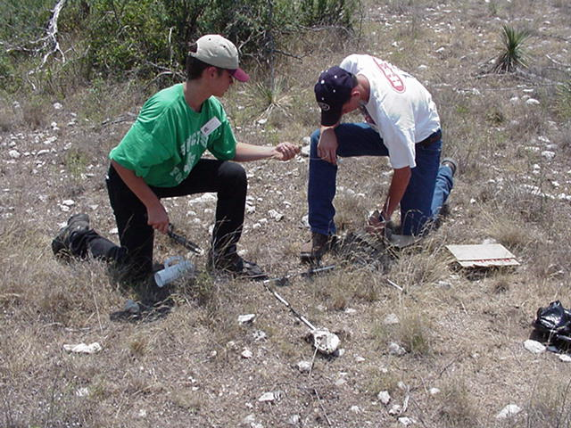Plant Species and Growth
- Plant-Soil-Water Relationships
- Primary and Secondary Succession
- Watershed Management
- Range livestock and wildlife needs
- 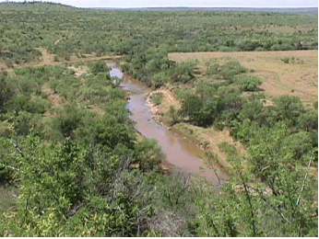Tools of range and natural resources management and restoration
- Landowner Goals & Objectives
- Impacts of Management Decisions
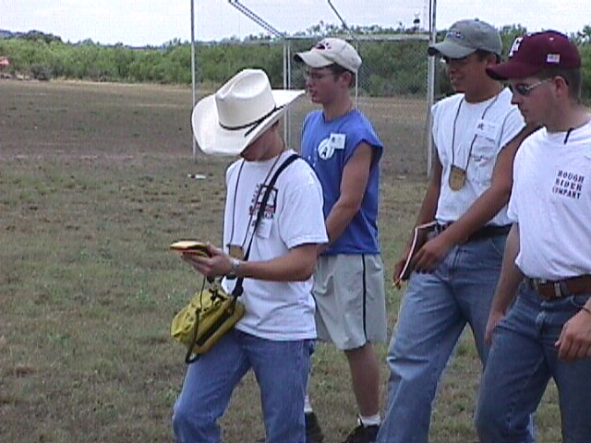
- New Technology
- Rangeland Monitoring (including photopoint establishment and monitoring using yearly and seasonal photographs, and fecal sampling).
This workshop has many hands on activities: plant id and collecting, plant species composition, total ranch planning, stocking rate evaluation, etc. Special sessions are held on water and total resource management.
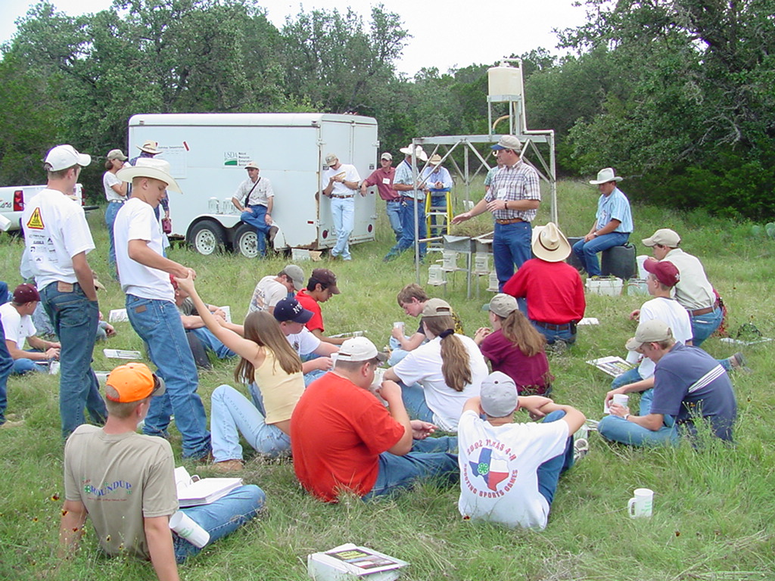
The dynamic curriculum is constantly changed as increasing importance is placed on the landowner's ability to make sound environmental, social and economic decisions.

Sponsors are often sought out by the students attending. Consult with your 4-H club/FFA Chapter leader for ideas. One can also contact your local Soil and Water Conservation District for potential leads.
Youth should be at least 14 years of age and have finished eighth grade but not have finished high school.

Applications are accepted by mail and can be completed by tearing off the form at right and completing both sides or printed from the following web site:

Applications/information, see the web at: www.rangelands.org/texas/youtheducation.htm
Application for
Youth Range Workshop
June 22-27, 2014

Full Name

Preferred Name

Male Female Date of Birth

Address

City State Zip

Home Phone

Email Address

has been nominated to attend the 2014 Youth Range Workshop representing

4-H Club/FFA Chapter

in County.

Applicant's T-shirt size (circle one):

S M L XL XXL

Mail Completed Application form to:
TSSRM Youth Range Workshop
%Mr. Hoyt Seidensticker and Barron S.
Rector, Workshop Co-Coordinators
1822 FM 473
Boerne, Texas 78006

Applications are accepted year- round and 40 participants will be selected for each workshop.

