Western Boots
Calum wants a new Western Boot for riding. He is an active member of the 4-H Horse Club and practices riding 2 hours a day. He needs something durable but affordable. He has $200 to spend and his shoe size is 8 ½. Help him find the best boot.
 | Product 1 | Product 2 | Product 3 | Product 4
Price | $139 | $199.99 | $100 | $220
Type | Alligator | Ostrich | Ostrich | Ostrich
Info | Leather lining; Leather Soles; 8 ½ size | Size 8 1/2; leather soles and leather lining | Size 8.5; leather soles and leather lining | Size 9 ; 12" Cognac with Matching Ostrich Print Plug. Urethane Shaft.  Composition Outsole. Cowboy Heel. 2 Toe.
Picture | 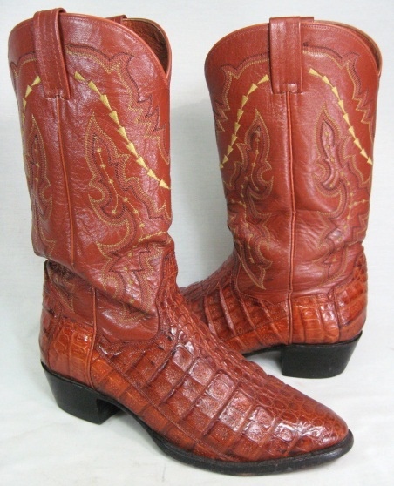 | 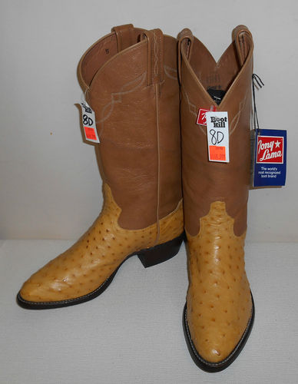 | 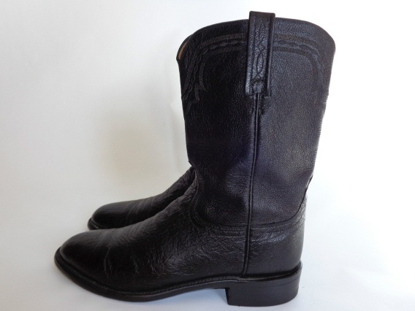 | 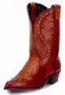
2-3-1-4
2- Ostrich; leather lining and soles (durable), pointing toes for ease of stirrups
3- Ostrich; leather lining and soles (durable), not pointing toes
1- Alligator- not durable; leather lining and leather soles
2- Ostrich; composition soles, over budget, and not right size

