Watches Scenario
Jon needs to buy a new watch because his old watch that he had for several years broke a few days ago. Jon has many events to attend that require him to be in formal wear so he needs a watch to match his formal attire. Jon is not worried about a price because he wants the best quality watch to wear at his formal and casual events. Jon does not like digital watches, he only likes analog. Jon would also like for the watch to display the date, but if possible the month too. He also needs the watch to be very accurate time piece. Please help Jon find the perfect watch to go with his formal and casual occasions.

#1
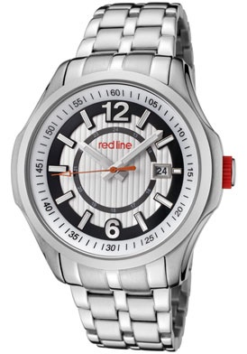Men's Starter Silver Dial Stainless Steel
Sale Price | $89.00 | price with promo
Brand | Red Line
Style | 50004-22S
Series | Starter
Style | Casual/Formal
Gender | Men's
Case | Stainless steel
Dial Color | Silver textured with black border
Hands | Silver tone and luminous hour and minute, orange and luminous second
Markers | Silver tone and luminous indices, silver tone Arabic numerals at 12:00 and 6:00
Bracelet | Stainless steel
Clasp Type | Push button deployment with safety
Movement | Japanese quartz
Crystal | Mineral
Water Resistant | 10 ATM/100 meter/330 feet
Calendar | Date display at 3:00
Case Back | Screw-down
Crown | Push/pull with red accent
Other | White inner bezel
Material | Stainless steel

#2

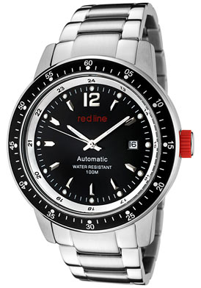Men's Meter Automatic Black Dial Stainless Steel
Sale Price | $85.00
Brand | Red Line
Style | 50013-11
Series | Meter
Style | Casual/Formal
Size | Men's
Case | Stainless steel
Dial Color | Black
Hands | Silver tone and luminous hour and minute; silver tone second
Markers | Silver tone and luminous indices; silver toen Arabic numerals at 12:00
Bracelet | Stainless steel
Clasp Type | Hidden
Bezel | Black aluminum and stainless steel
Movement | Japanese automatic quartz 21 Jewels (Miyota 8215)
Crystal | Mineral
Water Resistant | 10 ATM/100 Meters/330 Feet
Calendar | Date display at 3:00
Case Back | Screw-down
Crown | Push/pull with red accent
Material | Stainless steel
Warranty | Lifetime

#3
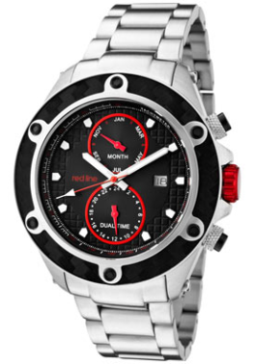Men's Carbon Brake Black Dial Stainless Steel
Sale Price | $99.99 | price with promo
Brand | Red Line
Style | 10106
Series | Carbon Brake
Style | Casual/Formal
Gender | Men's
Case | Stainless steel
Dial Color | Black with textured border
Hands | Silver tone and luminous hour and minute. Red and luminous second. Red subdial
Markers | White and luminous indices
Bracelet | Stainless steel
Clasp Type | Deployment with safety
Bezel | Black textured with silver tone accents on top ring
Weight | 174g
Movement | Quartz
Crystal | Mineral
Water Resistant | 10 ATM/100 meters/330 feet
Calendar | Date display at 3:00 and month subdial
Subdials | Month and dual time
Case Back | Screw-down
Crown | Push/pull metallic red ion plated stainless steel
Other | Black ion plated accent on pushers
Material | Stainless steel
Warranty | Lifetime

#4
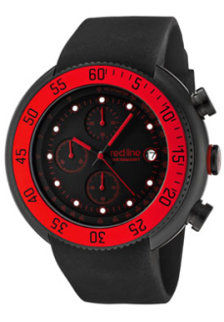Men's Driver Chronograph Black Dial Black IP Case Black Silicone
Sale Price | $125.99
Brand | Red Line
Series | Driver
Style | Chronograph
Gender | Men's
Strap Width | 24 mm
Case | Black ion plated stainless steel
Dial Color | Black
Hands | Red and black hour, minute and subdial. Red second
Markers | Red and luminous indices
Strap | Black silicone
Clasp Type | Buckle
Bezel | Black ion plated and red top ring with black numerals
Movement | Japanese chronograph quartz
Crystal | Mineral
Water Resistant | 10 ATM/100 meters/330 feet
Calendar | Date display at 3:00
Subdials | Black 60 second, 60 minute and 1/10 second
Case Back | Screw-down
Crown | Push/pull with red silicone accent
Other | Tachymeter inner bezel
Material | Silicone

Watches Placing & Reasons
Placing: 3 – 2 – 1 – 4
#3- Men’s Carbon Brake Black Dial Stainless Steel
- $99.99
- Casual/Formal
- Case: Stainless Steel
- Bracelet: Stainless Steel
- Movement: Quartz
- Crystal: Mineral
- Calendar: Date & Month
- Material: Stainless Steel
- Warranty: Lifetime
I placed 3 first because 3 was the only watch with the date and month on the watch like Jon wanted. Also 3 had a crystal that was mineral, which is made up of several different elements that come together and are heat-treated to create a hardness that helps in resisting scratches. 3 also has the movement that is quartz, which is basically batteries that the watch will run off of and they are very accurate. 3 is made of stainless steel for the case and bracelet, which is good to wear for casual or formal events that Jon will be attending. 3 also has a lifetime warranty so that way Jon will be able to replace his watch if ever breaks.
#2- Men’s Meter Automatic Black Dial Stainless Steel
- $85.00
- Casual/Formal
- Case: Stainless Steel
- Bracelet: Stainless Steel
- Movement: Japanese automatic quartz 21 Jewels
- Crystal: Mineral
- Calendar: Date
- Material: Stainless Steel
- Warranty: Lifetime
I placed 2 second because granted 2 was less expensive at $85.00 with a $14.00 difference from 3, I criticize that 2 did not have the month on the watch like 3, which is something Jon wanted. I also placed 2 second because it was for formal and casual occasions, the case and bracelet were stainless steel, the movement was quartz, and the crystal was made of mineral. 2 also has a lifetime warranty so that way Jon will be able to replace his watch if ever breaks and 1 does not have a lifetime warranty.
#1- Men’s Starter Silver Dial Stainless Steel
- $89.00
- Casual/Formal
- Case: Stainless Steel
- Bracelet: Stainless Steel
- Movement: Japanese quartz
- Crystal: Mineral
- Calendar: Date
- Material: Stainless Steel
I placed 1 third because although 1 and 2 had the same features 1 was more expensive at $89.00, a $4.00 difference from 2.
#4- Men’s Driver Chronograph Black Dial Black IP Case Black Silicone
- $125.99
- Style: Chronograph
- Case: Black ion plated stainless steel
- Strap: Black silicone
- Movement: Japanese Silicone Chronograph quartz
- Crystal: Mineral
- Calendar: Date
- Material: Silicone
I place 4 last because 4 was the most expensive watch at $125.99. Four was also last because it was a chronograph watch with a black silicone strap which is not considered to be a formal watch and Jon wanted a watch to wear to formal and casual events. Also the silicone is not a strong as the stainless steel, which made it easier to break.
Good to Know:
- Acrylic crystals: an inexpensive plastic that allows shallow scratches to be buffed out.
- Mineral crystals: Composed of several elements that are heat-treated to create an unusual hardness that aids in resisting scratches.
- Sapphire crystals: is the most expensive & durable, approximately three times harder than mineral crystal, and 20 times harder than acrylic crystals.

