Digital Cameras
Samantha wants a camera she can put in her pocket or purse and take to the Bell County Youth Fair to take pictures of her kids showing. She would like it to have no blinking feature and action photo option! Samantha will also need a good zoom for when she needs to take pictures of the kids in the ring far away. She only has $150 to spend.
Product #1 | Product #2 | Product #3 | Product #4
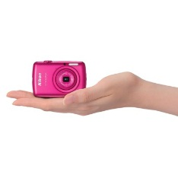 | 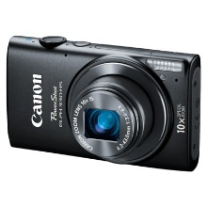 | 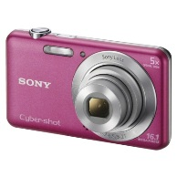 | 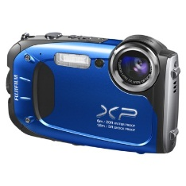
Nikon S01 10.1MP Digital Camera with Clutch Case Included | Canon PowerShot Elph 330 HS 12.1MP Digital Camera with 10x Optical Zoom | SONY Cyber-shot DSCW710 16.1MP Digital Camera with 5x Optical Zoom | Fujifilm FinePix XP60 16.4MP Digital Camerawith 7.2x Optical Zoom
$99.99 | $149.99 | $79.99 | $179.99
Megapixels: 10.1 Megapixels  Sensor Type: CCD Sensor  Zoom: 3.0 X Optical , 4.0 X Digital  Camera Features: Auto Focus, Electronic Image Stabilization, 720p HD Movie Recording, Auto Scene Selector, Face Detection Technology  Display Size: 2.5 "  ISO Equivalent: 80 - 1600  Battery Required, included: 1 lithium ion non-universal  Weight: 3.4 Oz.  Warranty: 1 Year Limited Manufacturer Warranty | Share with Powerful Style. Radiant in a sleekly rounded new design, the PowerShot ELPH 330 HS boasts enhanced built-in Wi-Fi® that enables you to comment on photos and share them to social networking sites.  Megapixels: 12.1 Megapixels  Zoom: 10.0 X Optical- 24mm  Camera Features: Face-activated self timer, Self Timer  Flash Features: Slow-Sync Flash, Auto On/Off  Lens Features: Wide Angle  Display Size: 3.0 "  ISO Equivalent: 3200, 800, 200, 1600, 100, 400  Battery Required, included: 1 lithium ion  Warranty: 1 Year Limited Warranty | You can even edit pictures straight from the camera with Beauty Effects—adjust skin tones, blot out blemishes, whiten teeth and more. It makes for utterly eye-pleasing portraits.  Megapixels: 16.1 Megapixels  Sensor Type: CCD Sensor  Zoom: 5.0 X Optical , 20.0 X Digital  Camera Features: Auto Focus, Red Eye Removal During Playback, Face Detection Technology, 720p HD Movie Recording, Blink Detection, Date and Time Print, Pan-Capture Panorama, Self Timer  Flash Features: Slow-Sync Flash, Built-In Flash, Red-Eye Reduction, Auto On/Off, Intelligent Flash  Display Size: 3.0”  ISO Equivalent: 80 - 3200  Battery Required, included: 1 lithium ion non-universal  Warranty: 1 Year Limited Manufacturer Warranty | Sensor Type: CMOS Sensor  Camera Features: Auto Focus, Auto Scene Selector, Face Detection Technology, Red Eye Removal During Playback, HD Still Capture, Underwater Capability, 1080p HD Movie Recording, Pan-Capture Panorama  Flash Features: Auto On/Off, Slow-Sync Flash, Forced Flash, Red-Eye Reduction, Suppressed Flash  Display Size: 2.7 "  ISO Equivalent: 100 - 6400  Battery Required, included: 1 lithium ion  Weight: 4.9 Oz.  Warranty: 1 Year Limited Manufacturer Warranty

 | Product 1 | Product 2 | Product 3 | Product 4
Compact | yes | No | No | No
MP | 10.1 | 12.1 | 16.1 | 16.4
Zoom | 3x | 10x | 5x | 7.2x
Under $150 | Yes | Yes | Yes | no
Blink Detection | No | No | Yes | No
Screen Size | 2.5 | 3.0 | 3.0 | 2.7

3-2-1-4

