Class #3
Fast Food
Amy loves to eat quick and healthy meals while traveling for work. She is looking for a healthy option for her lunch at the airport. She is vegetarian and is trying to find something low in fat but high in protein to supplement her nutrients. Help her find the best food to pick.

#1  Arby’s Turkey Classic  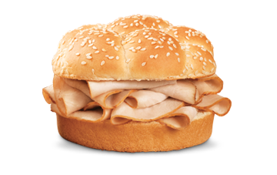 | #2  Panda Express Chow Mein  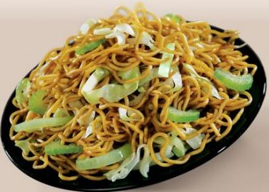 | #3  Subway 6'' Veggie Patty  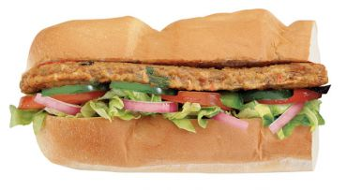 | #4  McDonald’s Premium Southwest Salad (without chicken)  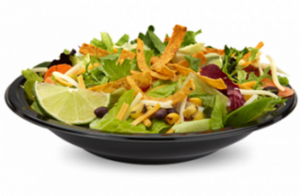
Calories: 290  Total Fat: 5g  Sodium: 1020mg  Fiber: 2g  Protein: 24g | Calories: 490  Total Fat: 22g  Sodium: 1060mg  Fiber: 4g  Protein: 13g | Calories: 390  Total Fat: 7g  Sodium: 800mg  Fiber: 8g  Protein: 23g | Calories: 140  Total Fat: 5g  Sodium: 150mg  Fiber: 6g  Protein: 6g
Price: $2.15 | Price: $8.79 | Price: $6.00 | Price: $2.19

CLASS PLACING: 3-4-2-1
Cuts: 1-4-5

3: Best protein for veggie only, semi low in sodium and fat
4: lowest in calories, lowest in fat, lowest in sodium, but very low in protein and will not provide enough
2: very high in calories, sodium, fat, and low in protein compared to 3 (still too high in other things to beat 4)
1: Turkey, she is vegetarian, one of the highest in sodium

