You may place your orders beginning October 25th through December 1st .. The site will close at midnight on December 1st
NO LATE ORDERS WILL BE ACCEPTED.

1. Go to: www.barefootathletics.com/cof ENTER CODE: COF29402
2. Enter sizes and quantities for each item, enter the student’s full name, and then click “Add to Cart”.

3. Check your selections and make any necessary corrections.

4. Once your order is correct click “Proceed to checkout”.

5. Enter your billing information.

6. Verify that your order is correct. Check the box next to “Yes, I agree with the terms and conditions”, and then click “Continue”.

7. Enter your payment information and click “Pay for Order”. You will receive a confirmation email.

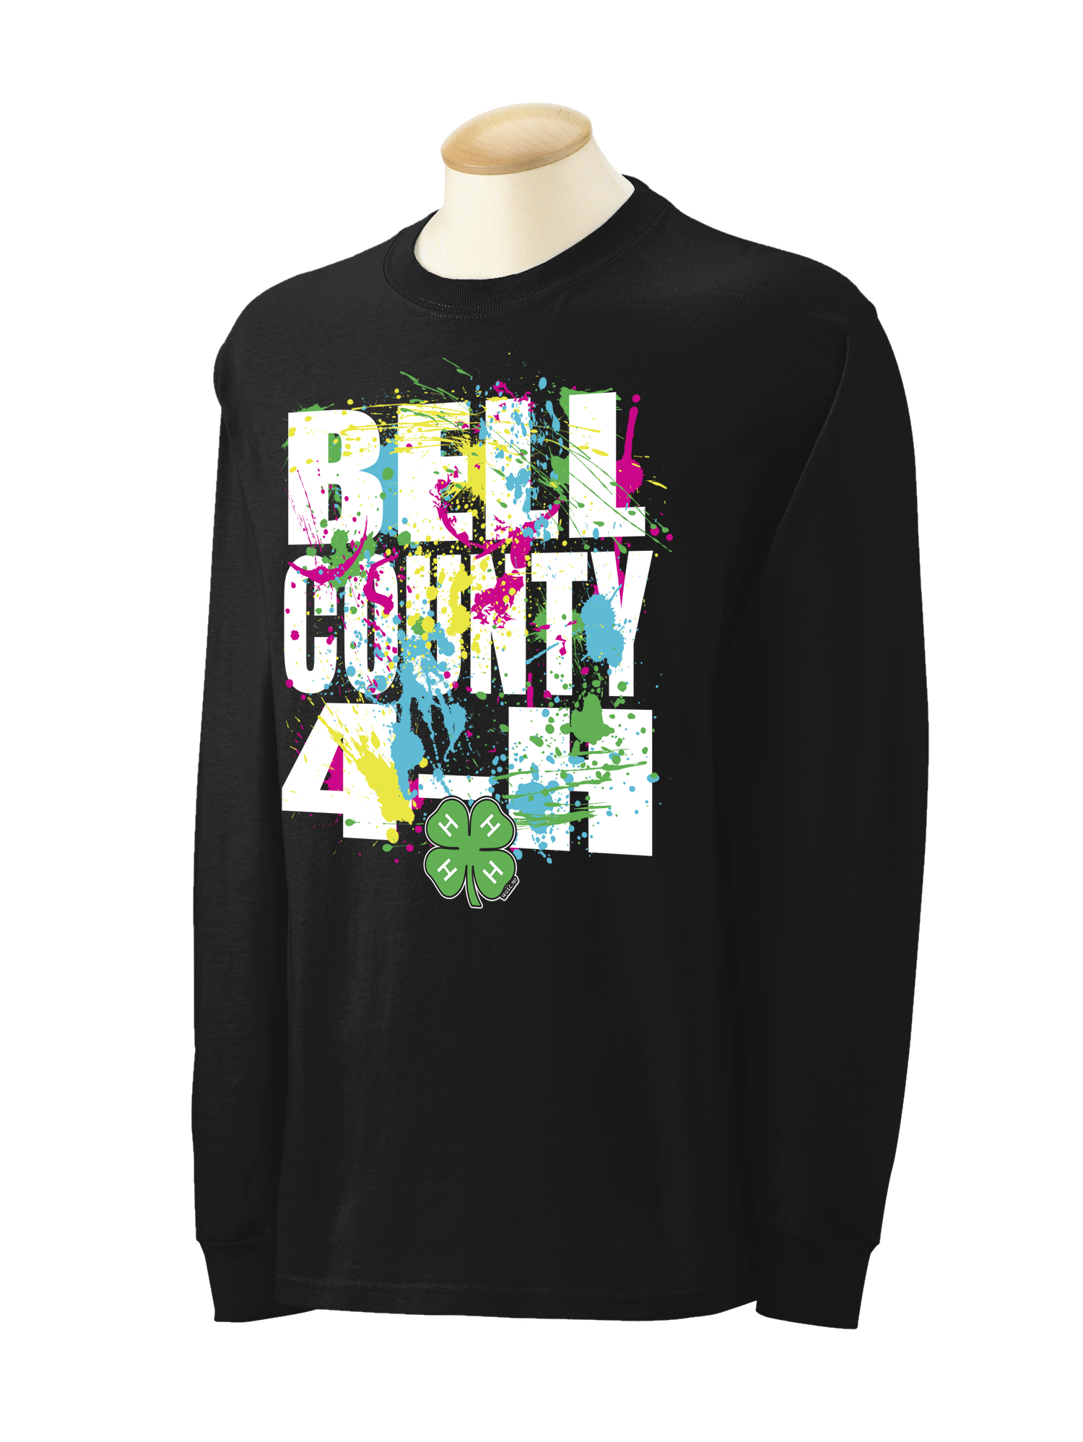

If you have any questions or concerns please contact Barefoot Athletics 254-918-0511

