Enclosed you will find the 2014 District 8 4-H Fashion Show, Fashion Storyboard, and Trashion Show contest information. The 2014 Texas 4-H Clothing & Textiles Packet is also attached.

Dates: | County Fashion Show Entries: Friday, October 17, 2014 (Entry forms Only)  County: Friday, October 24, 2014  District: Tuesday, November 18, 2014
Location: | Bell County Expo Center  301 W Loop 121  Belton, TX 76513  www.bellcountyexpo.com
Time: | - The District Fashion Show & Duds to Dazzle Contests will be held on the same day. 4-H members may participate in both events. They will be judged in Fashion Show first, then compete in Duds to Dazzle.  - District- Participants should plan to bring a sack lunch and/or snacks for the day.

D8 4-H FASHION SHOW, NATURAL FIBER,
STORYBOARD, TRASHION SHOW

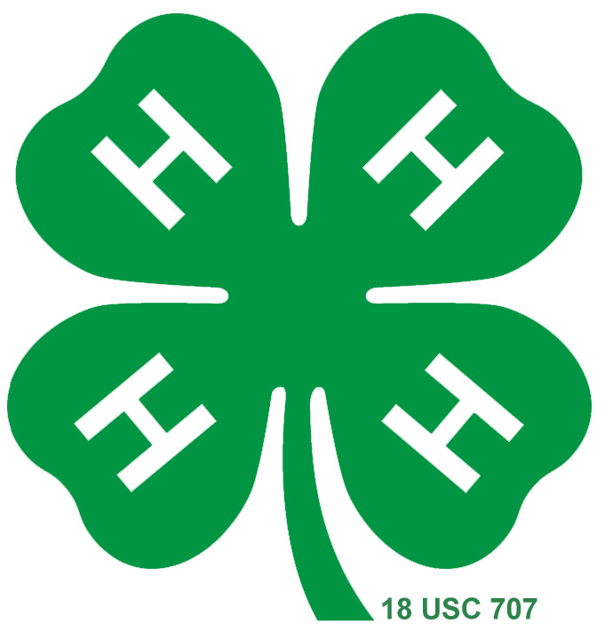
General Rules & Guidelines

OVERVIEW
The 4-H Fashion Show is designed to recognize 4-H members who have completed a Clothing and Textiles project. The following objectives are taught in the Clothing and Textiles project: knowledge of fibers and fabrics, wardrobe selection, clothing construction, comparison shopping, fashion interpretation, understanding of style, good grooming, poise in front of others, and personal presentation skills.

PURPOSE
The Fashion Show provides an opportunity for 4-H members to exhibit the skills learned in their project work. It also provides members an opportunity to increase their personal presentation skills.

ELIGIBILITY REQUIREMENTS
- Membership. Participants must be 4-H members currently enrolled in a Texas 4-H and Youth Development county program and actively participating in the Clothing & Textiles project.

- Age Divisions. Age divisions are determined by a participant’s age as of August 31, 2014 as follows:
Division | Ages | Birth date between:
Junior | 8 years old and in 3rd grade or 9 - 10 years | Sept 1, 2003 – Aug 31, 2006
Intermediate | 11-13 years of age | Sept 1, 2000 – Aug 31, 2003
Senior | 14 - 18 years of age | Sept 1, 1995 – Aug 31, 2000

- County and District Events. There are four (4) events conducted at the District Fashion Show:
Fashion Show | 3 age divisions (Junior, Intermediate, Senior)
Natural Fiber | Seniors only
Fashion Storyboard | 3 age divisions (Junior, Intermediate, Senior)
District and State Only: Trashion Show | 2 age groups (Junior OR Intermediate/Senior)

- Number of Entries. Participants may enter a maximum of one division/category in each of the four (4) events.
Fashion Show | Buying or Construction Division
Natural Fiber | Cotton or Wool/Mohair/Alpaca
Fashion Storyboard | Accessory, Jewelry, Non-wearable, Pet Clothing, or Wearable
Trashion Show | There are not separate categories/divisions. However, there are 2 age groups.

Counties may enter a maximum of one entry in each division/category in Fashion Show and Natural Fiber. There are no limits to the number of Fashion Storyboards per county. There are no limits on the number of Trashion Show entries per county.

- Qualifying for State. Only Senior 4-H members are eligible to advance to state.
  - Fashion Show: The district will send one (1) contestant from each of the four (4) categories in the Construction Division (Everyday Living, ReFashion, Semi-Formal to Formal, and Theatre/Costume) and one (1) contestant from each of the four (4) categories in the Buying Division (Business/Interview Attire, Fantastic Fashions Under $25, Semi-Formal to Formal, and Special Interest). (Maximum of 8 entries.) If a participant qualifies for the Texas 4-H Fashion Show in Buying or Construction and in Natural Fiber, he/she will be able to compete in both at the Texas 4-H Fashion Show.

  - Natural Fiber Contest: The district will send one (1) contestant from each of the two (2) categories (Cotton and Wool/Mohair) in the Natural Fiber Contest. (Maximum of 2 entries.) If a participant qualifies for the Texas 4-H Fashion Show in Buying or Construction and in Natural Fiber, he/she will be able to compete in both at the State Fashion Show.

  - Fashion Storyboard: The district will send the top three (3) placing entries in each of the five (5) categories (Wearable, Accessory, Jewelry, Non-Wearable, and Pet Clothing). (Maximum of 15 entries.)

  - Trashion Show. The district Trashion Show will not determine which entries advance to state. It will be for exhibition only. If Intermediates or Seniors are interested in advancing to state, they must follow the guidelines outlined at the state level for advancement. Please note the state deadlines may be different than district deadlines.

D8 4-H FASHION SHOW
Fashion Show Guidelines

- Objectives. To recognize 4-H members who have excelled in clothing projects and exhibit skills in the application of knowledge of fibers and fabrics to wardrobe selection, clothing construction, or comparison shopping, fashion interpretation and understanding of style, good grooming and poise in front of others, and modeling and presentation of themselves and their garments.

- Fashion Show Divisions. There are two divisions in the Fashion Show: Buying and Construction. Contestants may enter one category in one division.

The 4-H member must choose a division and category at the county level and must compete in that division and category at all levels of competition. Accessories such as shoes, jewelry, hats, gloves, scarves may be changed, but changes must be included on the paperwork. The appropriate garment category should be determined by the style, fabric, and use of garment. No one may change division or categories between district and state contests.

BUYING | CONSTRUCTION
- Garments will be purchased  - Seniors only: All garments worn (garments that are visible – i.e. blouse under jacket or vest) during the interview must be included in the buying worksheet.  - Seniors only: In Buying, the first place winners at the Texas 4-H Fashion Show may enter the same category in which they have previously been awarded a first place entry at the Texas 4-H Fashion Show. | - Garments may be constructed by sewing, knitting, or crocheting. Accessories may be purchased.  - Seniors only: All garments worn (garments that are visible – i.e. blouse under jacket or vest) during the interview must be constructed. Close-fitting leg wear, tights, and pantyhose do not need to be constructed.  - Seniors only: In Construction, the first place winners at the Texas 4-H Fashion Show may enter the same category in which they have previously been awarded a first place entry at the Texas 4-H Fashion Show.

- Fashion Show Categories. Below is a list of categories and brief description of each. Agents should assist 4-H members in placing entries in appropriate categories. Those not placed in appropriate categories may be disqualified.

JUNIOR/INTERMEDIATE BUYING CATEGORIES
Everyday Living | Includes casual sportswear, weekend-wear, clothing for school, casual after-school events, or hanging out with friends.
Fantastic Fashions under $25 | This category is designed to expand the 4-H member’s shopping experience to include different shopping venues. Outfits must be purchased at a garage sale, consignment store, Goodwill, Salvation Army, or other retail business. Receipts are required for everything that is visible during the interview, except shoes. Receipts for garage sales can be handwritten. This includes jewelry and accessories. Do not need to account for sales tax.
Dressy | Garments worn to dressy activities such as church, banquets, luncheons and 4-H interviews. Examples are children’s suits and dressy dresses. Original material must be fabric and not from recycled items.
Special Interest | Limited to special purpose garments. Examples are band, pep squad and cheerleader uniforms; sleep wear; theatrical and circus-type costumes such as clown suits and ballet costumes; equestrian clothing and riding apparel; hiking clothing; or rock climbing clothing. Garments in this category should not be suitable for ordinary activities.
JUNIOR/INTERMEDIATE CONSTRUCTION CATEGORIES
Everyday Living | Includes casual sportswear, weekend-wear, clothing for school, casual after-school events, or hanging out with friends.
ReFashion | The result of modifying existing clothing into something more fashionable. The main purpose of ReFashion is creativity, as well as sewing skills. The member designs and sews a wearable garment from previously used garments. The completed garment is different from its original use, not just an alteration. (Examples: neck ties sewn together to form a skirt or taking old t-shirts and making them into a skirt)
Dressy | Garments worn to dressy activities such as church, banquets, luncheons and 4-H interviews. Examples are children’s suits and dressy dresses. Original material must be fabric and not from recycled items.
Special Interest | Limited to special purpose garments. Examples are band, pep squad and cheerleader uniforms; sleep wear; theatrical and circus-type costumes such as clown suits and ballet costumes; equestrian clothing and riding apparel; hiking clothing; or rock climbing clothing. Garments in this category should not be suitable for ordinary activities.
SENIOR BUYING CATEGORIES
Business/Interview Attire | Entry should be an outfit you would wear for a job interview, scholarship interview, job fair, or other professional event.  1. Professional – This is a more traditional, conservative approach (e.g., business suit or blazer, tie and dress slacks for men; business suit, pantsuit, or jacket and dress for women) and may vary by employer or industry.  2. Business Casual – This is more relaxed and comfortable but demonstrates good judgment in choices and displays a neat appearance (e.g., polo shirt, shirt with a collar or sweater; khakis or other slacks; dress or casual leather shoes for men and women; moderate length dress or skirt for women).
Fantastic Fashions under $25 | This category is designed to expand the 4-H member’s shopping experience to include different shopping venues. Outfits must be purchased at a garage sale, consignment store, Goodwill, Salvation Army, or other retail business. Receipts are required for everything that is visible during the interview, except shoes. Receipts for garage sales can be handwritten. This includes jewelry and accessories. Do not need to account for sales tax.
Semi-Formal to Formal | Entry must be designed for semi-formal to formal occasions and made from fabrics intended for the same. Semi-formal is a little less formal than formal black tie. Example: For women: dresses or stylish pantsuit made of taffeta, chiffon, satin or other similar fabrics. For men: dress includes jacket or vest, trousers and a tie. Current fashion does not dictate that a tie is absolutely necessary. Formal includes men’s suits and tuxedos and women’s formal gowns, wedding dresses, and bridesmaid dresses.
Special Interest | Entry should be a specific outfit that you NEED to know how to purchase wisely. Entry should be something that reflects a special interest of the participant, such as equestrian clothing and riding apparel, dance costumes, hiking clothing, or rock climbing clothing.
SENIOR CONSTRUCTION CATEGORIES
Everyday Living | Includes casual sportswear, weekend-wear, clothing for school, casual after-school events, or hanging out with friends.
ReFashion | The result of modifying existing clothing or fabric item (such as table cloth or curtain) into something more fashionable. The main purpose of ReFashion is creativity, as well as sewing skills. The member designs and sews a wearable garment from previously used garments or fabric item. The completed garment is different from its original use, not just an alteration. (Examples: neck ties sewn together to form a skirt or taking old t-shirts and making them into a skirt)
Semi-Formal to Formal | Entry must be designed for semi-formal to formal occasions and made from fabrics intended for the same. Original material must be fabric and not from recycled items. Semi-formal is a little less formal than formal black tie. Example: For women: dresses or stylish pantsuit made of taffeta, chiffon, satin or other similar fabrics. For men: dress includes jacket or vest, trousers and a tie. Current fashion does not dictate that a tie is absolutely necessary.
Theatre/Costume | Garment intended for use as a costume, which would include stage production. May be sewn from fabric or from another garment. These garments may be unusual or innovative materials; imaginative but wearable.
- Fashion Show Judging Process.
  - All Age Divisions:
    - Judges. Contestants will be judged by a panel of no less than two qualified judges.
    - Age Divisions, Divisions, and Categories. Each age division, division, and category will be judged separately.
    - Paperwork. Juniors & Intermediates will turn in two sets of their required paperwork (see below) to their judges at the time of the interview. Seniors will turn in two sets of the appropriate required paperwork (see below) to their County Extension Agent by the deadline set by the county so paperwork may be judged prior to the Fashion Show.
    - Interview. Judges will interview contestants. No presentation will be given by contestants.
    - Time Limits. Judges will have four (4) minutes to ask questions of the contestant. Following this time, the contestant will leave the judging room and the judges will have an additional four (4) minutes to score the contestant and write comments.
    - Questions. Judges may only ask questions from the list of “Possible Interview Questions” for the appropriate division included in this packet.
    - Garment: Contestants will wear their Fashion Show garments in front of the judges.
    - Judges’ Decisions. All judges’ decisions are final after awards presentation is made.
    - Parents. No parents will be allowed in judging area. Parents will have a designated area to wait until their child is finished being judged.

- Paperwork Requirements.
Juniors & Intermediates | - Contestants will bring two sets of the District 8 4-H Project Information Sheet to submit to the judges during their interview.  - Contestants will bring two 4x6 photos to submit to the judges during their interview. The photo should be a head-to-toe photo of the contestant wearing his/her Fashion Show garment. The photos should be attached to the Photo Sheet.
Seniors | - Contestants will turn in two sets of the appropriate division Texas 4-H Fashion Show paperwork to the District Office by the deadline. (Check with your County Extension Agent for county deadlines.)  - This paperwork will be judged prior to the Fashion Show.  - Interview judges will be given a copy of this paperwork prior to the interview.  - Numerical paperwork scores will be combined with numerical interview scores to determine final ranking.  - Buying Paperwork: 2015 Texas 4-H Fashion Show Buying Entry Form (4 pages)  - Construction Paperwork: 2015 Texas 4-H Fashion Show Construction Entry Form (4 pages)
- Judging Criteria. Judging is based on the appropriate score sheet and will evaluate contestants based on their paperwork and interviews.
  - Ties – If a tie should occur in a Senior category, the ties will be broken using partial scores in the following order:
    - Construction skills/Consumer buying skills
    - Project goals and project activities
    - Knowledge of fiber and fabric characteristics
    - Interview
    - Outfit selection

- Garments. All garments/ensembles to be judged must have been purchased (renting a garment is not permitted in the buying division) or constructed (construction division) during participation in a 4-H clothing project during the current 4-H year.

- Awards. The top contestants in each category will be recognized during the awards program.

- Top Model Award. One award will be given to the best model during the Fashion Show for each age division: Junior, Intermediate and Senior. This award will be given to a 4-H member based on poise and modeling skills on stage.
D8 4-H FASHION SHOW
JUNIOR/INTERMEDIATE Fashion Show Possible Interview Questions

Questions for Buying
- How will the purchase of this garment enhance your present wardrobe?
- How do you care for this garment? (Example: hand-wash, cold water; dry clean; machine-wash, warm water, etc.)
- Tell us about the characteristics of your fabric (Example: Does it wrinkle easily? Does it stretch? Does it ravel?)
- What was the deciding factor in choosing this particular garment when comparing it against others? (Example: Was it the fit, cost, quality, etc.)
- How much did your garment cost? Is your garment a good value for the amount of money paid for it?
- How many garments did you compare before deciding to purchase this one?
- What attracted you to choose this outfit to (buy/make) for your Fashion Show entry?
- Is the fabric natural or man-made in your garment? What is the fabric content?
- Show us two reasons why you think your garment is well made. (Could show seam finishes, hem, zipper, set-in sleeve, etc.)
- What did you consider when selecting your accessories? How do you think your accessories complement your garment?
- Is there anything else you would like to tell us about your Clothing Buying project?
- If you could change one thing about your Clothing & Textiles project, what would it be?
- Based on what you learned this year, what are your goals for next year?
Questions for Construction
- How will this garment enhance your present wardrobe?
- How do you care for this garment? (Example: hand-wash, cold water; dry clean; machine-wash, warm water, etc.)
- Tell us about the characteristics of your fabric (Example: Does it wrinkle easily? Does it stretch? Does it ravel?)
- Name a new technique or skill used making the garment (Example: setting in a zipper, learning to cut out a garment, comparing body measurements against those on the pattern envelope, etc.)
- How much did your garment cost?
- What was the hardest part of constructing your garment? (Setting in the sleeves, putting in the zipper, etc.)
- What attracted you to choose this outfit to (buy/make) for your Fashion Show entry?
- Is the fabric natural or man-made in your garment? What is the fabric content?
- Show us two reasons why you think your garment is well made. (Could show seam finishes, hem, zipper, set-in sleeve, etc.)
- What did you consider when selecting your accessories? How do you think your accessories complement your garment?
- Is there anything else you would like to tell us about your Clothing Construction project?
- If you could change one thing about your Clothing & Textiles project, what would it be?
- Based on what you learned this year, what are your goals for next year?
D8 4-H FASHION SHOW
SENIOR Fashion Show Possible Interview Questions

Questions for Buying
- For what occasion did you select this outfit?
- Tell me how you went about selecting this outfit?
- What is the fiber content of your garment? Tell me two qualities of each fiber.
- Are the fibers in your garment natural or man-made?
- What considerations did you use when you selected this outfit? (fiber, fabric, design, construction)
- How does this outfit meet your clothing needs?
- What information does the garment’s hangtags give you?
- Why did you select the particular style, color(s), and/or fabric(s)?
- Explain how and why the style of this outfit is appropriate for your figure type.
- Describe what you think makes your outfit fit your personality?
- Are there any changes you would make to improve the fit?
- Explain what you considered when you choosing your accessories.
- How will you care for this garment? Is there any additional cost to consider when caring for this garment?
- What skills did you learn while shopping for this outfit?
- What is your “cost per wearing”? (The number of times you actually wear a garment divided by its cost. A formal that is only worn once will have a higher cost per wearing than a pair of jeans that will be worn many, many times.)
- Do you have a clothing budget? If so, who determines the budget amount?
- In your comparison shopping, what did you consider the most important thing to look for?
- As you selected the pieces for this outfit, what did you learn about price and quality?
- How reasonable was the cost of your outfit in terms of your family’s spending plan?
- Do you have a clothing budget?
- Describe your clothing and textiles leadership activities? What was your favorite leadership activity?
- How did you connect your clothing and textile project work with community service?

D8 4-H FASHION SHOW
SENIOR Fashion Show Possible Interview Questions

Questions for Construction
- Describe your clothing and textiles project goals. Describe how your project goals guided your project work.
- What is the fiber content of your garment? Describe two qualities of each fiber.
- Are the fibers in your garment natural or man-made?
- Why is this fabric a good choice for your garment? Describe fabric characteristics that make it suitable for the intended use of the garment.
- How will you care for this garment? Is there any additional cost to consider when caring for this garment?
- How did you decide which sewing methods to use for seams, hems, etc.?
- What occasion do you plan on wearing your garment?
- What did you consider when selecting your accessories? Why were these considerations important to you?
- What skills did you learn while constructing this garment?
- How will you use your sewing skills after you graduate from the 4-H program?
- How does this outfit meet your clothing needs?
- How often do you plan to use the outfit/accessories? What is your cost per wearing?
- Do you have a clothing budget? Describe how you allocate your clothing dollar.
- Why did you choose to construct this garment rather than buy it?
- Describe your clothing and textiles project activities? What was your favorite activity?
- How did you connect your clothing and textile project work with community service?
- What community service activities were you involved with?
- Talk about why this garment is a good fit for your body type.
- How does your garment fit in with current fashion trends?
- Describe how this garment will fit with your current wardrobe.
D8 4-H FASHION SHOW
2014 Fall District 8 4-H Fashion Show
Junior & Intermediate
Photo Sheet

Name |  |  |  |  |  | County
Age Division |  | Junior |  | Intermediate
Select either Buying or Construction Division:
Buying Division |  | Dressy |  | Everyday Living |  |  | Fantastic Fashions under $25 |  |  | Special Interest
Construction Division |  | Dressy |  | Everyday Living |  |  | ReFashion |  |  | Special Interest
Insert or glue a high quality front and back view head-to-toe photo of participant in the competition garment in the space below. Photo/Photos should not exceed the space below.

D8 4-H FASHION SHOW
2014 Fall District 8 4-H Fashion Show
Junior & Intermediate
Project Information Sheet
Name |  |  |  |  |  | County
Age Division |  | Junior |  | Intermediate
Select either Buying or Construction Division:
Buying Division |  | Dressy |  | Everyday Living |  |  | Fantastic Fashions under $25 |  |  | Special Interest
Construction Division |  | Dressy |  | Everyday Living |  |  | ReFashion |  |  | Special Interest
What did you learn in your clothing project?
What activities did you participate in during your clothing project?
Tell us about your leadership and/or community service.
What one thing would you have done differently in your Clothing &Textiles project this year?

D8 4-H FASHION SHOW
2014 Fall District 8 4-H Fashion Show
Junior & Intermediate
Score Sheet
 | Name |  |  |  |  |  |  | County
 | Age Division |  | Junior |  | Intermediate
 | Select either Buying or Construction Division:
 | Buying Division |  | Dressy |  | Everyday Living |  |  |  | Fantastic Fashions under $25 |  |  | Special Interest
 | Construction Division |  | Dressy |  | Everyday Living |  |  |  | ReFashion |  |  | Special Interest
JUDGING CRITERIA |  |  |  |  |  | JUDGE’S COMMENTS
Appearance, Fit, Fashion (25%)
- Garment becoming and fashionable for age of model
- Appropriate accessories
- Presentation skills, poise, and grooming
- Wardrobe coordination

Knowledge of Fiber & Fabric/Uses & Care (25%)
- Knowledge about garment care
- Knowledge about fabric
- Knowledge about fibers
- Man-made or natural source

Ability to Evaluate Garment Quality & Apply Knowledge (25%)
- Style makes good use of fiber and fabric characteristics and is appropriate for intended use of garment
- Garment is well made (plaids/seams match, edges smooth, hem even, closures, neat, well pressed, etc.)
- Garment meets the competition eligibility requirements (Division and category for complete garment)

Quality of Project Activities & Written Materials (15%)
- Adequate activities and projects
- Adequate community service and leadership
- Form is complete and legible

Interview (10%)
- Creates a good first impression
- Uses positive vocal qualities
- Answers questions correctly, with confidence
- Possesses good verbal communication skills

 |  |  |  |  |  | Ranking
 |  |  |  |  |  | Judge’s Initials
D8 4-H FASHION SHOW
Senior Fashion Show Materials

Senior Fashion Show Materials
Can be found online at:
http://fcs.tamu.edu/clothing/4h/packet/index.php

Fashion Show Buying & Construction General Rules & Guidelines
http://fcs.tamu.edu/clothing/4h/packet/2015/01-2015-fashion-show-new-categories-guidelines-and-rules.pdf

Buying Entry Form
http://fcs.tamu.edu/clothing/4h/packet/2015/05-2015-fashion-show-buying-entry-form.pdf

Buying Score Sheet
http://fcs.tamu.edu/clothing/4h/packet/2015/06-2015-fashion-show-buying-score-sheet.pdf

Buying Possible Interview Questions
http://fcs.tamu.edu/clothing/4h/packet/2015/07-2015-fashion-show-buying-interview-questions.pdf

Construction Entry Form
http://fcs.tamu.edu/clothing/4h/packet/2015/02-2015-fashion-show-construction-entry-form.pdf

Construction Score Sheet
http://fcs.tamu.edu/clothing/4h/packet/2015/03-2015-fashion-show-construction-score-sheet.pdf

Construction Possible Interview Questions
http://fcs.tamu.edu/clothing/4h/packet/2015/04-2015-fashion-show-construction-interview-questions.pdf

D8 4-H FASHION SHOW
Senior Fashion Show Materials

Senior Fashion Show Materials
Can be found online at:
http://fcs.tamu.edu/clothing/4h/packet/index.php

Construction Entry Form – Page 1
http://fcs.tamu.edu/clothing/4h/packet/2015/02-2015-fashion-show-construction-entry-form.pdf
D8 4-H FASHION SHOW
Senior Fashion Show Materials

Senior Fashion Show Materials
Can be found online at:
http://fcs.tamu.edu/clothing/4h/packet/index.php

Construction Entry Form – Page 2
http://fcs.tamu.edu/clothing/4h/packet/2015/02-2015-fashion-show-construction-entry-form.pdf
D8 4-H FASHION SHOW
Senior Fashion Show Materials

Senior Fashion Show Materials
Can be found online at:
http://fcs.tamu.edu/clothing/4h/packet/index.php

Construction Entry Form – Page 3
http://fcs.tamu.edu/clothing/4h/packet/2015/02-2015-fashion-show-construction-entry-form.pdf
D8 4-H FASHION SHOW
Senior Fashion Show Materials

Senior Fashion Show Materials
Can be found online at:
http://fcs.tamu.edu/clothing/4h/packet/index.php

Construction Entry Form – Page 4
http://fcs.tamu.edu/clothing/4h/packet/2015/02-2015-fashion-show-construction-entry-form.pdf
D8 4-H FASHION SHOW
Senior Fashion Show Materials

Senior Fashion Show Materials
Can be found online at:
http://fcs.tamu.edu/clothing/4h/packet/index.php

Construction Score Sheet
http://fcs.tamu.edu/clothing/4h/packet/2015/03-2015-fashion-show-construction-score-sheet.pdf
D8 4-H FASHION SHOW
Senior Fashion Show Materials

Senior Fashion Show Materials
Can be found online at:
http://fcs.tamu.edu/clothing/4h/packet/index.php

Buying Entry Form – Page 1
http://fcs.tamu.edu/clothing/4h/packet/2015/05-2015-fashion-show-buying-entry-form.pdf
D8 4-H FASHION SHOW
Senior Fashion Show Materials

Senior Fashion Show Materials
Can be found online at:
http://fcs.tamu.edu/clothing/4h/packet/index.php

Buying Entry Form – Page 2
http://fcs.tamu.edu/clothing/4h/packet/2015/05-2015-fashion-show-buying-entry-form.pdf
D8 4-H FASHION SHOW
Senior Fashion Show Materials

Senior Fashion Show Materials
Can be found online at:
http://fcs.tamu.edu/clothing/4h/packet/index.php

Buying Entry Form – Page 3
http://fcs.tamu.edu/clothing/4h/packet/2015/05-2015-fashion-show-buying-entry-form.pdf
D8 4-H FASHION SHOW
Senior Fashion Show Materials

Senior Fashion Show Materials
Can be found online at:
http://fcs.tamu.edu/clothing/4h/packet/index.php

Buying Entry Form – Page 4
http://fcs.tamu.edu/clothing/4h/packet/2015/05-2015-fashion-show-buying-entry-form.pdf
D8 4-H FASHION SHOW
Senior Fashion Show Materials

Senior Fashion Show Materials
Can be found online at:
http://fcs.tamu.edu/clothing/4h/packet/index.php

Buying Score Sheet
http://fcs.tamu.edu/clothing/4h/packet/2015/06-2015-fashion-show-buying-score-sheet.pdf
D8 4-H FASHION SHOW
Natural Fiber Guidelines

- Purpose. The Fashion Show Natural Fiber Contest provides an opportunity for 4-H members to exhibit the skills learned related to Cotton and Wool/Mohair. It also recognizes 4-H members who do outstanding work in a clothing project that includes the study of cotton or wool and mohair.

- Seniors Only. The Natural Fiber Contest is for Seniors only. This is a separate entry from the Fashion Show Construction/Buying Division. The Natural Fiber entry does not have to be the same entry as the Fashion Show Buying or Construction entry.

- Natural Fiber Categories. Below is a list of categories and a brief description of each. Agents should assist 4-H members in placing entries in appropriate categories. Those not placed in appropriate categories may be disqualified.

The 4-H member must choose a category at the county level and must compete in that division and category at all levels of competition. Accessories such as shoes, jewelry, hats, gloves, scarves may be changed, but changes must be included on the paperwork. The appropriate garment category should be determined by the style, fabric, and use of garment. No one may change categories between district and state contests.

Senior Natural Fiber Categories
Cotton | Each garment entered must contain a minimum of 60% cotton. Knowledge of fiber characteristics, production and end use is required.
Wool/Mohair/Alpaca | Each garment entered must contain a minimum of:  - 60% wool and 40% other fiber.  - 60% mohair and 40% other fiber.  - 60% alpaca and 40% other fiber.  - 60% blend of the above fibers and 40% other fiber.  - 100% wool/mohair blend is also acceptable.  Knowledge of fiber characteristics, production and end use is required.

- Garment. The garment selected can be purchased (renting a garment is not permitted) or constructed. A complete outfit, except for a blouse or shirt under the garment, is made of the eligible fashion fabric. Example: Jacket and pants made of wool, but shirt or blouse does not need to be made of wool; a full length coat made of eligible fashion fabric worn over a garment of any fiber content. Lining fabric, interfacing fabric, and trims are not required to meet the fiber content requirements.

- Paperwork Requirements.
Seniors | - Contestants will turn in two sets of the appropriate division Texas 4-H Fashion Show paperwork to the District Office by the deadline. (Check with your County Extension Agent for county deadlines.)  - This paperwork will be judged prior to the Fashion Show.  - Interview judges will be given a copy of this paperwork prior to the interview.  - Numerical paperwork scores will be combined with numerical interview scores to determine final ranking.  - Natural Fiber Paperwork: 2015 Texas 4-H Fashion Show Natural Fiber Entry Form (3 pages)

- Judging Criteria. Judging is based on the appropriate score sheet and will evaluate contestants based on their paperwork and interviews.
  - Ties – If a should occur in a category, the ties will be broken using partial scores in the following order:
    - Knowledge of fiber characteristics and uses sub-total score
    - Ability to apply knowledge sub-total score
    - Appearance, fit, and fashionability sub-total score
    - Garment is well made

- Awards. The top contestants in each category will be recognized during the awards program.

D8 4-H FASHION SHOW NATURAL FIBER
Fashion Show Natural Fiber Possible Interview Questions

Questions for Natural Fiber
- What is the fiber content of your garment? Tell me two qualities of the fiber.
- Why is this fabric a good choice for you garment? Describe fabric characteristics that make it suitable for the intended use of the garment.
- What type of weave or knit is your fabric? What are the characteristics of this weave?
- How will you care for this garment? Is there any additional cost to consider when caring for this garment?
- What occasion do you plan on wearing your garment?
- What did you consider when selecting your accessories? Why were these considerations important to you?
- How would you promote your natural fiber to others?
- How is use of natural fibers in clothing important to the Texas economy?
- How does this outfit meet your clothing needs?
- How often do you plan to use the outfit/accessories?
- Do you have a clothing budget?
- Describe your clothing and textiles leadership activities. What was your favorite leadership activity?
- How did you connect your clothing and textile project work with community service?

D8 4-H FASHION SHOW NATURAL FIBER
Senior Natural Fiber Materials

Senior Fashion Show Materials
Can be found online at:
http://fcs.tamu.edu/clothing/4h/packet/index.php

Fashion Show Natural Fiber General Rules & Guidelines
http://fcs.tamu.edu/clothing/4h/packet/2015/08-2015-fashion-show-natural-fiber-guidelines.pdf

Natural Fiber Entry Form
http://fcs.tamu.edu/clothing/4h/packet/2015/09-2015-fashion-show-natural-fiber-entry-form.pdf

Natural Fiber Score Sheet
http://fcs.tamu.edu/clothing/4h/packet/2015/10-2015-fashion-show-natural-fiber-score-sheet.pdf

Natural Fiber Possible Interview Questions
http://fcs.tamu.edu/clothing/4h/packet/2015/11-2015-fashion-show-natural-fiber-interview-questions.pdf

D8 4-H FASHION SHOW NATURAL FIBER
Senior Natural Fiber Materials

Senior Fashion Show Materials
Can be found online at:
http://fcs.tamu.edu/clothing/4h/packet/index.php

Natural Fiber Entry Form – Page 1
http://fcs.tamu.edu/clothing/4h/packet/2015/09-2015-fashion-show-natural-fiber-entry-form.pdf

D8 4-H FASHION SHOW NATURAL FIBER
Senior Natural Fiber Materials

Senior Fashion Show Materials
Can be found online at:
http://fcs.tamu.edu/clothing/4h/packet/index.php

Natural Fiber Entry Form – Page 2
http://fcs.tamu.edu/clothing/4h/packet/2015/09-2015-fashion-show-natural-fiber-entry-form.pdf

D8 4-H FASHION SHOW NATURAL FIBER
Senior Natural Fiber Materials

Senior Fashion Show Materials
Can be found online at:
http://fcs.tamu.edu/clothing/4h/packet/index.php

Natural Fiber Entry Form – Page 3
http://fcs.tamu.edu/clothing/4h/packet/2015/09-2015-fashion-show-natural-fiber-entry-form.pdf

D8 4-H FASHION SHOW NATURAL FIBER
Senior Natural Fiber Materials

Senior Fashion Show Materials
Can be found online at:
http://fcs.tamu.edu/clothing/4h/packet/index.php

Natural Fiber Score Sheet
http://fcs.tamu.edu/clothing/4h/packet/2015/10-2015-fashion-show-natural-fiber-score-sheet.pdf
D8 4-H FASHION STORYBOARD
Fashion Storyboard

- Overview. The 4-H Fashion Storyboard is an industry-inspired method of displaying original designs. The best storyboards create vivid visual images that are interesting and appealing to viewers. The storyboard “tells the story” of the designer’s idea. The storyboard includes original illustrations and flats, as well as additional materials (such as photos from the Internet or magazines, paper, fabric swatches, patterns, etc.) that have influenced the unique design.

- Purpose. The purpose of the 4-H Fashion Storyboard contest is to give 4-H members an opportunity to create a storyboard of their original design. It also provides the members an opportunity to gain knowledge of the career responsibilities of a fashion designer and illustrator, enhance creativity and originality, and develop visual communication skills.

- Design Brief. The following design brief serves as the direction for the 2015 Fashion Storyboards. 4-H members should create their Fashion Storyboard around their interpretation of the design brief.

Inspired by Art
Create a fashion piece inspired by art. Sculpture, painting, taxidermy…or any other visual art can spark your imagination and creativity! It might be the merging of colors and textures, eccentric imagery or just its simplicity that inspires you. Inspiration comes from great works of art as well as little known artists. Whatever art piece makes you stop and look twice can be used as inspiration.

- Participation and Level of Competition. A 4-H member may enter only one storyboard. Contestants advance from county to district. There are no limits to the number of Fashion Storyboards that a county may enter at the district contest.
Participation in the Fashion Storyboard competition at Texas 4-H Roundup is for Senior Texas 4-H members who have placed 1st, 2nd, or 3rd in their district contest in each category.
- Entry of Storyboard. Each storyboard must be created by the 4-H member. Fashion Storyboard layouts should include original illustrations and flats, as well as additional materials that have influenced their unique design. 4-H members may choose to manually affix the pieces of their layout to their storyboard, or computer-generated layouts can be printed and affixed to the foam core or mat board. All items need to be securely adhered to the board. It is the 4-H member’s responsibility to affix all components of their layout for secure transportation.
- Submission of Storyboard. Entering the competition is by submitting the Fashion Storyboard only. There will not be an interview. The Storyboard will be due on the district deadline in the District Office or if the County Extension Agent is planning to be at paperwork judging for Senior Fashion Show, he/she may bring it to the respective judging location on the deadline.
- Identification of Storyboard. The Fashion Storyboard Label must be securely affixed to the back of the storyboard. The label MUST be legibly printed or typed and MUST be complete, including the answer to the Originality of Design question. The 4-H member should not put his/her name on the front.
- Number of garments designed. Focus on one garment/outfit for the storyboard. Contestants may provide up to two (2) variations of the original design.
- Categories. The following is a list of the categories and descriptions. Each storyboard should be entered into one category. A 4-H member may enter only one storyboard.
- Accessory: Includes items such as belts, purses, bags, hats, etc.
- Jewelry: Includes necklaces, bracelets, rings, and earrings.
- Non-Wearable: Includes items such as pillows, organizers, holiday items, stuffed animals, items for the home, etc.
- Pet Clothing: Includes items that can be worn by a pet or any other animal.
- Wearable: Clothing that can be worn. Includes items such as pants, shorts, skirts, blouses, sweaters, coats, dresses, etc.
- Scoring. Storyboards will be evaluated based on the 4-H Fashion Storyboard Score Sheet.
- Each Storyboard must conform to and will be evaluated based on the following, but is not limited to:
  - Visual Appeal/Creativity of Storyboard – Storyboards should show evidence of creativity by the 4-H member. The layout of the storyboard should illustrate a theme, mood, or spirit of an idea.
    - A good storyboard should have a strong focal point.
    - Placement of the inspirational items should allow the eye to flow across all elements of the board without distracting from the design.
    - “White space” or “blank space” should be kept in consideration. Too much or too little white space detracts from the design.
    - Additional photos and other materials can be used to show the inspiration for the design. These additional materials should enhance the storyboard, without taking away from the original design.
  - Quality of Workmanship – Storyboards should be neat and demonstrate quality of workmanship.
  - Consistent Color Palette – Use a consistent color palette and theme throughout the board.
  - Fabric Samples, Trims, and Embellishments – Fabric samples must be included on the board and be appropriate for the design illustrated. Trims and embellishments that would be used on the garment/outfit should be included, if applicable to the design.
    - If the exact fabric swatch cannot be found, a “basic swatch” may be used to illustrate fabric type (denim, linen, etc.), and the 4-H member can draw out the detail.
    - Examples of trims and embellishments would be top stitching, piping, buttons, etc.
  - Dimension – Must use foam core board or mat board. Must be 20" x 30", displayed horizontally or vertically. Do not use poster board.
  - Consistent Theme – All elements are cohesive and support the design brief.
  - Originality of Designs – All design illustrations and flats should be the original work of the 4-H member. The design may be hand drawn or computer drawn. No “copying and pasting” from someone’s design as seen on the Internet, in a magazine, or other sources for the original design.
  - Design Detail – Should include the at least one Illustration and at least one flat.
    - Illustration – Include at least one main artistic and appropriate fashion illustration. At least one illustration must be on a model/croquis. The model/croquis does not have to be an original drawing and may be traced. See the example below.
    - Flats – Include at least one flat. Flats are working drawings that are not on a model/croquis that illustrate other views like you would find on a dressmaker’s pattern envelope. The flats should depict the garment from other views and details. See the example below.

Flats combine style with information. You have created an original design and now you need to be able to create a drawing to help someone else see how to make it. Flats are drawn to define shape, fit, construction and sometimes fabrication. Flats are more factual than the same garment drawn on the figure, posed for dramatic looks. They show how a garment is to be made versus how it will be worn.

These drawings for fashion manufacturing are always drawn looking at the garment, never at an angle. Consider this y our only means of communication to the seamstress; if you leave out a particular detail, the garment won’t end up being manufactured properly. The details must be exact and clearly specified.

www.fashion-templates.com/technical-drawings.html

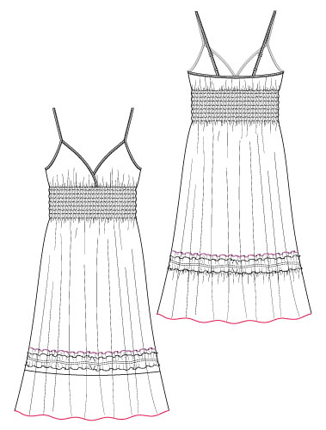
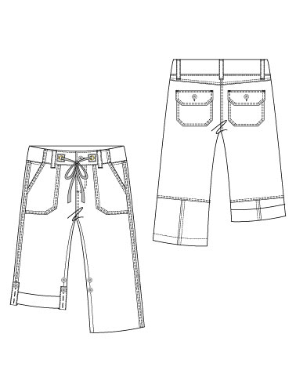
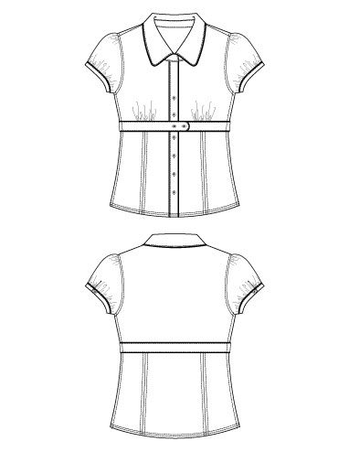
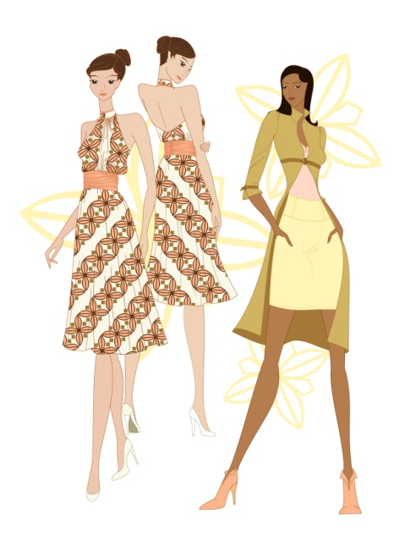
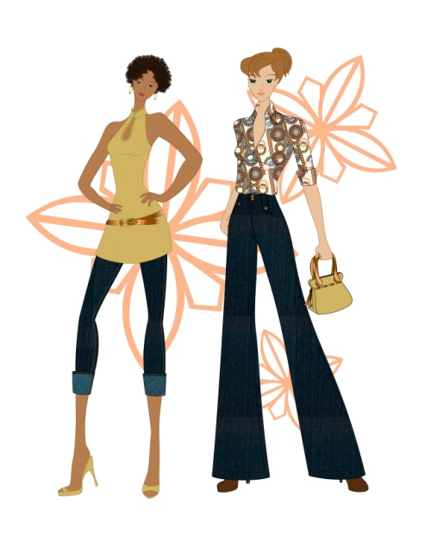
Illustration
outfit drawn on a model/croquis

Flats
showing other views

Pictures taken from: www.designersnexus.com

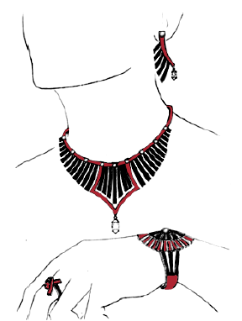
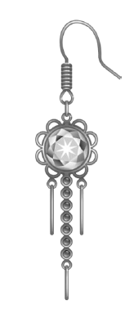
Jewelry Design – flats need to include technical aspects of a piece of jewelry including clasps, crimp beads, cord or wire, jump rings, etc.

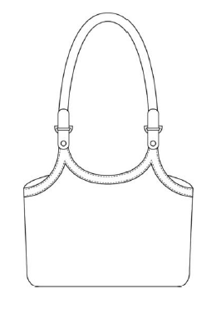
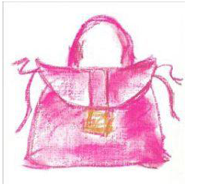
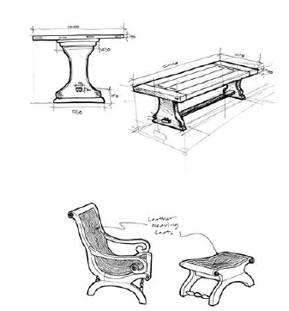
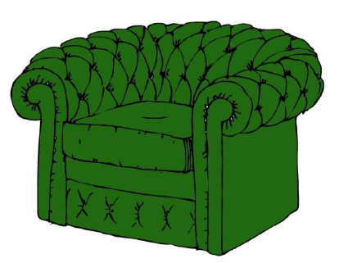
Non-wearable – can include details on construction materials and dimensions.

  - Titles/Labels – The title for the storyboard should be the same as the Design Brief: Inspired by Art.
    - A subtitle may be used for a more personalized name of the design. Labels may be included to enhance the storyboard or to clarify a point, but they will not be required.

  - Design Brief – Storyboards should follow the design brief and category descriptions.

- Texas 4-H Fashion Storyboard Website. For additional information and contest resources visit the website. http://texas4-h.tamu.edu/clothings-textiles#storyboard

D8 4-H FASHION STORYBOARD
Fashion Storyboard Label

This label should be cut out and affixed to the back of each storyboard. Label details must be neatly printed or typed. Label information should be COMPLETE!
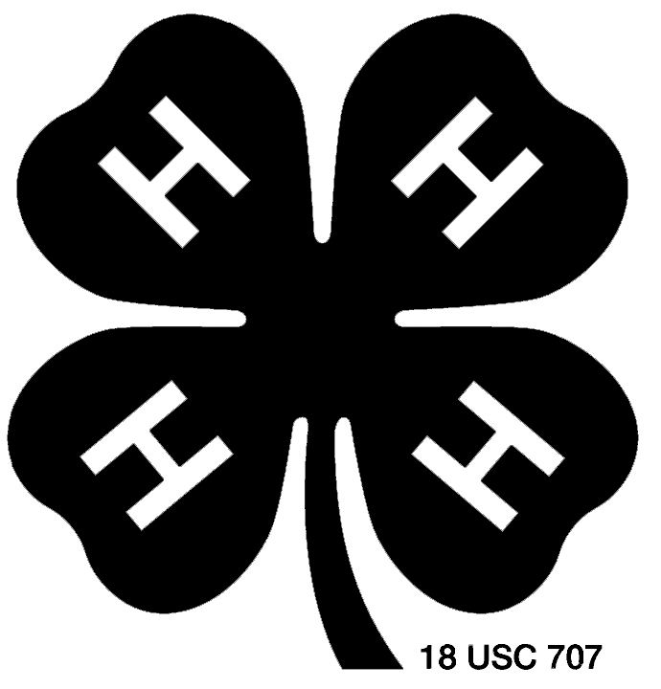
4-H FASHION STORYBOARD LABEL
Age Division (please check one): |  |  |  |  | □ |  | Junior |  |  |  | □ | Intermediate |  |  | □ | Senior
Category (please check one): |  |  |  | □ |  | Accessory |  |  | □ | Jewelry |  |  | □ | Non-wearable |  |  | □ |  | Pet Clothing |  |  | □ | Wearable
District:
County:
Name:
Birthday:
4-H Age (as of 8/31/14):
I do hereby consent and agree that Texas A&M AgriLife Extension Service, Texas 4-H Youth Development Program staff have permission to take photographs and/or record video and/or audio of me and/or my property and to use these for 4-H Youth Development educational, promotional, and/or marketing materials. I further do hereby give the right to exhibit any such works publicly or privately, including posting on the Texas 4-H Youth Development Program website. I waive any rights, claims, or interests I may have to control the use of my identity, the identity of the subject(s), or likeness in the photographs, video, or audio and agree that any uses described herein may be made without compensation or additional consideration. I represent that I have read and understand the foregoing statement, and I am competent to execute this agreement.
I have read and understand the foregoing statement, and I am competent to execute this agreement.
Name (please print):
Signature: |  |  |  |  |  |  |  |  |  |  |  |  |  |  |  |  |  |  |  | Date:
Parent/Guardian Name (please print):
Signature: |  |  |  |  |  |  |  |  |  |  |  |  |  |  |  |  |  |  |  | Date:
Agent Name:
Agent Signature:
Originality of Design
In 100 words or less, answer the following prompt in regards to originality:
Where did you get the idea for your design? What was your inspiration? What makes your design different from others on the market?

D8 4-H FASHION STORYBOARD
Fashion Storyboard Score Sheet

Fashion Storyboard Materials:
Can be found online at:
http://fcs.tamu.edu/clothing/4h/packet/index.php

Fashion Storyboard Score Sheet direct link:
http://fcs.tamu.edu/clothing/4h/packet/2015/19-2014-fashion-storyboard-score-sheet.pdf
D8 4-H FASHION STORYBOARD
Helpful Hints for Creating a Fashion Storyboard

Careful planning is essential to creating a professional presentation board. The list below is a general planning list to help in the creation of your storyboard.

Purpose | The purpose will be to create a storyboard of your original design based on the design brief.
Focus | Who would you market this design to?  What age?  What are their likes and interests?  How much would they (or their parents) be willing to spend?  How would you promote this product?
Creating an Original Design | Where did you get the idea for your design?  What was your inspiration?  What makes your design different from others on the market?  Think about the design elements and principles used in the design. How do you use those elements and principles to enhance the design?  What is your marketing plan?
Quantity | For this contest, you will be creating a single board.
Materials List | See the list on the following page.
Visual Elements | The visual elements that make up a professional board presentation fall into three basic categories: photographs/photocopies, fabric/trims, and figure/flat sketches.  Photographs/photocopies: Selecting the right visuals for boards containing mood/theme components is extremely important. Choosing photographs to coordinate with your fabric/color story creates a more aesthetic result and adds to the flow of the board.  Fabrics & trims: Fabrics and trims are a crucial part of the design process and must be displayed appropriately on your board. Whenever possible, trim fabric swatches to be the same size, with the exception of prints, which usually need to be larger to show the repeat of a pattern.  Illustrations and flats: Illustrations and flat sketches need to accurately show original design. An illustration is an outfit drawn on a model/croquis. Flats are working drawings that are not on a model/croquis that illustrate other views like you would find on a dressmaker’s pattern envelope. Like the old adage says, “a picture is worth a thousand words.”
Layout | The layout is the arrangement of all the elements that will be part of the presentation. The arrangement should be both logical and aesthetically pleasing. Most boards read left to right. Economize the space on the fashion board by overlapping your flats and other visuals. Haphazard or random arrangements can be confusing to the viewer.
Techniques and Technologies | The techniques and technologies used for creating presentation boards can vary on accessibility. Techniques can vary from cutting and pasting, handwork/ sketching and rendering, color copying, or computer-aided graphics.  Labeling: Mechanically generated for titling or labeling works best. There are many different lettering options.  Computer Design – Commercial design programs are available.  Create Dimension – When specific areas of a board need to be highlighted, an option includes mounting the item with an additional layer or layers of foam core on the main board.  Reproducing the Board – Because presentation boards are both fragile and cumbersome, some may prefer to have copies of their board printed. This is an expensive method (approximately $60 per board).

Basic Materials List:
- Mat board or foam core
- Approximately 20” x 30”
- Use magazine, Internet, or similar sources to obtain photos
  - Resize these photos as needed with a photocopy machine or computer for better layout.
  - They must be neat and creatively cut and presented.
  - 3-D mounting is good.
- Lettering
  - Make sure that the font/text goes well with the layout and is an appropriate size.
  - Transferable lettering, hand lettering is not recommended.
  - Check spelling.
  - Check alignment.
- Support Materials
  - Scissors and pinking shears for cutting paper and fabric swatches
  - Various adhesives
    - Rubber cement
    - Rubber cement pick-up
    - Removable adhesive glue stick
    - Remount repositionable adhesive
    - Adhesive transfer tape
  - Drawing pencils - used for a variety of sketching purposes; for both preliminary and finishing techniques, pencils are available in a variety of leads.
- Decorative papers in various colors and textures and fabric swatches
*This is a general list of supplies. Be sure to test the products before using them on your final product.

Other helpful tips:
- Avoid glue marks or fingerprints on your board.
- Pins/staples/tacks and tape are not recommended.
- Avoid a scrapbook look or science fair look.
- The background should support the theme and layout.
  - Consider colored boards, paper, or prints.
  - Glue down neatly and securely.
- Do not make your board too heavy or cumbersome.
- Make sure it is sturdy enough to travel.
- Determine your arrangement before you start to glue your designs on the board.

Transportation tips:
- If you are not transporting your board to a contest, provide the person transporting your storyboard a picture of the board and any supplies that they may need to repair any minor damage.
- Picture frame boxes can be purchased from any moving company.
- Large portfolio cases can be purchased to transport storyboards. Cost varies depending on the case that you select.
- Hanging garment bags make good storage containers for Fashion Storyboard.
D8 4-H TRASHION SHOW- DISTRICT AND STATE ONLY!!
Trashion Show Guidelines

- Purpose. The Trashion Show provides an opportunity for 4-H members to use their design skills to create and exhibit a recycled/reused garment created from items that would otherwise be thrown in the trash. It also recognizes 4-H members who do outstanding work in a clothing project.

- Overview. 4-H teams will submit a video application. All videos must be submitted by upload to YouTube by the deadline. For the District 8 4-H Trashion Show, a team of judges will evaluate the entries after submission. It will be a “video only” contest. There will be no interview.

This contest is for 4-H members who have a desire to turn trash into fashion, to create fun wearable garments from discarded material, and to recycle and repurpose “junk” into fabulous and fantastic fashion. Entrants are encouraged to let their imaginations go, be wildly inventive, and to “think outside of the recycle bin.”

- Age Groups. Two age groups will be offered for competition. Age groups are determined by a participant’s age as of August 31, 2014 as follows:
Division | Ages | Birth date between:
Junior | 8 years old and in 3rd grade or 9 - 10 years | Sept 1, 2003 – Aug 31, 2006
Intermediate/Senior | 11-18 years of age | Sept 1, 1995 – Aug 31, 2003

- Originality. Ideas and creations submitted for entry must be the original work of the submitting entrant(s).

- Entry Process & Forms. Submissions will include an online entry form and a video no longer than 6 minutes in length promoting their Trashion Fashion. Instructions on uploading a video to You Tube are available on the Texas 4-H website. Videos must be submitted by uploading to YouTube by the designated deadline. A direct link to the video must be provided when the team completes the entry form.

District entries (all age divisions) must be submitted on the District 8 4-H Trashion Show Entry Form (paper form) by the District deadline.

Intermediate and Senior 4-H members that plan to enter the Texas 4-H Trashion Show need to also be sure to enter their information on the online entry form by the state deadline of 5 pm on April 1, 2015.

- Recycled Materials. Fashions must be made from at least 75% recyclable or reused materials that would otherwise be thrown away or recycled. These fashions can include cardboard, steel/tin, recycled fabric or clothing, aluminum, plastics, paper cartons, chipboard, newspaper, mixed papers (magazines, junk mail, and catalogs), paper bags, and glass. Vintage or used clothing will not be accepted unless it has been significantly repurposed and redesigned into something substantially “new.”

- Durability. Contest pieces must be durable enough for wear through all contest levels of the Trashion Show.

- Design Team Members. Entries may include 1 to 4 people on their Trashion design team. Each entry must provide its own model. The model does not have to be a part of the design team.

- Accessories. Footwear, jewelry, purses, and other accessories may be used to enhance the overall costume.

- Environmental Factoid. Each Trashion design team must provide an “environmental factoid” that connects with your fashion. (i.e. “Angie’s dress is made of 138 sheets of paper. In the U.S., we throw away 4.5 million tons of office paper each year.)

- Disqualifications. If the Trashion Show Entry does not show to meet the eligibility requirements, the entry will be disqualified.

- Judging Criteria. During the video submission, design teams are encouraged to include at least the following items in their video:

  - An introduction of team members
  - Description of the process for creating your design
  - Description of the materials that your garment was constructed from
  - Description of how the outfit was constructed
  - Inspiration behind your creation
  - Environmental factoid
  - Include your Team Name on the Video (beginning and end) to help the judges and audience when voting.

4-H members’ presentation skills will also be taken into consideration during the judging process. It is the responsibility of the design team to make sure that their video is clear and understandable. The video should be narrated; video recordings without sounds or explanation will not be accepted for judging.

District 8 4-H Trashion Show judging is based on the 2015 Trashion Show Video Score Sheet. The Trashion Show Interview Score Sheet will not be utilized at the District 8 4-H Trashion Show.

- Judges Awards. Judges will consider awards for each of the following categories, if there are entries suitable to the award descriptions. Judges will not be required to present an award in each category.
  - Best Use of Recycled Materials
  - Best Design
  - Show Stopper – Best in Show

- Audience Choice Award. During the District 8 4-H Fashion Show, the Trashion Show videos will be on display. 4-H members, parents, volunteers, County Extension Agents, and others attending the Fashion Show will be able to vote on-site for the “Audience Choice” Award.

D8 4-H TRASHION SHOW
Trashion Show Entry Form

County
Age Division |  |  | Junior |  | Intermediate/Senior
Member #1 Name: |  |  |  |  | Date of Birth: |  |  |  | 4-H Age:
Member #2 Name: |  |  |  |  | Date of Birth: |  |  |  | 4-H Age:
Member #3 Name: |  |  |  |  | Date of Birth: |  |  |  | 4-H Age:
Member #4 Name: |  |  |  |  | Date of Birth: |  |  |  | 4-H Age:
Model’s Name: |  |  |  |  | Date of Birth: |  |  |  | 4-H Age:
Coach’s Name |  |  |  |  | Coach’s Email
Link to YouTube video:
When uploading your video to YouTube, be sure to select either “Public” or “Unlisted” for your privacy setting, otherwise your video will not be viewable by judges and will not be accepted.
Environmental Factoid:
Securely attach a head-to-toe photo of your model wearing your 4-H Trashion Show design. You may attach the photo or insert it electronically and print the form. The photo should be no larger than 4x6.
D8 4-H TRASHION SHOW
Trashion Show Video Score Sheet

Trashion Show Materials:
Can be found online at:
http://fcs.tamu.edu/clothing/4h/packet/index.php

Trashion Show Video Score Sheet:
http://fcs.tamu.edu/clothing/4h/packet/2015/13-2015-trashion-show-video-score-sheet.pdf

