Texas A&M AgriLife Extension





TEXAS PECAN PEST

MANAGEMENT NEWSLETTER

**Bill Ree, Extension Program Specialist II - IPM (Pecan) P.O. Box 2150, Bryan, TX 77806-2150 June 19, 2014 Ph: 979-845-6800 #14-5**

**Email:** [**w-ree@tamu.edu**](mailto:w-ree@tamu.edu)

**http://pecan.ipmPIPE.org**

**\*\*\*\*\*\*\*\*\*\*\*\*\*\*\*\*\*\*\*\*\*\*\*\*\*\*\*\*\*\*\*\*\*\*\*\***

**TEXAS PECAN GROWERS ASSOC.**

**4348 Carter Creek, Suite 101**

**Bryan, TX 77802**

**Ph: 979-846-3285**

**Fax: 979-846-1752**

**Email: pecans@tpga.org**

[**www.tpga.org**](http://www.tpga.org)

**\*\*\*\*\*\*\*\*\*\*\*\*\*\*\*\*\*\*\*\*\*\*\*\*\*\*\*\*\*\*\*\*\*\*\*\***

**GENERAL**

Scattered rains across the state have been a blessing but we will definitely need more over the course of the summer. I still see a good crop after PNC and some June drop but we still have a long way to go.

**INSECTS**

WALNUT CATERPILLAR: **ALERT**

Once again we are having/have had some localized severe outbreaks of walnut caterpillar. Well the horse is out of the barn on this one with the damage already done so the alert is going to be for the second generation in about 3 weeks.

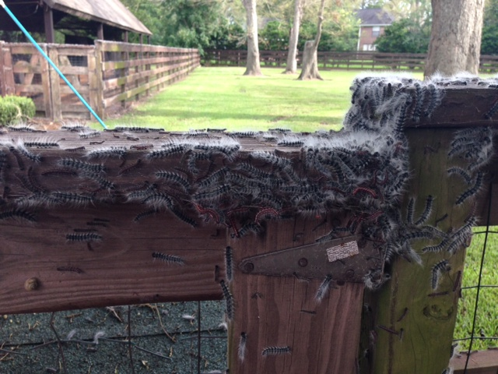

Figure 1. 5th instar walnut caterpillar larvae

The latest outbreak that I am aware of has been in the Richmond area of Fort Bend County.

Much of the defoliation observed was on old natives in residential areas and although nut production in this area is not important, these trees do have tremendous property value.

From my visit, a comment from one homeowner, who echoed the same comment from the neighbors, is “textbook” walnut caterpillar – “the trees looked fine when we left for the weekend and when we returned all the trees were defoliated”. When larvae reach the 5th and last instar, they are capable of consuming a tremendous amount of foliage in a very short time. Approximately 80 % of all foliage consume during the entire larval stage will occur in 3 days during the 5th instar and last instar.

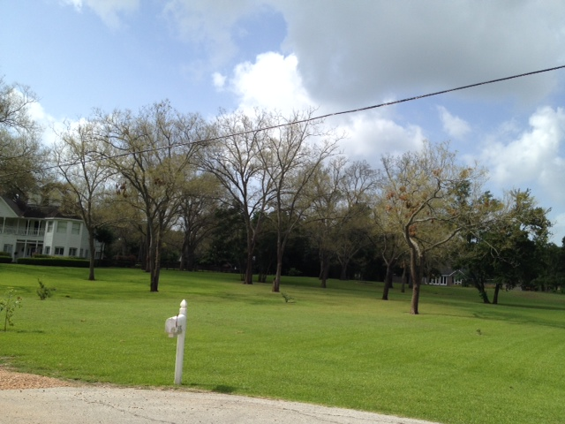

Figure 2 Defoliated trees in the Pecan Grove area of Richmond, TX

Although at this location this damage is primarily in a residential area, the lesson learned and the plan to help prevent future defoliations applies to homeowners as well as commercial producers. This lesson of “recognition of the early stages of an infestation” is import to help prevent this significant foliage loss.

Signs of the onset of an infestation that all producers should be aware of are: branch terminals with missing foliage; skeletonized leaflets (caused by 1st instar larvae); dropping (frass) on the orchard floor, sidewalks, driveways, vehicles and equipment and masses of cast skins or larvae in tree trunks or main scaffold limbs.

For control in the home and urban area I would lean toward spinosad and Bt. based products, because of their safety for early (1st – 4th) instars. For the 5th and last instar which has turned black with long white hairs, I would recommend a quick acting knock down treatment.

For commercial producers, the Lepidoptera specific products will do a good job as well as broad spectrum based pyrethroids or organophosphate product for late instars

It looks like this first generation is over and I expect the second generation to start in about 3 weeks. This is allowing 14 + day pupation time and 5 days pre-oviposition for females.

**Brown Marmorated Stink bug**: We are still on the watch for new introductions or infestations from this invasive stink bug. So far the only location were feral specimens have been collect has been from Corpus Christi. However, I have collected adults from a vehicle and a shipping container here in College Station last year and there has been a report from Leander, TX (North West of Austin in Travis County) here in 2014. This insect is a great hitchhiker on vehicles, RV’s, campers etc. so anyone taking a trip to the mid-Atlantic states this summer, be sure and check your vehicle and belongings before heading back. You just might have some stowaways.

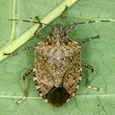

Figure 3 Adult Brown Marmorated Stink Bug

**Grasshoppers and June Bugs**: Several calls have come in over the past week concerning grasshopper and June bug activity on pecan. Feeding from this group can be more serious on young trees because of the smaller volume of canopy. If treatments are needed, then this should include the orchard floor and fence rows in order to create a barrier. Adults are migratory so this can be a season long battle.

**ORCHARD DEFINITIONS**

On an occasion a company will market the same active ingredient under two names with different registration sites. One example is Chlorantraniliprole which is marketed as Prevethon for forage, cotton, soybeans and it is also marketed as Altacor for pecans and assorted fruit. With grasshoppers being an issue and Prevethon being a popular treatment I asked TDA if Prevethon could be used on the orchard floor and the answer was NO. In some situations it is hard to define what an orchard is SO I have listed below the definition of an Orchard and Field according to according to TDA

Orchard - (or grove). A grouping of trees or shrubs arranged in rows to facilitate production efforts; or, a randomly spaced group of trees or shrubs of usually native origin. The boundaries of which extend to the outside perimeter of the drip line of the canopy on all sides of the area or the group.

Field - An area of land with or without a crop, defined on all sides by a change of vegetation type or by a man made or artificial structure (fence), natural barrier or road.

**STATE MEETINGS**

**June 19-20, 2014**

TriState ArkLaMiss Pecan Convention and Trade show, Alexandria, LA

Contact: Stephen Norman@ (318) 448-3139 or [pecans@rosaliepecans.com](mailto:pecans@rosaliepecans.com)

**July 13-16, 2014**

**Texas Pecan Growers Conference and Trade Show, Embassy Suites.**

**San Marcos, TX.**

**Contact: TPGA @979-846 -3285**

**August 29, 2014**

Arizona Pecan Growers Conference

Palo Verde Holiday Inn,

Tucson, AZ

Contact: Mike Kilby @ 520-403-4613 or [mkilby@cals.arizona.edu](mailto:mkilby@cals.arizona.edu)

**\*\*\*\*\*\*\*\*\*\*\*\*\*\*\*\*\*\*\*\*\*\*\*\*\*\*\*\*\*\*\*\*\*\***

**The information given herein is for educational purposes only. References to commercial products or trade names are made with the understanding that no endorsement by the Texas AgriLife Extension Service is implied.**

**Educational programs of the Texas A&M AgriLife Extension Service are open to all people without regard to race, color, religion, sex, national origin, age, disability, genetic information or veteran status.**

**The Texas A&M University System, U.S. Department of Agriculture, and the County Commissioners Courts of Texas Cooperating**

**\*\*\*\*\*\*\*\*\*\*\*\*\*\*\*\*\*\*\*\*\*\*\*\*\*\*\*\*\*\*\*\*\*\***