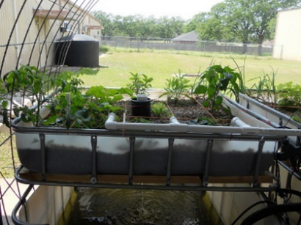
Aquaponics 101 Part 1:
An Introduction
Presented by Peter Woods, Texas A&M Extension Specialist

This workshop is intended to provide information to people interested in growing fish and vegetable/plants together in a closed system. Part 1 of this course will teach the terminology, system design, economics and some marketing ideas, while Part 2 will be a hands-on demonstration of how to build a simple system.

Part 1
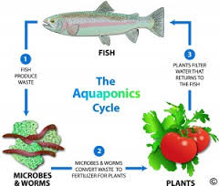
Wednesday, December 14 from 6-9 PM
Repeated
Thursday, December 15 from 9-noon
Part 2
Tuesday, January 10 from 9-noon
Comal County AgriLife Extension Office
325 Resource Dr.
New Braunfels, TX 78132
Hosted by: Troy Luepke,
Texas A&M AgriLife Extension Service CEA-Ag/NR
To RSVP call Janet Sweet at 830-620-3440
or email her at jlsweet@ag.tamu.edu.
Registration fee of $15 (cash/pers ck)is payable at the door

Texas A&M AgriLife Extension provides equal opportunities in its programs and employment to all persons, regardless of race, color, sex, religion, national origin, disability, age, genetic information, veteran status, sexual orientation, or gender identity. The Texas A&M University System, U.S. Department of Agriculture, and the County Commissioners Courts of Texas Cooperating.

Individuals with disabilities who require an auxiliary aid, service, or accommodation in order to participate in meetings are encouraged to contact the Texas A&M AgriLife Extension Service office at 830-620-3440 five days prior to the event so that appropriate arrangements can be made.

