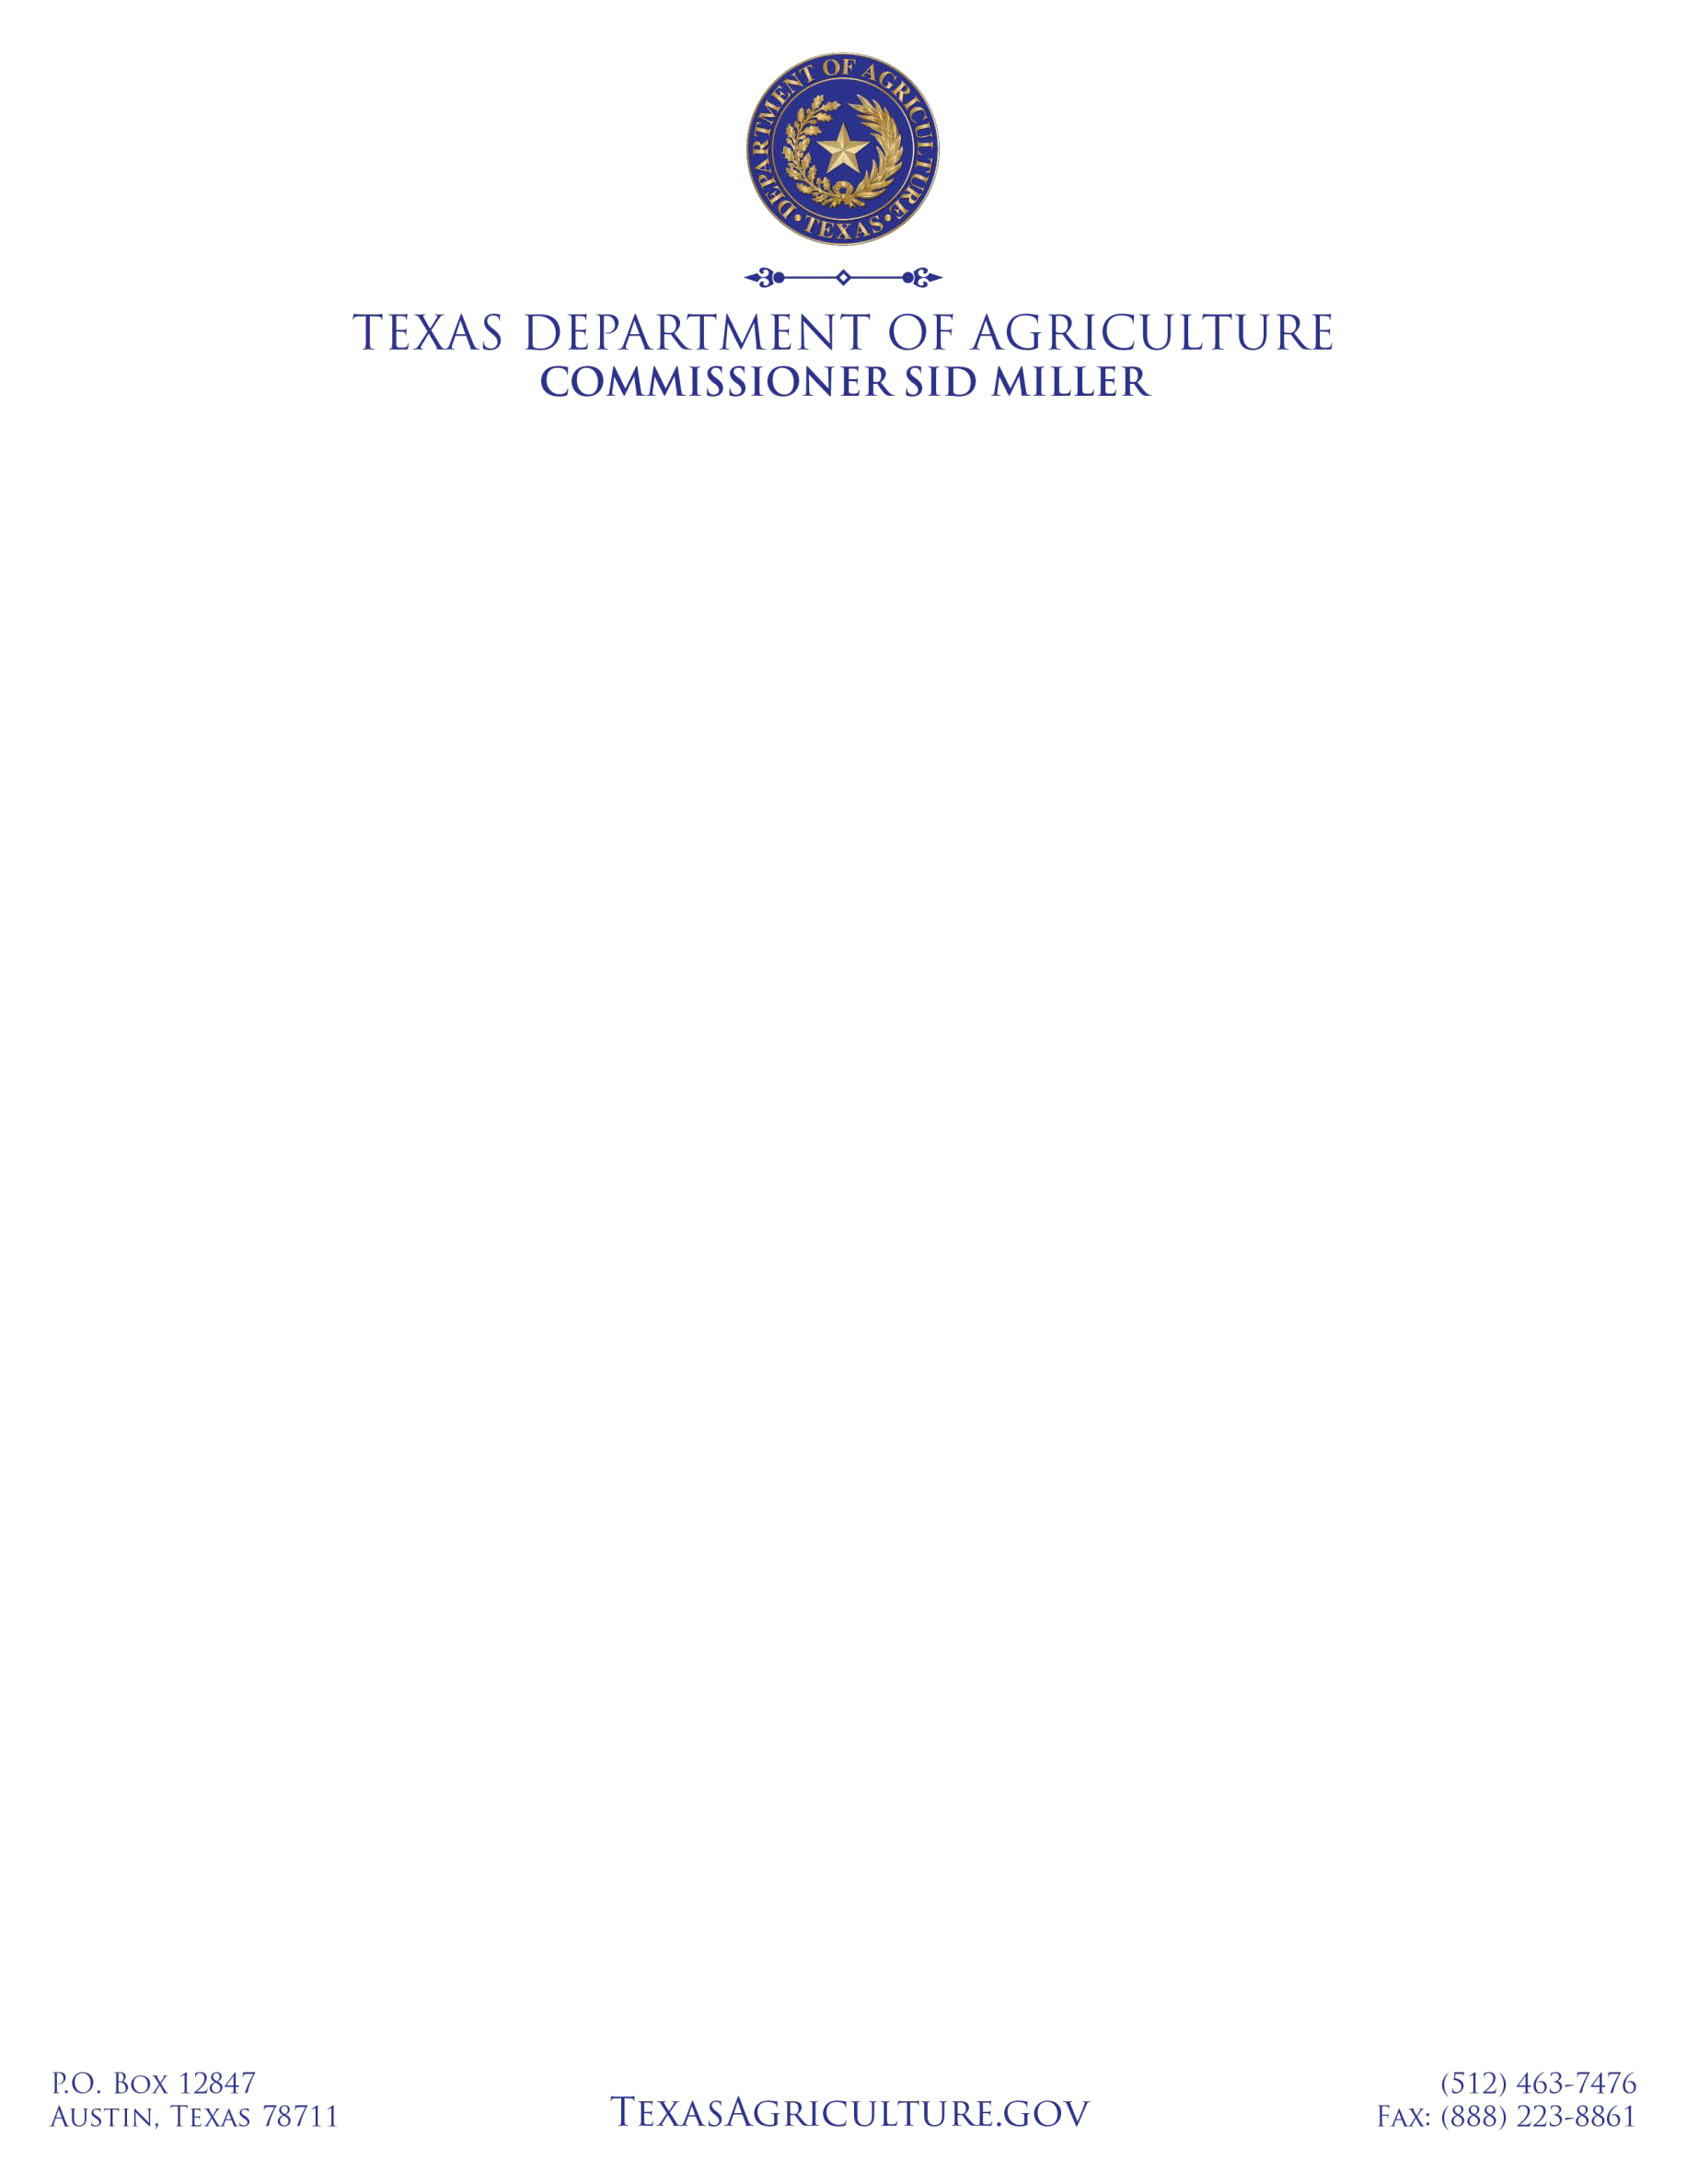

Structural Pest Control Certified Applicator CEU Course Provider and Technician Training Course Provider Update - 2023

The Texas Department of Agriculture (TDA) has proposed rule that CEU courses provided via webinar with a speaker presenting live and able to answer questions from attendees will be considered an in-person course. Applicants for this type of course must mark their CEU applications to indicate the course will be given via webinar. Applicants must also provide a link to join the webinar along with the course number to the department at least 72 hours prior to the webinar.

TDA will continue to enforce requirements for CAs to obtain their CEU’s for their respective license and categories each calendar year. CA’s must complete their calendar year 2022 CEU’s by 12/31/2022 and their 2023 CEU’s by 12/31/2023. Per 4 TAC § 7.134, self-study online CEUs may be used every other year to meet CEU requirements. Web-based interactive and live online courses as authorized by this notice are not considered self-study online courses.

INFORMATION FOR PROVIDERS OF CERTIFIED APPLICATOR CEU COURSES
Interactive and live courses that have received TDA approval for CEU credit may continue to be offered via-live web- based courses. These CEU courses must have the capability for the audience to ask questions and/or interact with the speaker. The Department must be notified at least 14 days ahead of time of any web-based interactive course and must be provided with web access to the course so that TDA may be able to monitor the course, should it choose to do so. The TDA will allow live web-based CEU courses to be given until such time as the proposed rules are adopted, which will allow live-web-based CEU courses to be considered in-person courses. Course providers are responsible for adhering to all other rules applicable to CEU courses such as establishing procedures for verification of completion, including accurately recording participant attendance records throughout the stated class length, and all other requirements outlined in applicable statutes or regulations.

INFORMATION FOR PROVIDERS OF TECHNICIAN TRAINING COURSES
The SPCS Advisory Committee approved a draft rule in October 2022 to allow for continuation of Technician Training Course via Webinar. TDA policy will allow for Technician Training course webinars, with required notifications and links provided, until the rule is proposed and eventually adopted.

TESTING
Testing is currently offered by the TDA’s third party testing company, PSI, LLC. PSI can be reached at their website, www.psiexams.com or 1-855-807-3998.

IMMEDIATE ASSISTANCE: Structural Pest Control Service. SPCS@TexasAgriculture.gov Phone: (512) 463-3207

