

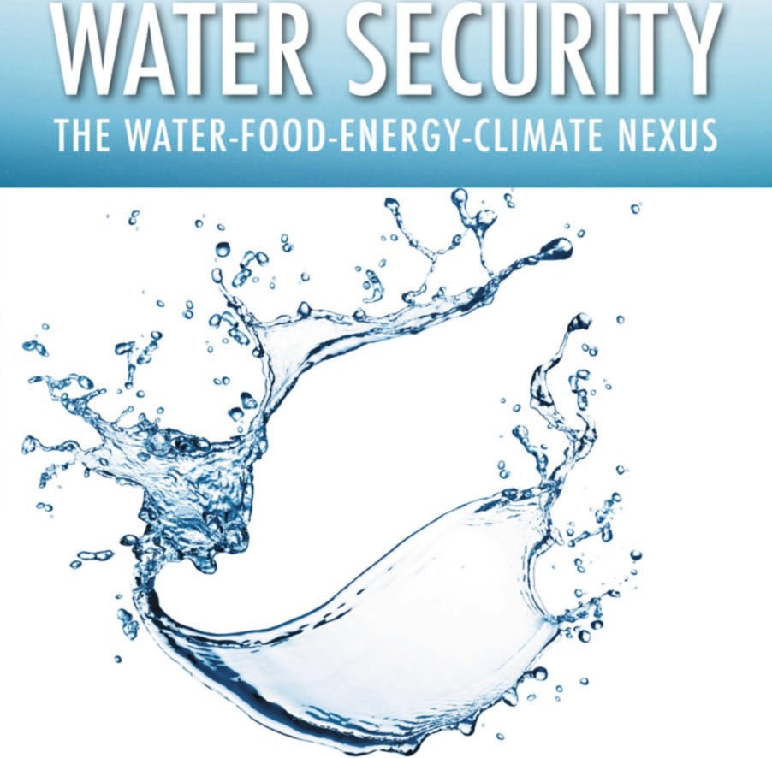

*The World Economic Forum Water Initiative*

# Water Security

### Water Security

##### The Water-Food-Energy-Climate Nexus

*“Water sits at the nexus of so many global issues . . . including health, hunger and economic growth. And sadly, water scarcity takes its greatest toll on society’s least fortunate. I am absolutely convinced that the only way to measurably and sustainably improve*

*this dire situation is through broad-scale collaborative efforts between government, industry, academia and other stakeholders around the world.”*

—Indra Nooyi,

Chairman and CEO of PepsiCo, Inc., Member of International Business Council, World Economic Forum

*“In 1911, John Muir observed how, ‘When we try to pick out anything by itself in nature, we find it hitched*

*to everything else in the Universe.’ A century later, a gathering of the World Economic Forum discovered the same phenomenon. Four hundred top decision-makers listed the myriad*

*looming threats to global stability, including famine, terrorism, inequality, disease, poverty, and climate change. Yet when we tried to address each diverse force, we found them all attached to one universal security risk: fresh water.”*

—Margaret Catley-Carlson, Patron, Global Water Partnership, 2008–2010 Chair of World Economic Forum Global Agenda Council

on Water Security

*“To make a difference on the water challenges we all face, governments, civil society and businesses must work together as never before. For business leaders in particular, we need to speak up, stand up and scale up our efforts on water sustainability.”*

—Muhtar Kent, Chairman and CEO, The Coca-Cola Company, Member of International

Business Council, World Economic Forum

*“Over the last few years, the scale and speed of response from a leading group of large companies to the water challenge has been impressive. As this book illustrates, their engagement*

*in partnerships with others to better understand how water works across the economy and how to manage water more efficiently as a result, can offer much potential.”*

—Professor Tony Allan, Kings College London, 2008 Recipient of the Stockholm Water

Prize, Member of the World Economic Forum Global Agenda Council on Water Security

This publication was prepared by the World Economic Forum Water Initiative to support the Industry Partnership Programme.

Dominic Waughray, Senior Director and Head of Environmental Initiatives at the World Economic Forum, led the development, collation, and editing of this publication, supported by

James G. Workman.

Industry Partners are select member companies of the World Economic Forum that are actively involved in the Forum’s

mission at the industry level.

Partnerships bring visibility and insight to strategic decision-making on the most important industry- and cross-industry-related issues and the

opportunity to engage in actions of global corporate citizenship.

*The Forum Industry Partners involved in the Water Initiative include*

CH2M HILL

Cisco Systems, Inc. The Coca-Cola

Company

The Dow Chemical Company

Halcrow Group Ltd.

Hindustan Construction Company Ltd.

McKinsey & Company

Nestlé SA PepsiCo, Inc.

Rio Tinto Group SABMiller plc Standard Chartered

Bank Syngenta AG Unilever

*With support from*

International Finance Corporation

Swiss Agency for Development and Cooperation United States Agency for International Development Water Resources Group

World Wide Fund for Nature

World Economic Forum Global Agenda Council on Water Security

*And project advisory support from*

McKinsey & Company

*Disclaimer*

The views expressed herein represent a collation of various viewpoints from participants in the World Economic Forum Water Initiative, the World Economic Forum Global Agenda Council on Water Security and viewpoints from other invited contributors. The text and the individual contributions do not necessarily reflect the views of every individual participant nor do they necessarily reflect

the individual institutional viewpoints of any of the participating companies, institutions or organizations, or the World Economic Forum.

**Water Security**

The Water-Food-Energy-Climate Nexus

The World Economic Forum Water Initiative



Washington | Covelo | London

Copyright © 2011 World Economic Forum

All rights reserved under International and Pan-American Copyright Conventions. No part of this book may be reproduced in any form or by any means without permission in writing from the publisher: Island Press, 1718 Connecticut Ave., NW, Suite 300, Washington, DC 20009.

ISLAND PRESS is a trademark of The Center for Resource Economics. Library of Congress Cataloging-in-Publication Data

Water security : the water-food-energy-climate nexus : the World Economic Forum water initiative / [edited by] Dominic Waughray.

p. cm.

Includes bibliographical references and index. ISBN-13: 978-1-59726-735-9 (cloth : alk. paper) ISBN-10: 1-59726-735-X (cloth : alk. paper) ISBN-13: 978-1-59726-736-6 (pbk. : alk. paper) ISBN-10: 1-59726-736-8 (pbk. : alk. paper)

1. Water supply—Management. 2. Water resources development—International cooperation. 3. Water supply—Risk assessment. 4. World Economic Forum.

I. Waughray, Dominic. HD1691.W365 2011

333.91—dc22 2010043396

Printed on recycled, acid-free paper 

Manufactured in the United States of America 10 9 8 7 6 5 4 3 2 1

**Contents**

*List of Illustrations xiii*

*Preface,* Richard Samans, Managing Director, World Economic Forum *xv*

Reproduction of Opening Remarks by the United Nations Secretary General Ban Ki-moon to the Session of the World Economic Forum Water Initiative at the Forum’s Annual Meeting in Davos, January 29, 2009 *xvii*

*Foreword,* Margaret Catley-Carlson, Patron, Global Water Partnership, Canada; Vice-Chair, World Economic Forum Global Agenda Council on Water Security *xix*

**Introduction**

The Water-Food-Energy-Climate Nexus: A Facts and Figures Overview 1

Background 17

Trends 20

Forecast 23

Implications 25

Chapter 1: **Agriculture** 17

The Way Forward 26 Perspectives 29

Responding to the Increase in Land and Water Demand to Guarantee Future

Food Security, *Pasquale Steduto, Chief, Water Development and Management Unit, Food and Agriculture Organization, United Nations, Rome* 30

Water Scarcity: Agriculture Provides Solutions, *Juan Gonzalez-Valero, Head of Public Policy and Partnerships, Syngenta AG, Switzerland; and Peleg Chevion, Head of Business Development Water, Syngenta AG, Switzerland* 33

Improving, Water, Food, and Climate Security: A Novel Approach to Direct Seeding of Rice, *Daniel Bena, Director of Sustainable Development, PepsiCo, Inc., United States* 35

Farmers Facing the Water Challenge, *Ajay Vashee, International Federation of Agricultural Producers* 36

Water Challenges in the Arabian Gulf, *Sir Mohammad Jaafar, Chairman and Managing Director, Kuwaiti Danish Dairy Company, Kuwait* 39

The High Cost of Priceless Water and Oman’s Ancient Alternative, *Peter*

*Brabeck-Letmathe, Chairman, Nestlé SA, Switzerland* 41

Background 44

Trends 45

Forecast 53

Implications 55

The Way Forward 57 Perspectives 58

Chapter 2: **Energy** 44

Water and Energy: New Thinking, *Peter Gleick, President and Cofounder, Pacific Institute, United States* 59

Burning Up Food as Fuel: The Role of Water, *Peter Brabeck-Letmathe, Chairman, Nestlé SA, Switzerland* 61

Choke Point: The Collision Between Water and Energy, *J. Carl Ganter, Managing Director, Circle of Blue, United States* 62

Solutions from the Sea, *The Dow Chemical Company, United States* 63

Background 68

Trends 72

Forecast 74

Implications 75

The Way Forward 76 Perspectives 77

Chapter 3: **Trade** 68

The Water-Trade Nexus, *James Bacchus, Chair, Global Trade and Investment Practice, Greenberg Traurig LLP; former member of United States House of Representatives and former Chairman of the Appellate Body of the World Trade Organization* 78

The Risks and Rewards of Water in Trade, *Stuart Orr, Freshwater Manager, World Wide Fund for Nature International, Gland, Switzerland; and Guy Pegram, World Wide Fund for Nature Adviser, South Africa* 80

Interlocking Crises of Water Scarcity: How Trade Can Make a Difference, *Herbert Oberhänsli, Head, Economics and International Relations, Nestlé SA, Switzerland* 82

Soft Approaches to Sustainable Intensification for Water Security, *Tony Allan, Professor and Head, King’s College London Water Research Group, United Kingdom* 84

Background 88

Trends 89

Forecast 92

Chapter 4: **National Security** 88

Implications 96

The Way Forward 97 Perspectives 99

Trans-boundary Waters and Geopolitics by 2025, *Claudia Sadoff, Lead Economist*

*and Team Leader, South Asia Water Initiative, World Bank, Nepal* 100 Hydro-solidarity as a National Security Foundation, *Patricia Wouters, Director,*

*UNESCO Centre for Water Law, Policy, and Science, University of Dundee, Scotland* 102

Water in the Arabian Gulf: How to Tell the Story?, *Francis Matthew, Editor at Large, Gulf News, Dubai, United Arab Emirates* 104

Land: A Question of Increasing Strategic Importance in Search of Better- Informed Answers, *Ralph Ashton, Convenor and Chair, Terrestrial Carbon Group, United Kingdom* 105

The Water–National Security Nexus: The Case of Pakistan, *John Briscoe, Gordon McKay Professor of the Practice of Environmental Engineering, Harvard University Schools of: Engineering and Applied Sciences; Public Health; and Kennedy School of Governance, United States* 107

Background 111

Trends 114

Forecast 115

Implications 116

The Way Forward 117 Perspectives 118

Chapter 5: **Cities** 111

A Socioeconomic Breakdown, *Arjun Thapan, Special Senior Adviser in*

*Infrastructure and Water, Asian Development Bank, Manila, Philippines* 119 Fatal Flooding in Modern Cities, *Richard Harpin, Senior Vice-President and Head*

*of Water Scarcity, Halcrow Group Ltd., United Kingdom* 121 Creating a Wastewater Revolution in Asian Cities: The Concept of

Cascading Use, *Margaret Catley-Carlson, Patron, Global Water Partnership; Member, United Nations Secretary-General’s Advisory Board on Water and Sanitation* 123

Social Enterprise Solution for Water and Sanitation Facilities in Kenya’s Slums,

*David Kuria, CEO and Founder, Ecotact, Kenya* 124

Urban Water Supply Security and Desalination, *Craig Fenton, Partner and Head of Water Sector Advisory Practice, PricewaterhouseCoopers LLP, Australia* 125

Background 131

Trends 132

Chapter 6: **People** 131

Forecast 134

Implications 135

The Way Forward 137 Perspectives 138

The Water Crisis Is Now, *Barbara Frost, Chief Executive, WaterAid* 139

Water for People: The Capacity Constraint of Governments Hinders Action, *Ajit Gulabchand, Chairman and Managing Director, Hindustan Construction Company Ltd.* 141

Free Access to the Water Nexus, *Thabo Makgoba, Anglican Archbishop of Southern Africa* 142

SaniShop: Transforming the Sanitation Crisis into a Massive Business Opportunity for All, *Jack Sim, Founder and Director, World Toilet Organization,*

*Singapore* 143

Background 148

Trends 149

Forecast 155

Implications 156

Chapter 7: **Business** 148

The Way Forward 157 Perspectives 158

Global Water Tool, *World Business Council for Sustainable Development, Geneva*

*Switzerland* 158

Water in the Value Chain, *Graham Mackay, Chief Executive, SABMiller plc, United Kingdom* 159

Water Resource Management and Sustainability, *Jeff Seabright, Vice-President, Environment and Water Resources, The Coca-Cola Company, United*

*States* 161

Appendix: A Snapshot of Business Water Leadership 164

Background 172

Trends 173

Forecast 179

Implications 180

Chapter 8: **Finance** 172

The Way Forward 181 Perspectives 182

Financing Water, *Usha Rao-Monari, Global Head of Water, Global Infrastructure*

*and Natural Resources Department, International Finance Corporation, United States* 183

Meeting the Water Challenge, *Alex Barrett, Global Head of Client Research, Standard Chartered Bank, United Kingdom* 186

Water, Agriculture, and the Pricing of Sustenance, *Stuart Orr, Freshwater Manager, World Wide Fund for Nature International, Gland, Switzerland; and Guy Pegram, World Wide Fund for Nature Adviser, South Africa* 186

Property Rights to Water for All, *David Zetland, Professor, University of California, Berkeley, United States* 187

An Example of Local-Level Water Market Innovation in Sonoma, California, *James G. Workman, Author and Cofounder, SmartMarkets, San Francisco, California, United States* 189

Background 193

Trends 195

Chapter 9: **Climate** 193

Forecast and Implications 196 The Way Forward 197 Perspectives 198

Glaciers, Water Security, and Asia’s Rivers, *Orville Schell,* [*Greater China*]

*Director, Center on US–China Relations The Asia Society, New York; Member, Global Agenda Council on Climate Change* 198

Combining the What and How of Building Climate Resilience: Water Ecosystems and Infrastructure, *Mark Smith, Head, International Union for Conservation of Nature Water Programme, Switzerland* 201

Chapter 10: **New Economic Frameworks for Decision-Making** 204

Background 205

Step 1: Identifying the Demand and Supply Gap through 2030 205

Step 2: How Can the Gaps between Supply and Demand Be Closed? 206 Step 3: What Technical Options for Supply and Water Productivity Exist to

Close the “Water Gap”? 207

The Way Forward: A Fact-Based Analysis as a Platform for Action 211 Perspectives 213

The Work of the Water Resources Group, *Herbert Oberhänsli, Head, Economics*

*and International Relations, Nestlé SA, Switzerland* 214

Water Portfolio Management, *Lee A. McIntire, Chairman and CEO, CH2M HILL; and Robert Bailey, President of the Water Group, CH2M HILL* 214

A “Cloud-to-Coast” Decision Framework, *Michael Norton, Managing Director, Water and Power Division, Halcrow Group Ltd.; and Roger Falconer, Halcrow Professor of Water Management, Cardiff University* 216

An Integrated Sustainability Index for Effective Water Policy, *Rabi H. Mohtar, Director, Global Engineering Program; Professor, Agricultural and Biological Engineering Department, Purdue University; Member, Global Agenda Council on Water Security* 217

Water Skin: A Global Multi-scale River Basin Decision-Support Framework for Collaborative Water Resource and Risk Management from the Planetary Skin Institute, *Juan Carlos Castilla-Rubio, President, Planetary Skin Institute;*

*Managing Director, Cisco Systems, Inc., Sustainability and Resources Innovation Group* 219

Chapter 11: **Innovative Water Partnerships** 225

Background 225

The Regional Platforms and Networks 226 An Evolving Process 230

The Way Forward 232

**Conclusion** 234

A Viewpoint from Jordan, *Ministry of Planning and Internatioinal Cooperation of Jordan* 237

So, How Will This Initiative Work? 239

*Acknowledgments 243*

### chapter 10

**New Economic Frameworks for Decision-Making**

*An Integrated Sustainability Index for Effective Water Policy*

Rabi H. Mohtar, Director, Global Engineering Program; Professor, Agricultural and Biological Engineering Department, Purdue

University; Member, Global Agenda Council on Water Security

The interlinkages of the water system with other systems, such as food, en- ergy, climate change, and the economy, must be explicitly defined to enable the exact quantification of those relationships. This will then allow for com- prehensive, integrated management systems to emerge. For example, devel- opment of a “water value” for all sources of water (sea, surface fresh, deep aquifer, recycled water, etc.) to feed into such a system would include the cost associated with transporting the water to a specific destination for a certain need; it would also consider the environmental quality associated with the use of this specific water, such as long-term soil quality, pollution risk, and so forth.

Even though specific metrics exist that can address the status and progress of water resources, a wider benchmarking tool that can address multidimen- sional water systems and their interrelations to food, energy, and other closely related systems is yet to be established. Water data attributes identified in rela- tion to these interlinkages and their multi-scale processes are needed. These attributes should include, but not be limited to: water values, water pricing, water laws, environmental impacts, energy impacts, food security, ecological impacts, biodiversity, and air, soil, and water quality.

As we explore the architecture and the implementation possibilities of such an interlinked water system (perhaps better described as an integrated sus- tainability index for effective water policy), various types of data will help us to connect and define the interface between its separate components. These data types include system *input data*, such as weather/climate with its spatial

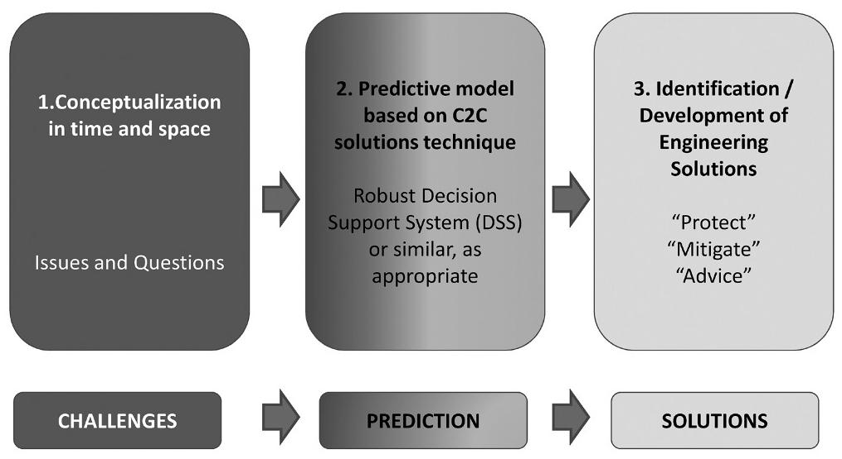

Figure 10.5 Cloud-to-Coast framework

and temporal variability in the short and long term; *system* data, such as soils, land use, geomorphology, socioeconomics, land management and tenure, governance system, social structure, indigenous knowledge, and the like; and system *output data*/*indicators*, such as the robustness of the system, the well- being of people being served, and the implications on food security, health, energy security, and so forth. Likewise, the development of an early warning system will also require system input and system parameters data; and for system sensitivities and evaluation, system output data are needed. A critical issue here is the quality of data, the standards/format, and their accessibility. Figure 10.6 is a simplified system for the elements of sustainability and includes explicit interlinkages. This system can be a starting point towards

sustainable water-food-energy systems.

It can be seen that a comprehensive, interlinked water security strategy will be complex and difficult to achieve. It can be attempted, however, using the perspective identified above, and based on relatively simple principles that focus on:

* + - multi-scale dimensions
    - metrics that are easily obtained
    - achievable benchmarking targets.

To obtain the data to underpin the activities, a *water knowledge virtual hub* that can integrate new and existing knowledge (from research centers, universities,

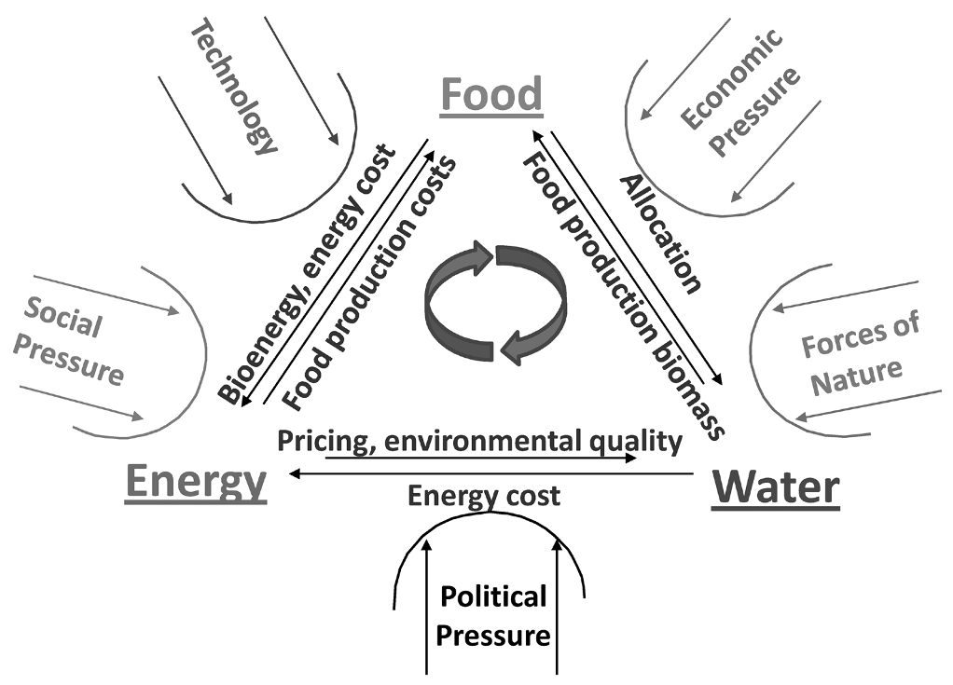

Figure 10.6 Energy-Food-Natural Resources Continuum: System Challenge

industrial and private patents), as well as effective rural community indige- nous knowledge, is a good starting place. As well as developing a suite of water knowledge hubs (domestically or regionally) to help pool and sift intercon- nected data, a comprehensive state-of-the-art model design exercise should be explored to identify the various areas in interlinked water-food-energy policy- making, where these tools/frameworks can be of most help.

*Water Skin: A Global Multi-scale River Basin Decision-Support Framework for Collaborative Water Resource and Risk Management from the Planetary Skin Institute*

Juan Carlos Castilla-Rubio, President, Planetary Skin Institute; Managing Director, Cisco Systems Sustainability and Resources Innovation Group

Two powerful trends are reshaping the world. The first trend is *resource scarcity*, the result of explosive demand growth for resources (water, energy, food, land,

etc.) driven by growing populations and economic development. The second trend is *data abundance,* driven by huge but siloed data sets and increasing information processing capabilities, space-to-ground sensor networks, and emerging information and communication technologies.

Planetary Skin Institute (PSI) aims to address the challenge posed by the first trend with the opportunity presented by the second. In March 2009, Cisco and NASA agreed a multiyear R & D public private partnership to pool their capabilities and assets in a partnership based on joint and open innova- tion. Cisco has embedded the fruits of this partnership in the PSI, which was named one of *Time* magazine’s “Top 50 Inventions of 2009.”4 PSI is a unique R&D partnership between leading corporations, government agencies, and research institutions around the world.

PSI’s nonprofit status is intended to facilitate cooperation across institu- tional, disciplinary, and national boundaries and to create a space for flexible pooling of assets, capabilities, and ideas among stakeholders. PSI has recruited a global advisory council consisting of thought leaders in science, technology, economics, and innovation to guide this work.

PSI is currently working with selected corporate, government, and aca- demic partners in the US, EU, India, and Brazil to build working prototypes of resource and risk management *decision-support tools* that have the potential to increase food, water, and energy security and protect ecosystems such as tropical forests. These include the utilization of satellite data to analyse land use change and estimate greenhouse gas emissions; integration of sensor data and analytics to identify cost-effective pathways to significantly increase re- newable energy and energy efficiency adoption; and the use of satellite sen- sors, mobile networks, and analytic models to support smallholder agriculture productivity enhancement and accelerate crop insurance. A water component of this work is also under way.

Water Skin

The challenges facing the world’s water resources have been addressed in de- tail in this book. Yet society’s ability to manage these challenges is impaired by seemingly intractable informational, political, economic, and institutional challenges. Decision-makers need substantially more data and analytic support to reconcile water demands at local and regional levels and to build consensus among users for adaptive water resource and risk management. But data at appropriate spatial (i.e., subbasin) and temporal (e.g., seasonal) resolution are uncommon. More flexible, adaptable, and integrated decision-support tools are also required to reflect the highly localized and cross-disciplinary chal- lenges of water resource management. Consequently, and recognizing that every watershed faces unique challenges, some subset of the following five

capabilities will likely need to be built in order to create an overall supporting “skin” for water resource decision-making in any given location.

1. *Systems modeling*. How does the hydrology of the system work today? What are the major sources and the dynamics of supply and demand across all stock and flow categories, and how do they interact with natural features of the environment?
2. *Change modeling*. How are the mean and variance characteristics of supply and demand likely to change under various economic and climatic scenarios? What are the implications from the increasing frequency of weather extremes in the short term? What are the implications for risk prevention, mitigation, and transfer?
3. *Infrastructure optimization*. What infrastructure choices are available to manage change, and what trade-offs do they imply for the welfare of various stakeholders, including both economic and environmental considerations? What are the right infrastructure build-out linkages and sequencing decisions? What are the optimal demand-side infrastructural choices? How to optimize these choices for a systemic view of the water-food-energy-climate nexus?
4. *Policy optimization*. What policy choices (e.g., adaptive resource allocation) are available to manage change, and what trade-offs do they imply for the welfare of various stakeholders, including both economic and environmental considerations? What is the policy trade- off, for example, for homegrown production versus trade, and in terms of optimal crop choices for the environment?
5. *Ecosystem management*. Where are the different sources of ecosystem damage (pollution) in the water system, and how can policy-makers attribute responsibility to different stakeholders under a regulatory or market-based approach?

Managing Water, Food, and Energy Interdependencies

Unlocking humanity’s ability to manage water resources will require, among other things, advanced decision-support capabilities that provide a shared ana- lytic and technical basis for cooperation. The Water Skin R&D program aims to engineer new decision-support capabilities that draw upon innovations in the sensing, the analytic and the collaboration layers to create the groundwork for integrated and adaptive water resource and risk management:

* + Innovations in the *sensing layer* are designed to leverage integrated configurations of ground-, people-, airborne-, and satellite-based technologies to monitor the state of land, catchments, rivers, defenses

and vulnerable areas in near real time. A common problem in resource management is the absence of data at temporal and spatial resolutions detailed enough to guide decision-making of both surface and underground water levels. Another has to do with data sharing across local and international boundaries. Water Skin will test innovations

in targeted low-cost sensor data from a variety of platforms (e.g., *in situ*, wireless water quality sensors, satellite sensing, UAV sensing) to evaluate their potential contribution to better decision-making.

* + Innovations in the *analytics layer* are designed to integrate and analyze data in the sensor layer to draw inferences that are useful to end users, enabled by a cloud-based compute and open modeling capability. The analytics layer will include cross-disciplinary analytic and modeling capabilities to support decisions in water resource management that require analyzing issues from a range of perspectives (e.g., decision- support systems to optimize water (re)allocation strategies; reservoir and water transport management; hydropower systems; energy generation strategies; demand-side management for devising short- term crop-planting strategies, for informing crop-choice optimization decisions, and for precision farming in agriculture, among others). Other examples in water risk management include early warning systems for floods and droughts to assess, for example, the reliability of flood infrastructure, to improve evacuation strategies, and to develop model-driven management strategies to predict and minimize the impacts of flooding and drought.
  + Innovations in the *collaboration layer* are designed to provide meaningful, value-added and collaborative interfaces with local context for a myriad of end users and decision-makers in the public and private sectors and in local communities. Innovations in this space include advances in user interfaces, immersive geospatial visualization environments, collaboration capabilities, and end uses themselves (i.e., the creation and support of ecosystem market infrastructure).

Assessing the multiple risks that water shortages will create requires infor- mation integration across multiple disciplines and domains (e.g., economics, weather, hydrology, energy systems, crop-systems risk modeling), scenario- based and geo-spatially explicit modeling and analysis tools, and the ability to characterize information in terms of risk distributions and mitigation mea- sures. PSI is designed to address these challenges.

Consequently, the Water Skin is just one component of a broader set of sensing, analytic, and collaboration capabilities under the PSI decision- support framework and platform. This allows for the Water Skin to interface

natively with other PSI Energy, Agri-food, and Forestry resource decision- support management and risk systems to better understand the complex interactions, particularly the dynamic risk characteristics, and spatial dimen- sions of this interconnected challenge.

Currently, only rudimentary insights exist on when and where interlinked problems are likely to materialize, and under what assumptions and scenarios. Most analytic approaches to date are static, lack geo-spatial resolution, and do not incorporate effective risk analyses. But these features are precisely the capabilities that policy-makers, communities, businesses, investors, and asset operators need in order to make better resource allocation and risk manage- ment decisions.

When fully developed, the Water Skin will provide an immersive infor- mation-rich platform to better understand and model the complex interre- lationships between energy, water, land, agriculture, and other resources. In particular, the Water Skin decision-support platform, with a focus on the global public good, will be structured to allow open access and interoper- ability to specific areas of the platform by a broader set of cross-disciplinary experts across the public, private, and research sectors. Open data exchange standards will be published to allow research and development communities globally to integrate and access data and decision-support capabilities through Water Skin user collaboration inter-faces.

The Journey Ahead

The ambition is that a Water Skin R & D consortium of leading corporations, governments, space agencies, NGOs, foundations, and research academic in- stitutions codevelops new technical and institutional capabilities in the next three to five years that will substantially advance the ability of decision-makers in both water resource and risk management to meet changing needs in an environmentally sustainable and equitable fashion. Our plan is to prototype a next-generation set of capabilities for water resource managers and experts that can be replicated and scaled globally. By developing and testing innova- tions in sensing, analytics, and collaboration layers in several high-priority river basins of the world, Water Skin will demonstrate the art of the possible, yield significant benefits for participating communities, and generate a new set of research and development questions to be addressed iteratively over time.

#### Notes

1. World Economic Forum Water Initiative, *The Bubble Is Close to Bursting*, 2009.
2. <http://www.mckinsey.com/App_Media/Reports/Water/Charting_Our_Water_> Future_Full_Report_001.pdf
3. Global Water Partnership/Technical Advisory Committee, “Integrated Wa- ter Resources Management—at a Glance.” [http://www.gwp.org/Global/The%20](http://www.gwp.org/Global/The) Challenge/Resource%20material/IWRM%20at%20a%20glance.pdf
4. *Time*, “The 50 Best Inventions of 2009.” <http://www.time.com/time/specials/>

packages/completelist/0,

World Economic Forum, Geneva, October 2010