Dallas County Food Challenge January 21, 2016 / 8:00 AM
Junior and Intermediate Scorecard-Presentation
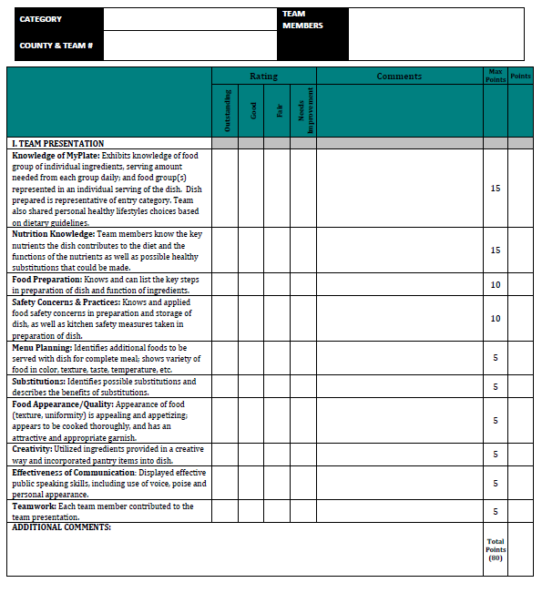

Dallas County Food Challenge January 21, 2016 / 8:00 AM
Junior and Intermediate Food Challenge Worksheet
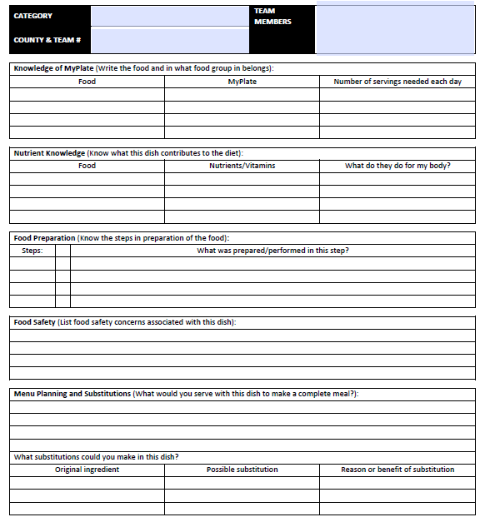

Dallas County Food Show January 21, 2016 / 12:30 PM
Senior Food Show Worksheet

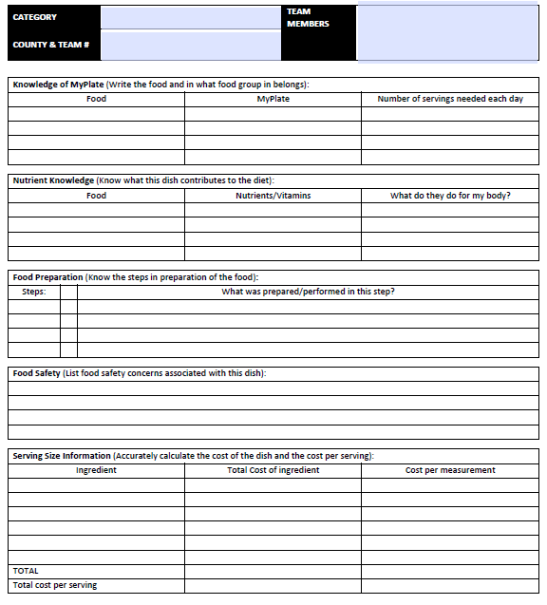
Dallas County Food Show January 21, 2016 / 12:30 PM
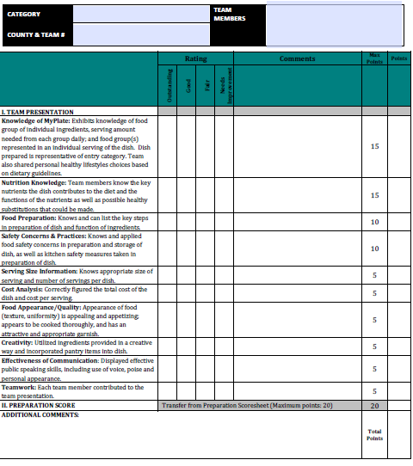
Senior Food Challenge Score Card

