SAMPLE

NEW EMPLOYEE PACKET

- Sample Welcome Letter to New Employee p. 3

- “Next Steps” for new employee p. 4

- Helpful phone numbers and websites p. 4

- Payday Schedule – biweekly & monthly
https://agrilifeas.tamu.edu/documents/pay-schedule-biweekly-fy18.pdf
https://agrilifeas.tamu.edu/documents/pay-schedule-monthly-fy18.pdf

- Holiday Schedule
http://agrilifeas.tamu.edu/hr/benefits-retirement/holiday-schedules/

- Things to know about insurance coverage p. 5

- Employee Benefits Guide 2017-2018
http://assets.system.tamus.edu/files/benefits/pdf/ae/FY18/booklets/BenefitsGuide.pdf

- Brochure – Travel Assistance Services (Minnesota Life)
http://assets.system.tamus.edu/files/benefits/pdf/travelassistanceredpoint.pdf

- Brochure – Employee Assistance Program
https://agrilifeas.tamu.edu/hr/about-us/eap/

Provide specific information about your unit

Suggestions:

- Unit web page – provide link

- Organizational Chart of your Unit

- Your Unit Contacts or Directory/Names and phone numbers

- Map of Your Location/Campus map

- Email Link to Agency/College Checklist or refer new hire to website http://agrilife.org/onboarding/

(Campus-based units)
- What is CODE MAROON? p. 6

[letterhead]

Dear (fill in the name),

Texas A&M AgriLife (fill in the unit/agency) would like to take this opportunity to welcome you to your position as (fill in job title). We are confident that, as a new employee, you will find many opportunities to grow and develop both professionally and personally in your new position.

We hope that your first day finds you well and excited to learn all about your new duties and responsibilities. We have enclosed some key information in hopes that it will help make your transition smoother and provide the necessary tools to get you started in your new role.

We anticipate that your full integration into (unit/agency) will take some time so please know we are here to be a resource for you.

Again, we welcome you and thank you for joining our staff.

Sincerely,

Next Steps…

What Where

Aggie Card GSC
Complete training SSO
Enroll in benefits WorkDay

Helpful Phone Numbers & Websites

Human Resources (979) 845-2423
First Call (979) 985-5737

Single Sign On http://sso.tamus.edu
First Call http://first-call.tamu.edu/
AgriLife Admin Services http://agrilifeas.tamu.edu
Contact Directory http://agrilifeas.tamu.edu/contacts/index.php
Benefits & Retirement http://agrilifeas.tamu.edu/hr/benefits-retirement/
Payroll http://agrilifeas.tamu.edu/hr/payroll/index.php
Rules & Procedures http://agrilifeas.tamu.edu/rules-procedures/index.php

THINGS TO KNOW ABOUT INSURANCE COVERAGE
State Contribution
The state makes a significant contribution toward your health insurance coverage. All new Employees are eligible for this state contribution the first of the month following their 60th day of employment, referred to as a 60-day waiting period or state contribution eligibility date. New employees will receive the state's contribution whether they select employee-only coverage or other coverage options such as employee plus family. Part-time employees will receive ½ of the state's contribution. The premiums are listed in the New Employee Benefit Guide Booklet. See below for the State Contribution Chart.

*Employees are allowed to start insurance coverage before the state contribution – they will pay the full premium (employer + employee portion) for those months.

Payroll Deductions
If you are paid monthly, the premiums deducted from your paycheck are for the previous month's coverage. If you are paid bi-weekly, ½ of your monthly premium is deducted from each paycheck to pay for coverage in the current month.

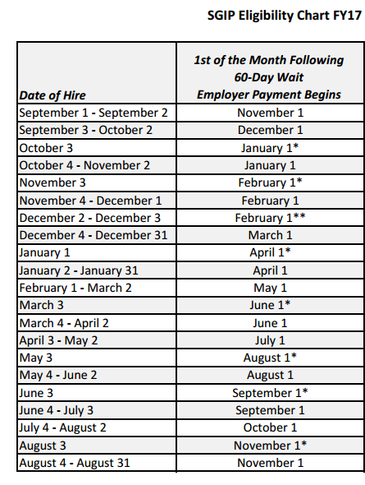

Texas A&M University
Code Maroon Emergency Notification System
Code Maroon is Texas A&M University's emergency notification system that gives the University the ability to communicate health and safety information in an emergency.
Recent Presentation about Code Maroon
Texas A&M will use the system only to provide official notification of critical emergencies (i.e. situations that pose an imminent, physical threat to the community).

Sign Up
- Campus Members
- Public Access

Emergency Alerts
Code Maroon uses multiple notification methods in a best effort to reach campus members in an emergency. While no emergency communications system can be guaranteed to be effective and reliable in every situation, you are encouraged to sign up to receive text message alerts as one part of your personal emergency preparedness plan.
Contact information you provide on the Code Maroon website will only be used for delivering health and safety emergency information. A ZERO SPAM policy is strictly enforced that prohibits unsolicited messages and the selling of contact information to third-party marketers.

Code Maroon Vendor
Texas A&M selected AtHoc, Inc. to provide its campus-wide emergency alert system. AtHoc's system uses a single, integrated system to send alerts.
Texas A&M's goal is to reach as many people as possible in an emergency and AtHoc provides the most robust system. AtHoc is based in San Mateo, California, and is at the forefront of mass notification systems.

Code Maroon Deletion Policy
In order to ensure that Code Maroon alerts are delivered as quickly and efficiently as possible, periodic checks are done to identify registrants who are no longer directly affiliated with Texas A&M University.
If our records indicate that a registrant is no longer a member of the student body or employed by the university, Code Maroon will send an email notice to the email address they provided during registration. Unless a justification is provided to that email within 15 days, the registrant will be scheduled for deletion from the Code Maroon system.

https://codemaroon.tamu.edu/About.aspx

