**The Relationship between Hotel Financial Performance, IT Spending and IT “Value”**

Hilary Catherine Murphy  
Ecole Hoteliere de Lausanne, Switzerland  
hilary.murphy@ehl.ch

**Abstract**

This research note examines the relationship between hotel revenues and IT spend and explores the concept of IT value by linking explicit financial data to IT spend at property level. A quantitative method is employed, with an online questionnaire completed by 150 hotel properties. Results show a relationship between IT spend and gross revenues and that IT value is high, at least compared to other sectors.

**Keywords:** Hotel property, IT spend, IT value

# Introduction

Information technology (IT) is critical to all business sectors in term of customer services, financial cost control, and strategic planning (Laudon & Laudon, 2010). Sunny et al. (2005) established the relationship between IT investments and performance improvements in the hotel sector at five levels; enhanced annual sales, reduced operating costs, increased occupancy rate, greater level of repeat business, and enhanced positive word of mouth and identifies a significant positive impact on performance in all but guest-related interface applications. This paper specifically examines IT “value” and the relationship between IT spend and financial performance.

# Literature Review

Proving a link between IT investments and business performance has been a nearly impossible challenge for organizations, particularly at the property level. “However, despite unclear causality, on an industry level there appear to be interesting relationships between the level of investment and the operating profits of organizations… many organizations with high operating margins also have high IT spending as a percentage of revenue. This view should not imply that, by investing more in IT, an organization should expect to get better profitability, rather, it should simply outline how different industries behave under varied economic conditions.” (Gartner, 2012, p29). What is clear is that financial return is not the only performance indicator and cannot be the only “benefit” from IT investment and we should consider “IT Value” (Gartner, 2012). Gartner further defines “IT Value” as, IT spending as a percentage of Gross Operating Revenue (GOR) versus Operating Margin.

Justifying investment in technology and whether it improves performance has long been an issue for hotel properties, companies and groups (Gil-Padilla et al., 2008). This is further exacerbated by the contentious issue of the “productivity paradox” where gains through IT investment are deemed hard to quantify. However, Devaraj & Kohli (2003) in their study, using a sample of hospitals, identified the “actual usage” of technology as a significant factor and they showed a positive and significant relationship between technology usage and revenue and other quality measures. Marchand (2005) confirms that 25% of the business value of IT lies within the deployment and investment whereas 75% of the business value is in fact in factors related to the usage of the information. In the hotel sector, Law et al. (2013) make the case “to allocate sufficient budget to provide ongoing training on the latest IT developments for staff at all organizational levels, ranging from operational to strategic” (p19). They encourage further research to investigate what they term as “overall IT proficiency”, an area which researchers have failed to explore, so far, mostly as a result of lack of access to explicit financial data IT Budget (Law & Leung, 2013).

Thus, this paper investigates the role of “IT value” by linking explicit financial data to IT spend at property level and explores the relationship between hotel revenues and IT spend and addresses the research questions; 1. Do hotels’ financial performance increase with IT investment and 2. How do we measure “value” from IT investments?

# Methodology

The method used is quantitative with an online questionnaire used to collect the data. This was emailed to 500 hotels and completed by 150 hotels (30% response rate).The population under examination is mid and upper-scale hotels in Europe, Middle East and Africa (EMEA) and the data reported are for financial year 2011, as submitted in May 2012. Through a series of interviews with IT leaders in the hospitality sector, the questionnaire was designed and validated by both these professionals and academics and consisted of 18 questions focusing on demographic data, financial performance indicators, i.e. GOR, GOP, EBITDA ADR, occupancy, and IT metrics, i.e. TOTAL, CAPEX and OPEX spending. Preliminary results for 2012 are published in this paper and some figures for Asia are included in regional breakdowns.

# Results

As seen in Figure 1, the overall average % of IT / GOR 1.83%. A statistically significant linear relationship has been obtained between IT spend and revenues through regression analysis (R-square=54.5%, coefficient=41.3 with a p-value of 0%). The Kruskal-Wallis test (as normality and homogenous variances assumptions were not met for ANOVA) between the IT spend quartiles and the hotel revenues reveals a statistically significant difference between the average revenues for each IT spend quartile (p-value = 0%) in Figure 3.



**Fig. 1.** IT Spend as % of Key Financial Performance Indicators

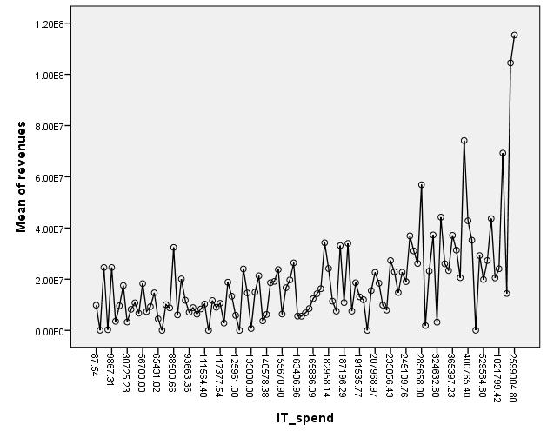

**Fig. 2.** Change in Hotel Revenues vs. IT Spend

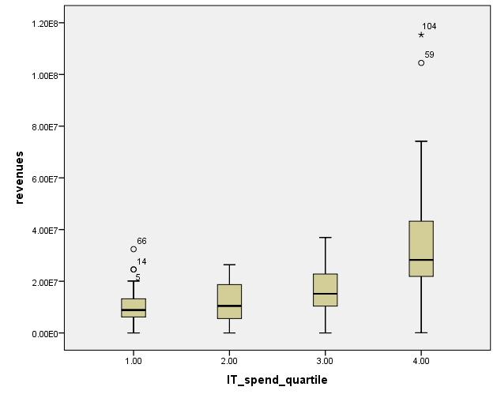

Quartiles for IT Spend:

1 = ≤100,000

2 = 100,000 – 165,000

3 = 165,000 – 275,000

4 = >275,000

**Fig. 3.** Box Plot of Hotel Revenues vs. IT Spend Quartiles

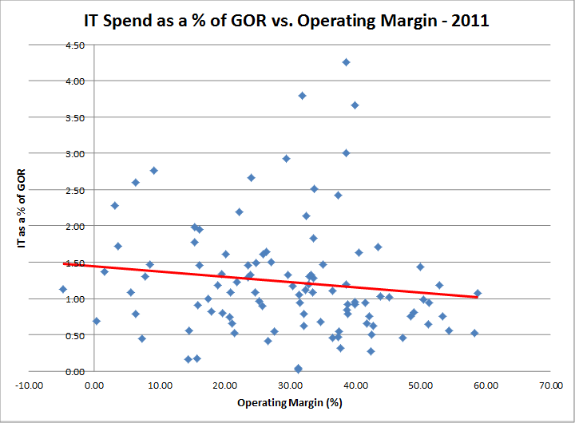

**Fig. 4.** IT VALUE (as measured % of GOR plotted against Operating Margin, Gartner metric, 2012)

# Conclusions, implications and limitations

This paper endeavours to launch and enrich the discussion in this domain by probing the role of IT and examining it’s contribution to property performance These preliminary results indicate that hotels that spend more on IT also have improved financial performance (even when data is normalized for size, i.e. number of rooms). “IT value” seems higher than most other sectors which vary from 5-25% (Gartner, 2012) whereas these reporting hotels cluster around 30-50% for similar IT investment as % GOR. Limited results are shown here in this ongoing research project which will examine in more detail the construct of IT spend, particularly the moderating role of training in IT, IT Staff, and hotel demographics and the concept of “value” from technology, particularly at property level.

# References

Devaraj S. & Kohli R. (2003). Performance Impacts of Information Technology: Is Actual Usage the Missing Link? *Management Science,* 49 (3), 273–289.

Gartner (2012). IT Metrics: IT Cost Transparency Action Plan, Definition and Performance Metrics to Start the Journey, [Retrieved 11.11.2012 from http:// gartner.com/ mark_mcdonald/2012/08/22/metrics]

Gil-Padilla, A. M & Espino-Rodriguez, T. F. (2008). Strategic value and resources and capabilities of the information systems area and their impact on organizational performance in the hotel sector, Tourism Review, 63(3), 21 – 47.

Laudon, K. C., & J. P. Laudon. (2010). *Management Information Systems: Managing the Digital Firm. 11th ed.* Upper Saddle River, NJ: Pearson Prentice Hall

Law, R. & Leung, R (2013). Evaluation of Hotel Information Technologies and EDI Adoption, The Perspective of Hotel IT Managers in Hong Kong, *Cornell Hospitality Quarterly* 54 (1), 25-37

Law, R, Leung, D., Au, N.& Lee, A (2013). Progress and Development of Information Technology in the Hospitality Industry: Evidence from Cornell Hospitality Quarterly, *Cornell Hospitality Quarterly*, 54, 10-24

Marchand D. A., Devaraj & Kohli (2003). Reaping the Business Value of IT. *Business & Economic Review*, 1, 21-24.

Sunny, H., Kim, W.G. & Jeong,S (2005). Effect of information technology on performance in upscale hotels. *International Journal of Hospitality Management,* 24(2), 281-294.