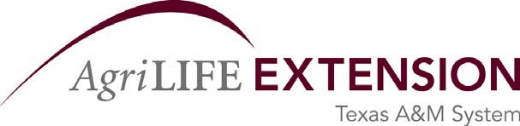
COST-SHARE (MATCHING) FUNDS COMMITMENT
For Commitment of In-kind Funds Provided by County
October 1, 2014 - September 30, 2015

I certify that the following in-kind matching funds will be provided in performance of tasks required to complete the above referenced project, and that salary and fringe benefits and other costs committed for this project will be paid from County source(s) appropriate for matching the subject agreement.

Commitment of County-only paid (Not Texas Agrilife Extension Services) personnel costs that will be used for in-kind matching:

Employee Name | Title | County | District | Full-time or  Half-time employee | Annual Salary | Fringe  Benefits | Total Salary and Benefits
EXAMPLE: Minnie Mouse | County  Secretary | Anywhere | 15 | full-time | $ 12,000 + | $ 3,360 = | $ 15,360
 |  |  |  |  | $ | $ | $
 |  |  |  |  | $ | $ | $
 |  |  |  |  | $ | $ | $
 |  |  |  |  | $ | $ | $
 |  |  |  |  | $ | $ | $

* A commitment of 5% of an employee's time is 104 hours, 10% is 208 hours. But, any number of hours can be specified.

I further certify that the specific salaries and fringe benefits included as in-kind matching funds in this commitment are not committed to any other federally-assisted project. Certified as accurate and appropriate by my signature below.

Signature Date

Title of Official County Representative
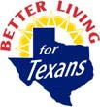
(County Judge, Auditor or Treasurer)

District:
County:

