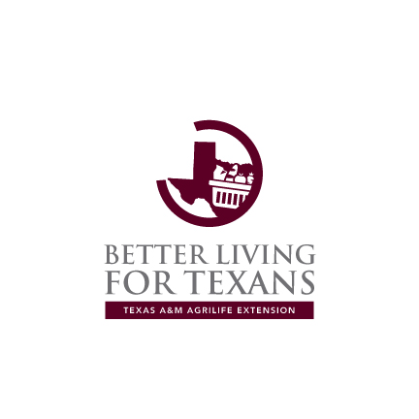

On the Track to Better Health….

September 2016 BLT Newsletter
Gluten-Free and Paleo Diets: What’s the Scoop?

Gluten is a protein found in wheat, rye, and barley. In the last few years, gluten-free products have become much more readily available than they have been in the past. For those who are unable to tolerate gluten, such as those with celiac disease, this is great news. However, as the term gluten-free has become much more mainstream, many who do not have an intolerance for gluten are also consuming gluten-free products.
With the growing popularity of these items, some who are not gluten intolerant are going gluten-free. Many believe gluten-free foods are healthier options while others are engaging in a gluten-free diet in an attempt to eat healthier and/or lose weight.
So, what’s the reality? Is gluten-free a healthier option? Is the gluten-free diet the better way to lose weight?
Research has shown that consuming gluten-free foods will have little, if any, effect on those who are not intolerant to gluten. In fact, because gluten-free products are usually more expensive, the person buying gluten-free who has no intolerance is probably doing nothing more than wasting money.
The paleo diet promotes eating fresh fruits and vegetables, healthy fats and lean proteins while reducing sugar and salt intake. This diet eliminates whole grains, oats, and lentils. Other items left out in the paleo diet include dairy, potatoes, legumes (including peanuts), and prepackaged foods.
On the surface, this diet can be attractive to many. However, there are concerns to be considered. Certain nutritional deficiencies can result from adhering to the paleo diet. Removing all grains and legumes can remove certain B vitamins like folate and niacin. The removal of dairy can lead to calcium deficiencies. In short, without supplementing this diet in some way, the paleo diet may be nutritionally incomplete.
In essence, a generally healthy individual should consult his physician before starting a gluten-free or paleo diet. In most cases, you can eat healthy (and save money) by simply following a diet based on the MyPlate model combined with regular exercise.
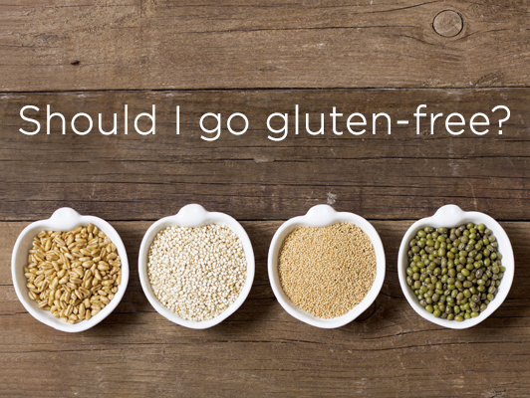
Local Events

Recipe of the month:
Whole Grain Strawberry Pancakes

Ingredients

1 1/2 cups whole wheat flour
3 tablespoons sugar
1 teaspoon baking powder
1/2 teaspoon baking soda
3 eggs
1 container vanilla low-fat yogurt (6 oz)
3/4 cup water
3 tablespoons canola oil
1 3/4 cups sliced fresh strawberries
1 container strawberry low-fat yogurt (6 oz)

Directions

1. Heat griddle to 375°F or heat 12-inch skillet over medium heat. Grease with canola oil if necessary (or spray with cooking spray before heating).

2. In large bowl, mix flour, sugar, baking powder, baking soda and salt; set aside.

3. In medium bowl, beat eggs, vanilla yogurt, water and oil with egg beater or wire whisk until well blended.

4. Pour egg mixture all at once into flour mixture; stir until moistened.

5. For each pancake, pour slightly less than 1/4 cup batter from cup or pitcher onto hot griddle. Cook pancakes 1 to 2 minutes or until bubbly on top, puffed and dry around edges. Turn; cook other sides 1 to 2 minutes or until golden brown.

6. Top each serving (2 pancakes) with 1/4 cup sliced strawberries and 1 to 2 tablespoons strawberry yogurt.



Note: This recipe makes for a healthy breakfast that provides ¼ cup of fruit, 1 ½ ounces of grains, ½ ounce of protein, and ¼ cup dairy.

