

On the Track to Better Health….

October 2016 BLT Newsletter
Pumpkin Facts

The pumpkin is much more than a gourd to be used as part of fall decorations. The reality is that the pumpkin is a versatile fruit that offers many nutrients such as potassium, vitamin A, and the anti-oxidant beta carotene. Both vitamin A and beta carotene promote healthy eyes and skin and can help protect against the development of infection.
Pumpkins come in various sizes, with some weighing less than a pound and others weighing over one-thousand pounds. They are in season from September to November (the canned variety is available all year) and are often used to make soups, pies, casseroles, cookies, breads, and pumpkin butter.
Composed of 90 percent water, pumpkins are low in calories. Pumpkin seeds are often roasted to make a healthy snack and, while little known, pumpkin flowers are edible.
When selecting a pumpkin for cooking, the best choice is a “sweet pumpkin.” This variety of pumpkin is smaller than the pumpkins usually used for carving, commonly known as the “jack-o-lantern” pumpkin. The flesh of the sweet pumpkin is sweeter and less watery than the jack-o-lantern variety.
When choosing a pumpkin, look for one that has one to two inches of stem left. The longer stem helps to stave off decay. The shape of the pumpkin is not important, as a lopsided pumpkin is not necessarily a bad one. A pumpkin with blemishes or soft spots, however, should be avoided.
When planting pumpkins in the southern region, it is best to start planting in early July so that the harvest is ready in the fall.
Pumpkins can be cooked by boiling/steaming, baking in the oven, or even prepared in the microwave.

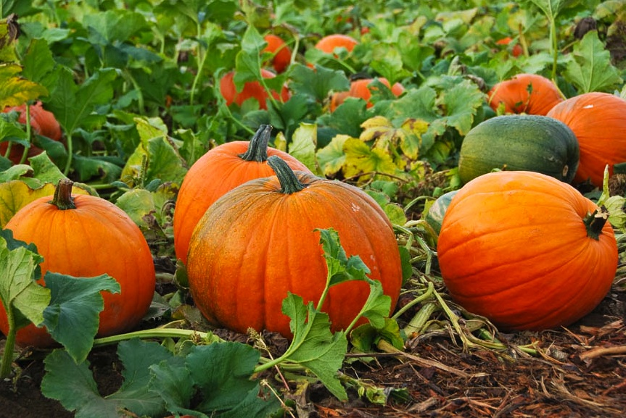
Local Events

Recipes of the month:
Roasted Pumpkin Seeds

Ingredients
- 1 quart water
- 2 Tablespoons salt
- 2 cups pumpkin seeds
- 1 Tablespoon vegetable oil or melted, unsalted butter

Directions
- Preheat oven to 250°F.
- Pick through seeds and remove any cut seeds. Remove as much of the stringy fibers as possible.
- Bring the water and salt to a boil. Add the seeds and boil for 10 minutes. Drain, spread on kitchen towel or paper towel and pat dry.
- Place the seeds in a bowl and toss with oil or melted butter.
- Spread evenly on a large cookie sheet or roasting pan.
- Place pan in a preheated oven and roast the seeds for 30 to 40 minutes. Stir about every 10 minutes, until crisp and golden brown.
- Cool the seeds, then shell and eat or pack in air-tight containers or zip closure bags and refrigerate until ready to eat.
Yield 2 cups
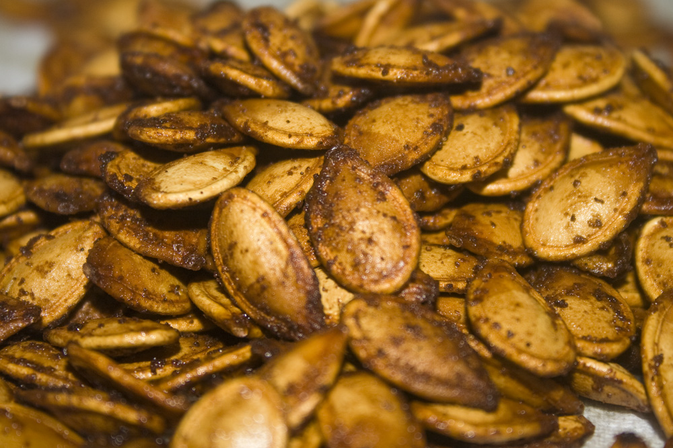

Pumpkin Nut Bars

Ingredients
- 1 cup cooked pumpkin puree, fresh or canned
- 1/2 cup butter or margarine (melted)
- 2 egg whites, slightly beaten
- 2 cups oats
- 1 cup brown sugar, packed
- 1/2 cup shredded coconut, toasted
- 1/2 cup wheat germ
- 1 cup chopped salted peanuts, pecans, or almonds

Directions
- Preheat oven to 350°F. In a large bowl, beat egg whites slightly; add pumpkin and melted butter or margarine beat until smooth.
- In another bowl combine oats, brown sugar, coconut, wheat germ, and nuts.
- Fold oat mixture into pumpkin mixture to form stiff dough.
- Press dough into a lightly greased 15 1/2 x 10 1/2 inch jelly roll pan.
- Bake 40 to 45 minutes or until golden brown. While still warm, cut into 2x3 inch bars.
Yields about 30 bars. Serve warm or cool completely.
