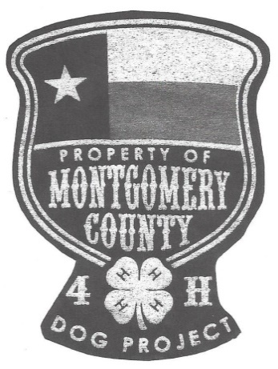
Presents

The 10th Annual
Montgomery County Open 4-H Dog Show
(open to all 4-H members in Texas)

February 4, 2017
**Entries due January 20, 2017**

Montgomery County Fairgrounds Exhibit Building
9301 FM 1484 ~ Conroe, Texas 77303

CLASSES WILL NOT BE BROKEN INTO AGE DIVISIONS, BUT THERE WILL STILL BE A HIGH POINT FOR EACH AGE DIVISION. PLACEMENTS ARE AWARDED THROUGH 10TH PLACE.
CLASSES FOLLOW STATE SHOW DESCRIPTIONS.

http://texas4-h.tamu.edu/events/dogshow/

PLEASE ENTER THE CORRECT CLASS, WHICH IS THE CLASS YOU WILL SHOW IN AT STATE 2017.

Check-in Begins at 7:30 AM ~ Show Starts at 8:30 AM

Concession Stand Opens at 8:00 AM ~ Vendors Open at 9:00 AM

******** Pre-Ordered BBQ Sandwiches sack lunch (with chips, drink, and dessert) Offered for $5 each********

There will be a chance to win items for Conroe Animal Shelter for $1 per ticket or Six for $5.00
Several silent auction items for the dog project.

Make checks payable to Montgomery County 4-H Dog Project

Mail completed entry form, signed rabies certificate, and payment to
Darcie Myers 10756 Stidham Rd. Conroe, TX 77302

Eligibility forms must be submitted to your agent prior to the show.

Questions??? e-mail adogpark@consolidated.net
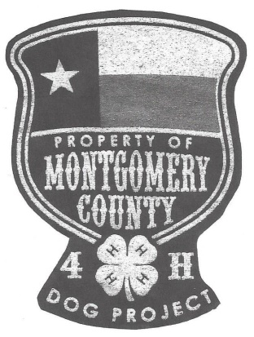
10th Annual Dog Show
February 4, 2017
Montgomery County Fairgrounds
Conroe, Texas
Participant’s Name Please circle one Junior Intermediate Senior

Address City Zip

County Phone E-mail

Dog’s Name Breed Jump Height
**include current RABIES CERTIFICATE with entry****
PLEASE READ NEW 2017 RULES FOR CHANGES TO PROGRESSIONS! Entry Fee $5.00 Per Class, Circle Class(es) To Be Entered
No. of BBQ Sandwich Sack Lunches __________ ($5/Plate)
Conformation Pure Breeds:
Sporting Hound Working Terrier Toy Non-Sporting Herding Miscellaneous Specials
Conformation Mixed Breeds:
25 Lbs & Under 26 Lbs to 54 Lbs 55 Lbs & Over Specials
Showmanship: (1 child 1 dog only)
Pre-Novice Novice Open Advanced Masters
Obedience:
Pre-Novice A Pre-Novice B Novice A Novice B 4H Grad Novice AKC Grad Novice Open Utility
Rally:
Novice A Novice B Rally Transition Novice C Advanced Excellent
Agility Standard (circle your class, note some classes run together):
Novice A and Novice B Will run together scored separately Open and Excellent Will run together scored separately
Agility Jumpers (circle your class, note some classes run together):
Novice A and Novice B Will run together scored separately Open and Excellent Will run together scored separately
Costume:
Yes
Drill Team:
Small group 3 or less Large group 4 or more No. in Team__________ Team Name__________________________________
Tricks
Yes
Photography
Photos should be 5 x 7 in size and brought to the show. They do not need to be mounted. Refer to state rules for details
Dog Still Life Dog Active Story Board Theme-Reflections

4-H Dog Agility Release Form

I/we agree to hold the Texas AgriLife Extension Service, the Texas 4-H and Youth Development Program, Montgomery County 4-H Dog Show, including its members, agents, and volunteers or employees, the owners of the premises upon which this event is held, and the owners of any equipment used harmless from any claim of loss or injury which may be alleged to have been caused directly or indirectly to any person or thing by act of this dog while in or upon the event premises or grounds or near any entrances hereto, and I/we will personally assume all responsibility and liability for any such claim. I/we further agree to hold the aforementioned parties harmless from any claim for loss of this dog by disappearance, theft, death, or otherwise, and from claim for damage or injury to the dog, whether such loss, disappearance, theft, damage or injury be caused or alleged to be caused by the negligence of the parties aforementioned, or by the negligence of any other person or any other cause or causes. I/we agree to assume the sole responsibility for and agree to indemnify and save the aforementioned parties harmless from any and all loss and expenses (including legal fees) by reason of the liability imposed by law.
I/we agree to abide by the rules as stated in the Texas 4-H Dog Show Catalog which will be used at the Montgomery County 4H Dog Show.

4-H Member’s Signature: ________________________________________________________________________________________________
4-H Member’s Name (please print): ___________________________________________________________________________________________
4-H Parent’s Signature: ________________________________________________________________________________________________
Dog’s Call Name: __________________________________ Breed: _____________________________
Age: ______________ Jump Height ______”

Dog’s Call Name: __________________________________ Breed: _____________________________
Age: ______________ Jump Height ______”
If Age is under 2 years, please give age in months. ________________
Number of Agility Classes Attended This 4-H Year:_________________
Name and Address of Sponsoring Club Where Training Was Received: (To be completed by the trainer/dog project leader verifying training)
Name: ________________________________________________________________________________________________
Address: ________________________________________________________________________________________________
City, State Zip: ________________________________________________________________________________________________
Phone: (___) __________________________

Signature of trainer or project leader: _____________________________________________

Please Circle Below the Equipment Your Dog Has Been Trained on:

Pipe Tunnel See Saw Dog Walk A-Frame Pause Table Broad Jump
Tire Jump Panel Jumps Weave Poles

Note: this form must be completed, signed, and submitted with your entry.
Mail entries payment, and release form to:
Darcie Myers 10756 Stidham Rd. Conroe, TX 77302

