Media Players– Class #1

Mike wants to purchase an iPod for his new walking class. Mike needs to make sure that, the iPod is small enough to fit in his pocket. So, that hands will be free, to hold dumbbells. But, also would like storage space of 16– 32 GB, in order to upload his favorite songs. The problem is that Mike only has $195, for this purchase.

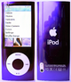
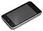
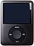
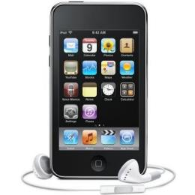
#4
Memory
8 GB

Video Quality
Digital Video
Screen Size: 2 in

Battery Life
audio: 24 Hrs
video: 4 Hrs

Special Feature
USB, FireWire for charging only), colors refreshed with chrome back, new interface, video capability, smaller Click Wheel.

Price
$100.00
#3
Memory
32GB

Video Quality
Color LCD
Screen Size 3.0 in

Battery Life
audio: 22 Hrs
video: 5 Hrs

Special Feature
USB, FireWire for charging only), Touch Screen, Wi-Fi and a Muilt-Touch interface, Safari browser and wireless access to the iTunes Store and You Tube Store.

Price
$205.00
#2
Memory
32 GB

Video Quality
Color
Screen Size 2.5 in

Battery Life
audio: 40 Hrs
video: 7 Hrs

Special Feature
USB, FireWire for charging only), video camera, larger screen, FM radio, a speaker , and pedometer

Price
$ 134.00
#1
Memory
32 GB
Flash Portable Media Player

Video Quality
Color LCD
Screen Size 3.5 in

Battery Life
audio: 40 Hrs
video: 7 Hrs

Special Feature
two cameras for Face Time and HD video recording , USB, Touch Screen

Price
$192.00
Placing: 2‐1‐4‐3
Cuts: 1‐3‐4
Reasoning:

I placed 2 over 1 because 2 is smaller in size and more cost efficient. 2 also has a pedometer that he can use in his new walking class.

I placed 1 over 4 because 1 has a long Battery Life than 4. 1 also, has
storage space of 32 GB, whereas 4 only has 8 GB of storage space.

I placed 4 over 3 because 4 had a longer battery life, was smaller in size and the least expensive in the class.

I placed 3 last because has the lowest battery life, and costs more than Mike can afford.

