Watches- Class #5
Anthony is looking for a new watch to wear when he goes around town and for casual occasions. He has $150.00 to spend on his new watch. Anthony prefers for his watch to have some kind of black so that it will go with any of his outfits. Please help Anthony find the perfect watch for his outings.

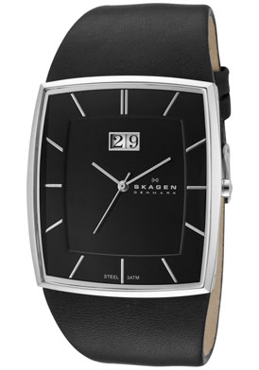 #1
Skagen
Men’s Black Dial Leather
$99.99
- Brand: Skagen
- Style: 567LSLB
- Style: Casual
- Gender: Men’s
- Case: Stainless steel
- Dial Color: Black
- Hands: Silver tone
- Markers: Silver tone indices
- Strap: Black Leather
- Clasp Type: Buckle
- Movement: Japanese quartz
- Crystal: Super hardened mineral
- Case Width: 36 mm
- Case Height: 40 mm
- Case Thickness: 9 mm
- Calendar: Big date display at 12:00
- Strap Length: Up to 8.25 inches
- Case Back: Snap-down
- Crown: Push/pull
- Other: Hypo-Allergenic Nickel Safe
- Material: Leather
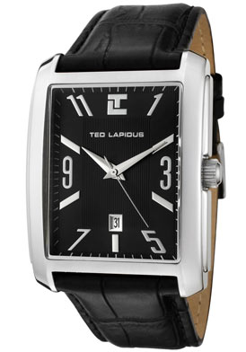 #2
Ted Lapidus
Men’s Black Dial Black Leather
$51.92
- Brand: Ted Lapidus
- Style: 5115601
- Style: Casual
- Gender: Men’s
- Strap Width: 24 mm
- Case: Stainless steel
- Dial Color: Black
- Hands: Silver tone
- Markers: Silver tone indices and Arabic numerals
- Strap: Black leather with alligator pattern
- Clasp Type: Buckle
- Movement: Japanese quartz
- Crystal: Mineral
- Case Width: 36 mm
- Case Height: 38 mm
- Case Thickness: 10 mm
- Calendar: Date display at 6:00
- Strap Length: Up to 8.5 inches
- Case Back: Snap-down
- Crown: Push/pull
- Material: Leather

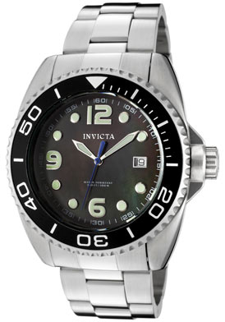 #3
Invicta
Men’s Pro Driver Black Mother of Pearl Dial Stainless Steel
$130.00
- Brand: Invicta
- Style: 0480
- Series: Pro Diver
- Style: Casual
- Gender: Men’s
- Case: Stainless steel
- Dial Color: Black mother of pearl
- Hands: Silver tone and luminous indices and Arabic numerals
- Bracelet: Stainless steel
- Clasp Type: Deployment with safety
- Bezel: Unidirectional, black
- Movement: automatic movement/mechanical
- Crystal: Mineral
- Case Width: 48 mm
- Case Height: 42 mm
- Case Thickness: 14 mm
- Calendar: Date display at 3:00
- Bracelet Width: 24 mm
- Bracelet Length: 9.5 inches
- Case Back: Screw-down
- Material: Stainless steel

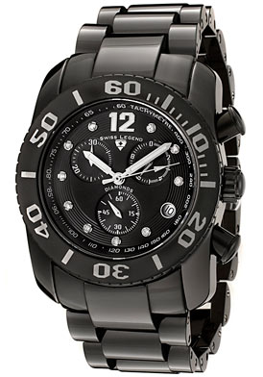 #4
Swiss Legend
Men’s Commander White Diamond (0.144 ctw) Chronograph Black High Grade Ceramic
$349.99
- Brand: Swiss Legend
- Style: 10127-BKBD
- Series: Commander
- Style: Chronograph
- Diamonds: 7 white diamonds hour markers (0.144 ctw)
- Size: Men’s
- Case: Black high grade ceramic with stainless steel black
- Dial Color: Black dial with silver tone hands and Arabic numeral at 12:00
- Bracelet: Black high grade ceramic
- Clasp Type: Push button hidden
- Luminous: Hands and Arabic numerals at 12:00
- Bezel Material: Black high grade ceramic
- Bezel Function: Unidirectional
- Movement: mechanical
- Crystal: Sapphire
- Case Diameter: 446 mm
- Case Thickness: 13 mm
- Calendar: Date display at 4:00
- Subdials: 60 seconds, 30 minutes and 1/10 second
- Bracelet Width 27 mm
- Bracelet Length: 9.75 inches
- Crown: Black ceramic cabochon screw-down
- Material: High grade ceramic
Watches Placings and Reasons
Placing: 2-1-3-4
#2 Ted Lapidus Men’s Black Dial Black Leather
- $51.92 (within budget)
- Casual
- Black
- Movement: Japanese Quartz
- Crystal: Mineral
- Case: Stainless Steel
I placed 2 first because it is the least expensive watch and within the budget. It is for casual use, it is black, and it has a quartz movement, mineral crystal to resist scratches, and the case is stainless steel for durability.
#1 Skagen Men’s Black Dial Leather
- $99.99 (within budget)
- Casual
- Black
- Movement: Japanese Quartz
- Crystal: Mineral
- Case: Stainless Steel
I placed 1 second because it is with in the price range but more expensive than #2. It is for casual use, it is black, and it has a quartz movement, mineral crystal to resist scratches, and the case is stainless steel for durability.
#3 Invicta Men’s Pro Driver Black Mother of Pearl Dial Stainless Steel
- $130 (within budget)
- Casual
- Black- Semi
- Movement: automatic movement/mechanical
- Crystal: Mineral
- Case: Stainless Steel
I placed 3 third because it is one of the most expensive watches but was still within budget. It was casual but it was not all black because the band was silver. He wanted black. Also the movement of the watch was an automatic movement and while nice, it does not keep accurate time and must be wound.
#4 Swiss Legend Men’s Commander White Diamond (0.144 ctw) Chronograph Black High Grade Ceramic
- $349.99 (not in budget)
- Chronograph (not casual)
- Black
- Movement: mechanical
- Crystal: Sapphire
- Case Ceramic and Stainless steal
I placed 4 last because it was not within budget, it was not a casual watch, and the movement was mechanical which while nice, it does not give accurate time and must be wound by hand.

