Class #6- Outdoor Equipment
Tony is going to the Alps for an outdoor excursion in January. He needs a sleeping bag that he can carry a long ways. He does a lot of backpacking so he needs this sleeping bag a long time and he does not have any allergies. Tony is very tall and is around 6’7’’ tall. Please help him find a good sleeping bag. He has $130 to spend.
 | Product #1  Slumberjack Latitude 0 Degree SyntheticSleeping Bag  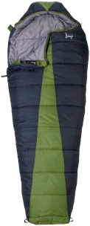 | Product #2  Suisse Sport Adventurer Mummy Ultra-Compactable Sleeping Bag  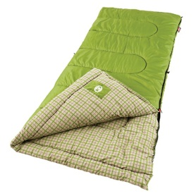 | Product #3  TETON Sports Mammoth Queen Size Flannel Lined Sleeping Bag (94"x 62")  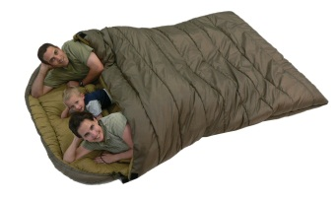 | Product #4  Coleman North Rim 0 Degree Sleeping Bag  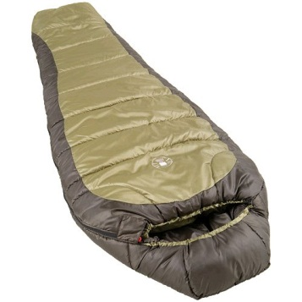
Price | $125 | $37 | $135 | $30
Dimensions | Long | Regular | Long | Long
Temperature Rating | 0 Degrees F | 30 Degrees F | 0 Degrees F | 0 Degrees F
Insulation | Down | Synthetic | Synthetic | Synthetic

Outdoor Equipment Placing: 1-4-2-3
Cuts: 1-3-5

