Class #4
Cookware
Rhettlee is engaged to be married and needs to pick out a set of cookware for her registry. She would like something that is scratch resistant and nonstick. She wants the most pots and pans for her money but no utensils as she has received a lot for bridal shower gifts. She would like them to be no more than $150 because she does not want someone to spend more than that.

#1  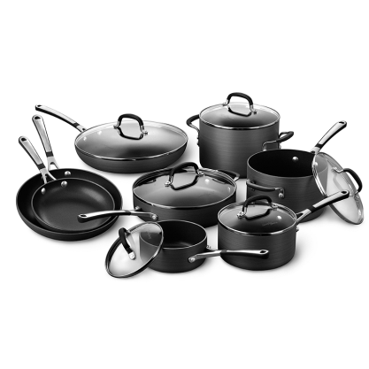  Simply Calphalon® Nonstick 14-Piece Cookware Set and Open Stock | #2  Bialetti® Aeternum Red 10-Piece Cookware Set and Open Stock  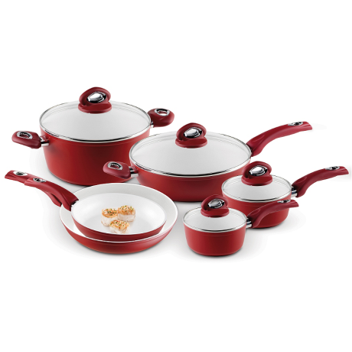 | #3  Chef's Du Jour 32-Piece Kitchen Combo Set  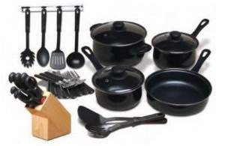 | 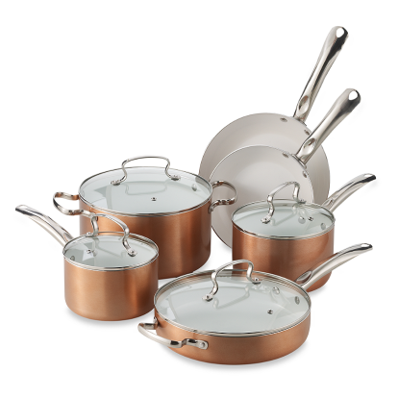  #4  Denmark Tools for Cooks® 10-Piece Ceramic Nonstick Aluminum Cookware Set
General Features  Set Includes:  2qrt Saucepan w/cover  4 qrt Saucepan w/cover  1 qrt Saucepan w/cover  5 qrt Saute pan w/cover  2-8in and 10 in omelet pans  12in everyday pan w/cover  Constructed of: Hard-anodized Aluminum  Other: Non-Stick  Dishwasher Safe: No | General Features  Set Includes:  8" and 10.25" saute pans, 2-quart and 2.5-quart covered sauce pans, 5-quart covered Dutch oven and an 11" covered deep saute pan.  Constructed of: Heavy gauge aluminum  Other: Scratch and Stain Resistant, Nonstick  Dishwasher Safe: No | General Features  Set Includes: 32-piece set consists of 3-1/4-quart covered Dutch oven, 1-3/4-quart covered sauce pan, 1-1/4-quart covered sauce pan, 8-5/8-inch saute pan, 7-piece cutlery set, 6 kitchen tools and 12-piece flatware set  Constructed of: 0.7 mm carbon steel with nonstick interiors  Other: Stay cool handles, tempered glass lids  Dishwasher Safe: Yes | General Features  Set Includes: 2-qt. and 3-qt. covered saucepans, 6-qt. covered Dutch oven, 8" and 10" fry pans, plus  3-qt. covered sauté pan  Constructed of: Aluminum  Other: Nonstick  Dishwasher Safe: No
Price: $300 | Price: $150 | Price: $34.15 | Price: $100

Cookware CLASS PLACING: 2-4-3-1
CUTS 1-4-5

2: Scratch resistant and nonstick
4: nonstick
3: more utensils less pots and pans
1: too expensive

