Digital Cameras Class #3
June is looking for a digital camera to take with her on her trip to France. She just wants a simple point and shoot camera because just in case it gets lost she would not have spent a lot of money for it. June has $200.00 to spend on the camera. She would like for the camera to have Face Detection, but it’s not a necessity. She would like for the zoom to be at least 4x.

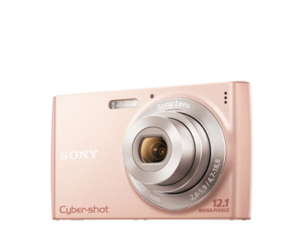
Cyber-shot Digital Camera W510 #1 | Cyber-shot Digital Camera WX10 #2 | Cyber-shot Digital Camera W530 #3 | Cyber-shot Digital Camera W560 #4
$89.99 | $229.99 | $89.99 | $109.99
Model number: DSC-W510/P  Rated 3 out of 5 stars  Model Highlights: 12.1-megapixel, 26mm equivalent lens with 4x optical zoom, Sweep Panorama Mode, 2.7" LCD, iAuto, Smile Shutter™ and Face Detection, SteadyShot™ image stabilization, VGA movie capabilities | Model number: DSC-WX10/B  Rated 5 out of 5 stars  Model Highlights: 16.2-megapixel, 7x optical zoom, 2.8" screen, Full HD 1080/60i video, "Exmor R" CMOS sensor, 10fps, background defocus, manual control, 3D Sweep Panorama | Model number: DSC-W530/L  Rated 3.7 out of 5 stars  Model Highlights: 14.1-megapixel, 26mm equivalent lens with 4x optical zoom, Sweep Panorama Mode, 2.7" LCD, iAuto, Smile Shutter™ and Face Detection, SteadyShot™ image stabilization, VGA movie capabilities | Model number: DSC-W560/L  Rated 5 out of 5 stars  Model Highlights: 14.1-megapixel, Sweep Panorama Mode, HD Movie mode (720p), 3.0" LCD, iAuto mode, Optical SteadyShot™ image stabilization, Carl Zeiss® Vario-Tessar 4x (25mm wide) optical zoom lens

Digital Cameras Placing & Reasons
Placing: 3 – 1 – 4 – 2
Cuts: 1-4-6
#3- Cyber-shot Digital Camera W530
- $89.99
- 14.1 megapixel
- 4x optical zoom
- Face Detection
- Steady Shot
I placed 3 first because 3 was only $89.99 and it was everything that June asked for with a high megapixel of 14.1, 4x optical zoom, Face Detection and Steady Shot.
#1- Cyber-shot Digital Camera W150
- $89.99
- 12.1 megapixel
- 4x optical zoom
- Face Detection
- Steady Shot
I placed 1 second because granted it was the same price as 3 and had all the same qualities, I criticize that 1 only had a 12.1 megapixel, whereas 3 had a 14.1 megapixel.
#4- Cyber-shot Digital Camera W530
- $109.99
- 14.1 megapixel
- Optical Steady Shot
- 4x optical zoom
I placed 4 third because 4 was $109.99, which is a difference of $20.00 more than 3 and 1.
#2- Cyber-shot Digital Camera W560
- $229.99
- 16.2 megapixel
- 7x optical zoom
- No Face Detection
I place 2 last because 2 did not have Face Detection and 2 was over priced at $229.99.

