
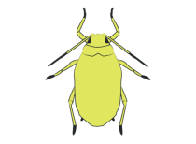

Another year is closing out as a new season approaches. 2016 was a great production year for most farmers in south Texas. Favorable environmental conditions were exceptional for grain production. Now it is time to recharge and prepare for 2017.
Sugarcane Aphid Update:
Summary of SCA occurrence from 2013 through 2016. Sugarcane aphid was identified on sorghum for the first time in Arizona and California. It is safe to say that SCA has now been reported in all sorghum production regions in North America.

SCA observations in 2016: In late-April and early-May of 2016 sugarcane aphid (SCA) populations increased rapidly on sorghum grown in southern regions of Texas. Several rain events and cooler conditions immediately followed the explosion of SCA on sorghum. But, with a blink of the eye, SCA populations declined and collapsed across wide regions of southern Texas. Numerous sorghum acres in some areas were treated for SCA while others had very few to no acres requiring SCA insecticide treatements.
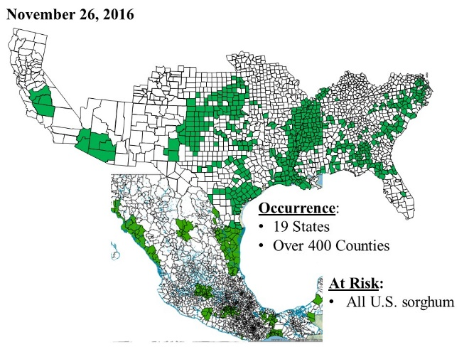
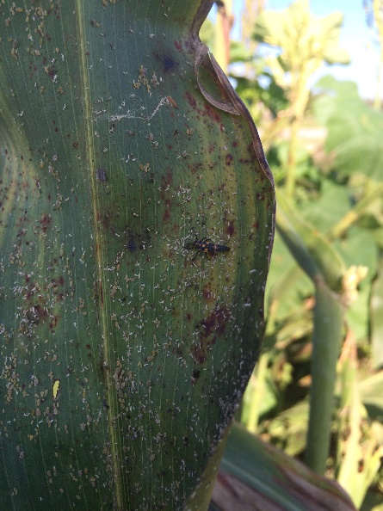
In May I was surveying sorghum fields in Nueces, Kleberg, Jim Hogg, and San Patricio counties for SCA following several rain events and it was very difficult to find what had obviously been large SCA populations. My assumption was that the fields had been treated but I could find small colonies of SCA in just about every field. I visited with most of the farmers whose fields I had surveyed and they all shared the same story…the fields were scheduled to be treated but the SCA populations collapsed prior to insecticide applications. A number of crop advisors shared the same story.
We had a number of SCA research projects at the Corpus Christi AgriLife Research and Extension center. SCA moved in the second week of May following above normal temperatures and what had been a very dry fall/winter and early spring. It was shaping up to be a very productive year for SCA research at the center. Counts were made, treatments were applied and post-treatment evaluations were made. But, as with the surrounding sorghum production regions, the aphid populations collapsed 7 to 10 days after establishing various research projects and SCA did not return prior to harvest. The sudden collapse of SCA was very fortunate for area farmers but extremely frustrating for researchers.
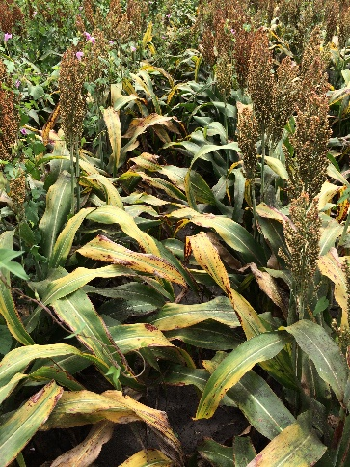
I had a large SCA insecticide efficacy trial that I was desperate to establish. In late-August John Gordy (Fort Bend County agent) located a perfect late-planted sorghum patch to conduct the SCA efficacy trial. It was a very hot day when we made the pretreatment SCA counts in this sorghum. The aphid was spread uniformily across the field with populations just over 100 individuals per leaf. By late afternoon there was a late shower. An ominous sign? Perhaps!
We left the field without applying the insecticide treatments. Rain was in the forecast the following day but Friday looked promising. I made the trek to Beasly, Texas on Friday to apply insecticides. I arrived at the location around 4:00 p.m. and…it was showering! I waited the shower out, applied the insecticides (I used the flashlight on my mobile phone to finish the last four treatments) and crossed my fingers that the test would be a success. Our three day post-treatment evaluations went as expected with a three fold increase in SCA populations in the untreated check plots. Then the 7-day counts…the first rep we counted revealed that SCA populations in the untreated check were similar to those made four days earlier. By the time we completed the counts it was obvious the SCA populations were beginning to collapse. By 10-days post-treatment SCA had completely collapsed.
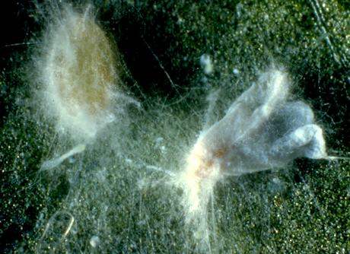
We did observe SCA covered in a white growth on every leaf previously harboring large populations of SCA in the Beasley insecticide efficacy trial. I collected leaves with what I presumed to be diseased SCA and brought them to Corpus Christi. I collected some of these aphids and sent them to Dr. Donald Steinkraus in Arkansas. I was skeptical that anything would be found because I had made similar attempts early in 2015.
About two weeks ago Dr. Steinkraus identified the fungal growth on SCA as Verticillium lecanii. This information came to me while I was in Mexico participating in sugarcane aphid management symposium. Dr. Raquel Alatore Rosas, an entomologist specialing in entomopathogens, presented research on entomopathogens of sugarcane aphid at this symposium. One of the common entomopathogens she introduced as an important biocontrol agent against the sugarcane aphid on sorghum in Mexico was V. lacanii.
What is V. lecanii? Verticillium lecanii is a fugus that infects certain insects (an entomopathogen). It was first observed in the 1860’s on a scale insect in Sri Lanka. This entomopathogen has been reported on scale insects, aphids, whiteflies and thrips.
How does it work? V. lecanii spores in contact with the insects cuticle (skin) germinate and grow directly through the cuticle into the body of its host. The fungus grows throughout the insect’s body, essentially exhausting the insect of nutrients. The insect will die within 48 to 72 hours of infection.
Environmental factors favoring V. lacanii infection may vary upon the strain but the fungus requires a specific range of temperatures and high relative humidity for spores to germinate (sporulation). In general, the pathogen requires a temperature range from 77° to 86° fahrenheit. Sporulation may cease at temperatures above or below this range. Other factors that influence the ability of this insect pathogen to infect its host include inoculum concentration and the growth stage of its host.
Back to the efficacy trial at Beasley. I was curious about the temperature range when V. lecanii caused the total collapse by SCA in our trial. The ambient high temperatures during the epizootic (a disease outbreak) were in the 90° F range and the lows were running in the lower 70° range. My first impression was that the temperature range was outside that needed for V. lecanii sporulation. I then considered the microclimate where SCA had colonized plants. The majority of aphid colonies were on the lower leaves where the temperatures were much lower than the ambient and the dense canopy buffered wide swings in low and high temperatures. Also, I recalled the soil was saturated from recent rains providing favorable humidity for fungal growth. An ideal situation for an epizootic! Also, rain splash possibally moved V. lecanii spores from the soil or surrounding foliage onto the aphids. So, the microclimate was ideal for disease infection among SCA colonizing sorghum at this test site. I was amazed at the rapid decline of SCA in this test plot. But, I am almost certain similar events have occurred in SCA on south Texas sorghum.
Some thoughts and ramblings? I often ask myself if V. lecanii could have played a role in the sudden and region wide collapse of SCA in south Texas. This event occurred shortly after a cold front and several rain events. It is possible but it is very hard to prove without documentation. I do believe this is an important factor when climatic conditions favor an epizootic (reduced temperatures behind cold fronts accompanied by rain). It is something that would be difficult to predict and certainly not a reliable SCA biological control agent in all years but certainly something to consider when climatic conditions favor an epizootic. The timing for epizootics would most likely occur in the spring and fall.
I have talked exclusively about V. lecanii but there are other fungi that attack SCA. Several have been identified from diseased SCA on sorghum in Mexico. Unfortunately, there are no entomologists investigating fungal pathogens of SCA in the U.S.
Predicting SCA outbreaks. Experiences with SCA over the past four seasons suggest SCA outbreaks commonly occur during dry conditions and moderate temperatures (mid-70’s to upper 80’s/low 90’s). The aphid demonstrates explosive reproduction potential under these cimatic conditions.
Company | Hybrid | Maturity
Alta | AG1203 | Medium-late
B&H Genetics | BH 4100 | Medium
Sorghum Partners | SP 7715 | Medium-full
Warner | W7051 | Medium-late
DKS48-07 | DeKalb | Medium
REV9782 | Terral | Medium-full
Hybrid resistance: Evaluation of commercial hybrids has been important for identifying/confirming an ever growing list of hybrids with resistance/tolerance to SCA. A short list of products identified as SCA ‘tolerant’ from 2016 field trials in north, central, and south Texas can be found in the table below.
This is in no way an exhaustive list of sorghum hybrids with resistance to SCA but those that have been evaluated in Texas A&M AgriLife Research and Extension trials. Also, it is likely that SCA will occur on any of these hybrids but population growth will be much lower when compared to susceptible hybrids.
Although SCA resistant hybrids are available, it is important that you select products that have the right agronomic mix to ensure a high probability of achieving production goals. The SCA can easily be managed with insecticides when routinely scouted and timely insecticide applications are made once the aphid reaches the economic threshold.
Spray Tip Summary: SCA populations colonizing the the underside of leaves, often beginning at the base of lower leaves. We continue to see good efficacy of Sivanto and Transform WG, but we wanted to look at some of the commonly used and available spray tips to see if there were differences in spray coverage and canopy penetration, as those may be important points of consideration for expected efficacy of an insecticide application.
This season, we were able to look at seven spray tips in two trials – one in Rosenberg in boot-stage sorghum on 40” rows, and one in Corpus in headed sorghum on 38” rows. Spray coverage was measured at the base of the plant, lower canopy, mid canopy, and upper canopy.
In the Rosenberg trial, which was made with a Spra-coupe at 10 gpa, there was no difference in spray coverage at any level of the canopy. In the Corpus trial, where the application was made with a plot sprayer at 20 gpa, there was no difference in percent coverage at the lower, middle, and upper canopy. However, at the base of the plant, percent coverage of the TeeJet TXR Conejet (8004) was more than double that of any other tip.
Due to wet conditions when aphid populations were highest, we were unable to perform any insecticide efficacy studies comparing different spray tips. Hopefully we will be able to look at that next year to see if coverage and canopy penetration translate into improved efficacy.

Closing thoughts. Often times we get caught up in our busy lives and forget to take time for ourselves, our families, and our friends. I hope all of you find time to spend with those closest to you during this holiday season. I would like to say “Thank you!” to all those that made this a great year for me and I am looking forward to another successful year in 2017.
ACKNOWLEDGEMENT: I would like to thank John Gordy for reviewing this newsletter and providing the update on spray nozzel tip research.

Better Yield in the Field
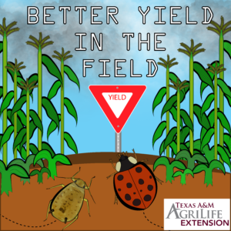
You can now follow south Texas insect and production news on Facebook and Linkedin (Better Yield in the Field) and our website is coming together (http://agrilife.org/sca/). Check us out as we grow and expand our offerings.

Robert Bowling, Ph.D.

Assistant Professor and Agrilife Extension Entomology Specialist
Texas A&M Agrilife Research and Extension Center at Corpus Christi
10345 Hwy 44
Corpus Christi, TX 78406
wk. (361) 265-9201

